

2025

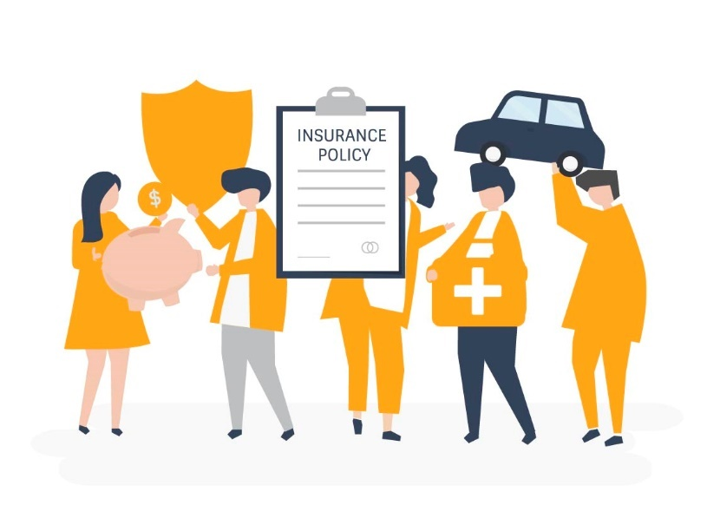

PolicyPro360 – Online

Insurance Management System

Your Policy, Our Priority” –

delivering trusted, secure, and

simplified insurance services.





**Our Logo**

**PolicyPro360** stands for "**Policy Professionals**", committed to delivering reliable and secure insurance solutions tailored to your needs. Our platform brings together expertise, ease, and trust — making insurance simple for everyone.

**Tagline: "Your Policy, Our Priority"**

At PolicyPro360, we believe that every policy matters. That’s why we focus on providing clear, fast, and personalized services — whether it's life, medical, motor, or home insurance.

**Font Style**

The project uses **Segoe UI** and **Roboto** fonts for a clean, modern, and highly readable interface.

**Color Meaning**

**Orange (#f5a526)** –Symbolizes energy, urgency, and responsiveness in service.  
**Dark Charcoal (#171827)** Reflects professionalism, trust, and modern design.  
**Black (#000000)** – Represents strength, authority, and confidence.



|  |  |  |
| --- | --- | --- |
| **Supervisor** | **Miss Kiran Shakeel** | |
| **Batch** | **PR2-202401B2** | |
| **Serial No.** | **Enrollment Number** | **Student’s Name** |
| **01.** | Student1539217 | KASHAF JAMIL |
| **02.** | Student1534559 | MUHAMMAD SAMI KHAN |
| **03.** | Student1547835 | FIZA ZULFIQAR |
| **04.** | Student1530801 | MUHAMMAD HASAN |
| **05.** | Student1548125 | RABEEA QASIM |
| **06.** | Student1542241 | MUHAMMAD ARMAN |

**Table of Contents**

**Contents**

**CERTIFICATE OF COMPLETION 7**

**ACKNOWLEDGEMENT 8**

**INTRODUCTION 9**

**PROBLEM STATEMENT 9**

**CUSTOMER REQUIREMENTS 11**

**SPECIFICATIONS – PolicyPro360 11**

**SCOPE OF THE PROJECT 14**

**PROPOSED SOLUTIONS 15**

**HARDWARE/ SOFTWARE REQUIREMENTS 16**

**DATABASE DESIGN 17**

**INTERFACE DESIGN DOCUMENT 18**

**1. Introduction 18**

**2. User Roles and Interface Responsibilities 18**

**3. Workflow Summary 18**

**WORKFLOW DIAGRAMS 19**

**ADMIN DASHBOARD 19**

**COMPANY DASHBOARD 20**

**USER DASHBOARD 21**

**System Architecture and Design of the System 22**

**Complete Website Workflow and Interface Snapshots 22**

**Home 22**

**About 25**

**Insurance 27**

**Home Insurance 28**

**Motor Insurance 29**

**Life Insurance 30**

**Medical Insurance 31**

**Policies 32**

**Medical Insurance Policies 34**

**Medical Policy Premium Calculator & Premium Quote 35**

**Policy Proceed to Checkout 36**

**Life Insurance Policies 37**

**Life Policy Premium Calculator & Premium Quote 38**

**Motor Insurance Policies 39**

**Motor Policy Premium Calculator & Premium Quote 40**

**Home Insurance Policies 41**

**Home Policy Premium Calculator & Premium Quote 42**

**How to File a Claim 43**

**Health & Medical Claims 44**

**Home Insurance Claims 45**

**Motor (Car/Bike) Claims 46**

**Life Insurance Claims 47**

**Loan Against Policy 48**

**News 49**

**News Detail 1 51**

**News Detail 2 52**

**Frequently Asked Questions 53**

**Privacy Policy 54**

**Terms & Conditions 56**

**Sign In 57**

**Sign Up 58**

**Contact Us 59**

**User Login 60**

**User Dashboard 60**

**User Wallet 61**

**Add Money to Wallet 61**

**User Profile 62**

**User Edit Profile 63**

**User Change Password 63**

**User Policies 64**

**User Policy View Details 1 64**

**User Policy View Details 2 65**

**User Policy View Details Print 65**

**User Make Payment 66**

**User File a Claim 67**

**User Track Your Claim 67**

**User Apply Loans 69**

**User Applications 71**

**User Support 71**

**User Logout 72**

**Company Register 73**

**Company Login 74**

**Company Login After Approval 74**

**Company Dashboard 75**

**Company Wallet 76**

**Company Withdraw 76**

**Company Insurance Policies 78**

**Company Policyholders 80**

**Company User Claims 80**

**Company User Claims Views & Change Status 81**

**Company User Pending Loans 82**

**Company User Loan History 84**

**Company Profile 85**

**Company Edit Profile 86**

**Company Logout 86**

**Admin Login 87**

**Admin Dashboard 87**

**Admin Register 88**

**Admin Wallet 88**

**Admin Policy Category 89**

**Admin Companies 90**

**Admin Company View details 91**

**Admin Company Policies 92**

**Admin Company Policy View 93**

**Admin User All Policyholders 94**

**Admin User Claims 94**

**Admin User Loans 95**

**Admin User Payments 95**

**Admin User Supports 96**

**Admin Site Settings – FAQs 96**

**Admin Site Settings – Contact Form 98**

**Admin Site Settings – Contact Form 99**

**Admin Site Settings – Terms and Conditions 101**

**Admin Site Settings – Privacy Policy 103**

**Admin Logout 103**

**TASK SHEET 104**

**PROJECT REVIEW AND MONITORING REPORT 105**

**UNIT TESTING CHECKLIST 106**

**FINAL SUBMISSION CHECKLIST 107**





# **CERTIFICATE OF COMPLETION**

**KASHAF JAMIL, MUHAMMAD SAMI KHAN, FIZA ZULFIQAR, MUHAMMAD HASAN, RABEEA QASIM & MUHAMMAD ARMAN**

This is to certify that

Has Successfully Completed Their

**ACCP Prime 2.0 Semester III E-Project**

Submitted To:

**Aptech Computer Education**

Date of Issue:

**July 24th, 2025**



# **ACKNOWLEDGEMENT**

First and foremost, we are deeply thankful to Almighty Allah for granting us the strength, patience, and ability to complete this project successfully.

We would like to express our heartfelt gratitude to our respected teacher, Miss Kiran Shakeel, for her invaluable guidance, continuous support, and encouragement throughout the development of our project **"PolicyPro360 – Online Insurance Management System"** Her supervision not only kept us on the right track but also enhanced our learning experience through exposure to new ideas and technologies.

We are also sincerely thankful to our parents and friends for their constant motivation, moral support, and assistance during every phase of this project.

Finally, we would like to extend our appreciation to the E-Project Team at Aptech Head Office for their valuable feedback, resources, and overall support, which played a key role in the successful completion of this project.

We hope that PolicyPro360 serves its purpose effectively and proves to be helpful for its intended users. We warmly welcome any suggestions and feedback for future improvements.



# 

# **INTRODUCTION**

**PolicyPro360** is a web-based insurance management system that allows insurance companies to create and manage policies, while users can view, purchase, and manage their insurance online. The platform streamlines the entire insurance process and provides secure access to users, companies, and administrators.

This documentation outlines the system's purpose, features, and implementation approach.

# **PROBLEM STATEMENT**

The problem statement is attached separately in a file “Insurance-services.doc”

**Standards plan:**

Every code block must have comments.

The logic of the program needs to be explained. Proper documentation should be

maintained.

Complete Project Report along with synopsis, code and documentation should be

prepared.

**Documentation:**

No project is complete without documentation. In fact, it is one of the most

important activities during the development of a project. The documentation of an

The ideal project will be in the form of a project report comprising of the following

documents:

* Certificate of Completion.
* Table of Contents.
* Problem Definition.
* Customer Requirement Specification.
* Project Plan.
* E-R Diagrams.
* Algorithms.
* GUI Standards Document.
* Interface Design Document.
* Task Sheet.
* Project Review and Monitoring Report.
* Unit Testing Check List.
* Final Check List.



# **CUSTOMER REQUIREMENTS**

# **SPECIFICATIONS** **– PolicyPro360**

Insurance services

Insurance is a contract for the payment of a sum of money to the person assured upon

the happening of the event insured against.

Usually, the contract provides for:

* Payment of a specific amount on the date of maturity
* Payment at specified intervals
* Payment upon the unfortunate death of the insured, if it occurs earlier

The insured agrees to pay periodic premiums to the corporation. Insurance is widely

recognized as an institution that eliminates risk by replacing uncertainty with certainty

and provides timely aid to the family in the event of the breadwinner’s death.

**🔹 Project Requirements**

This software system provides support for four main types of insurance services:

* Life Insurance
* Medical Insurance
* Motor Insurance
* Home Insurance

The project operates in **Internet mode**, allowing authorized company officials to **view**

**and update** data online.

**🔹 Key Features of Online Insurance Service**

1. **Policy Viewing**  
   Users can view details of various policies and schemes offered by insurance companies.
2. **User Registration**  
   New users can register on the platform to access policy information online.
3. **Policyholder Dashboard**  
   Existing policyholders can:
   * View their current policy details
   * Calculating premium amounts based on selected term plans
4. **Information Updates**  
   The website provides updates about:
   * New strategies
   * New subsidiary schemes offered by the companies
5. **Loan and Online Payment Facility**
   * Policyholders can apply for loans against their policies
   * Premiums can be paid online securely

**🔹 Insurance includes**

Insurance services

* **Life Insurance:** Life insurance is a plan which provides protection to

the insured and his family with financial coverage in case of any

mishaps. To avail yourself of the benefits of life insurance policy, the policy holder

must pay a monthly premium to the insurer for a certain period of

time.

* **Medical Insurance:** Under this type of health care cover, medical

expenses are covered. When an insured person needs medical

treatment due to illness or accident, the insurance agent provides

coverage for his expenses such as doctor fees, hospital fees, medicine

cost and other related bills.

* **Motor insurance:** Under this type of plan which provides protection

against the automobile the user owns.

* **Home Insurance:** The most popular among the 6 types of

insurance is the home insurance that provides compensation for any

mishaps that occur in your home. Coverage is provided according to

the policy and premium paid by the homeowner. There are various

types of home insurance plans that you can choose from to suit your

needs.

# 



]

# **SCOPE OF THE PROJECT**

**PolicyPro360** is an online insurance management system designed to streamline the interaction between insurance companies and customers.

The platform allows **insurance companies** to register and **create various policy types**, such as Life, Medical, Motor, and Home Insurance.  
**Users** can register, view policy det ails, purchase policies, pay premiums, and submit claims or loan requests.  
**Admins** have full control to manage users, companies, policies, and monitor system activities.

The system ensures a secure, user-friendly, and efficient experience, aligning with our commitment:

**"Your Policy, Our Priority."**



# **PROPOSED SOLUTIONS**

To address the challenges faced in traditional insurance systems—such as manual processes, lack of transparency, and limited customer access—**PolicyPro360** offers a **centralized and digital solution**.

This web-based platform will:

* Allow **insurance companies** to register and easily create/manage policies online
* Enable **users** to register, view policies, buy them, pay premiums, and submit claims or loan requests from anywhere
* Provide an **admin panel** to oversee all operations, user activity, and generate reports

By automating core insurance functions and providing real-time access, PolicyPro360 ensures a secure, fast, and hassle-free experience for all stakeholders.

The system simplifies insurance processes, reduces paperwork, and builds trust through transparency and digital convenience.

# 

# **HARDWARE/ SOFTWARE REQUIREMENTS**

**Hardware**

• A minimum computer system that will help you access all the tools in the courses is a Pentium 166 or better

• 128 Megabytes of RAM or better

**Software**

* Visual Studio .Net / ASP
* IIS server
* .Net Framework
* Java Virtual Machine/ J2EE server
* 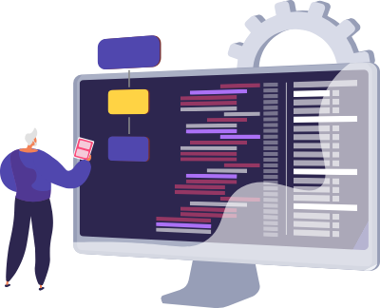Notepad/Java editor
* j2sdk1.4.1_02 (or later).
* EJB Dev Kit
* Java enabled web server
* JSP / Servlets Dev. Kit

# **DATABASE DESIGN**

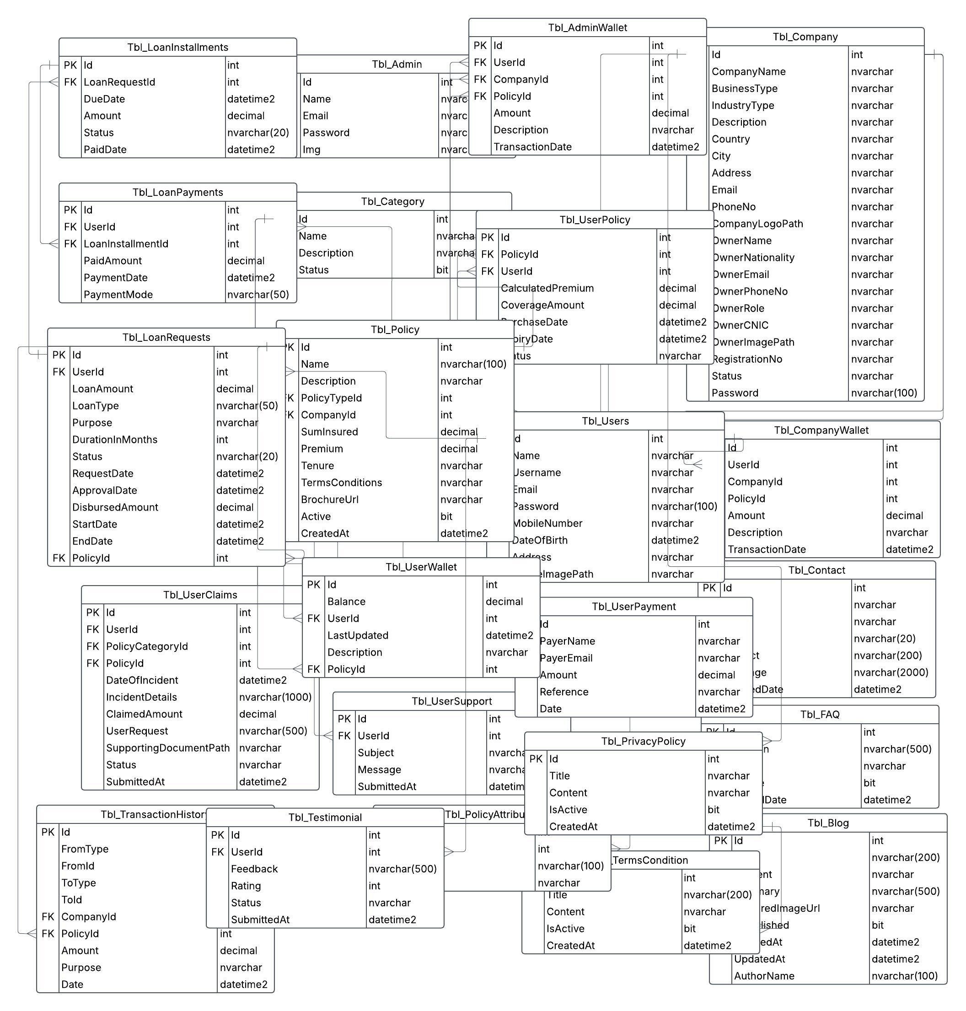

# **INTERFACE DESIGN DOCUMENT**

## **1. Introduction**

This document outlines the design and interaction structure of the **PolicyPro360** platform, focusing on clear navigation, smooth workflows, and user-centric layout across all roles.

## **2. User Roles and Interface Responsibilities**

|  |  |
| --- | --- |
| Role | Responsibilities / Access |
| Customer | Register, log in, view/purchase policies, calculate premiums, and **submit claim/loan requests** |
| Company | Manage their insurance policies and **view/process claim and loan requests** from customers |
| Admin | Full system access. **Manages websites**, approve companies, views reports, and monitors all modules |



## **3. Workflow Summary**

* **Customer Side**
* Access dashboard to:
  + View policies
  + Use premium calculator
  + Submit **claim** or **loan** request
* **Company Side**
* View dashboard listing:
  + Added policies
  + Incoming **claim requests**
  + Incoming **loan requests**
  + Approve/Reject options available for each
* **Admin Panel**
* Approves companies before they can add policies
* Can view all customer activities, system statistics, and reports
* Responsible for full system supervision and integrity



# **WORKFLOW DIAGRAMS**

## **ADMIN DASHBOARD**

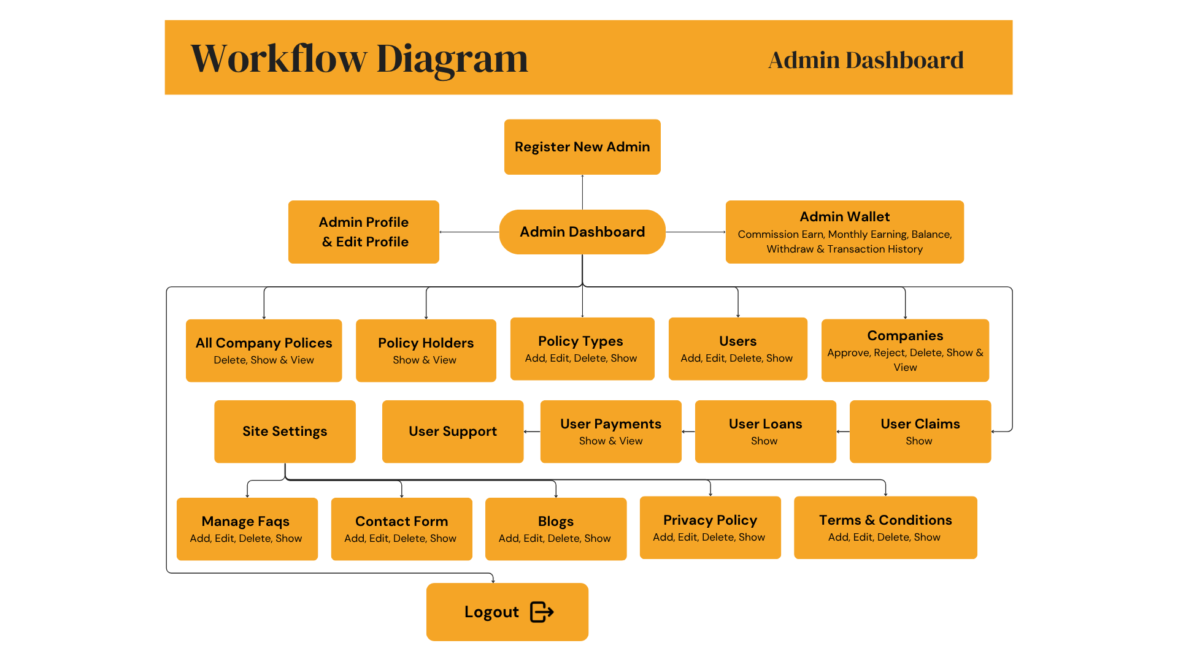



## **COMPANY DASHBOARD**

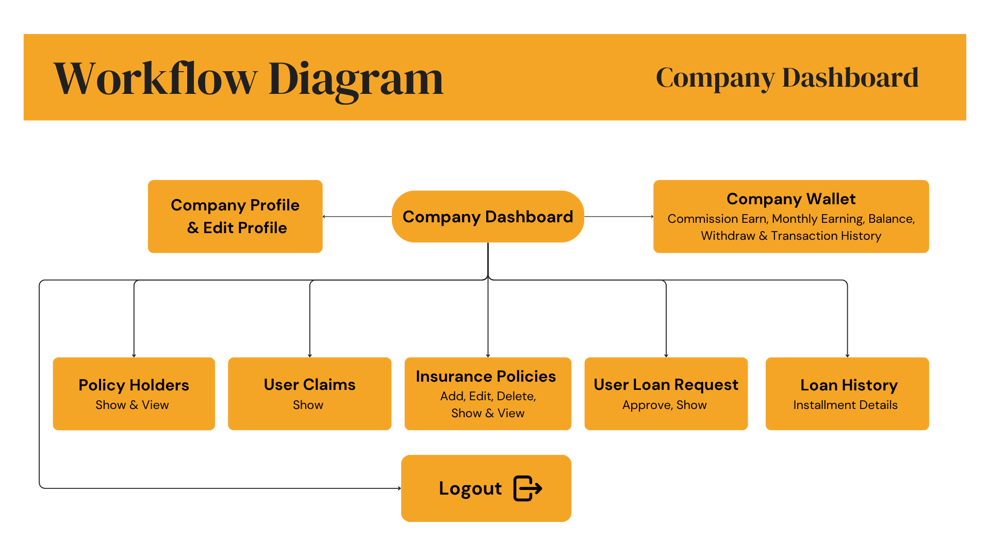

\

**USER DASHBOARD**





# **System Architecture and** **Design of the System**

## **Complete Website Workflow and Interface Snapshots**

### **Home**

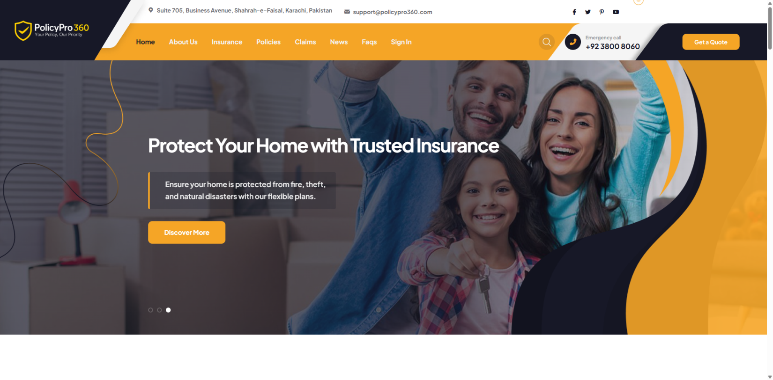

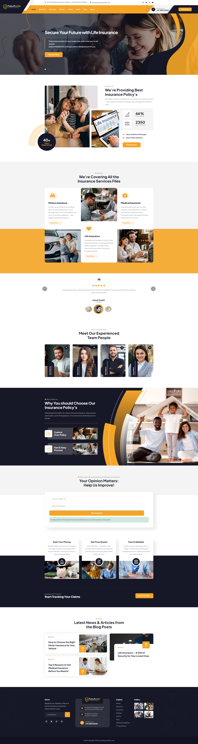

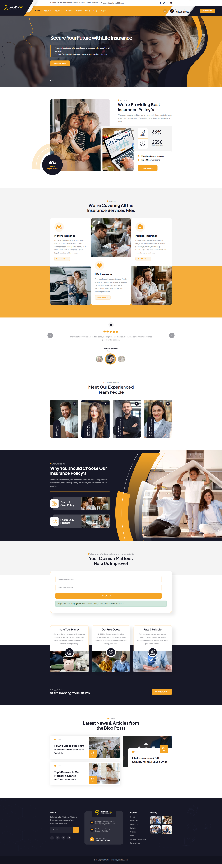

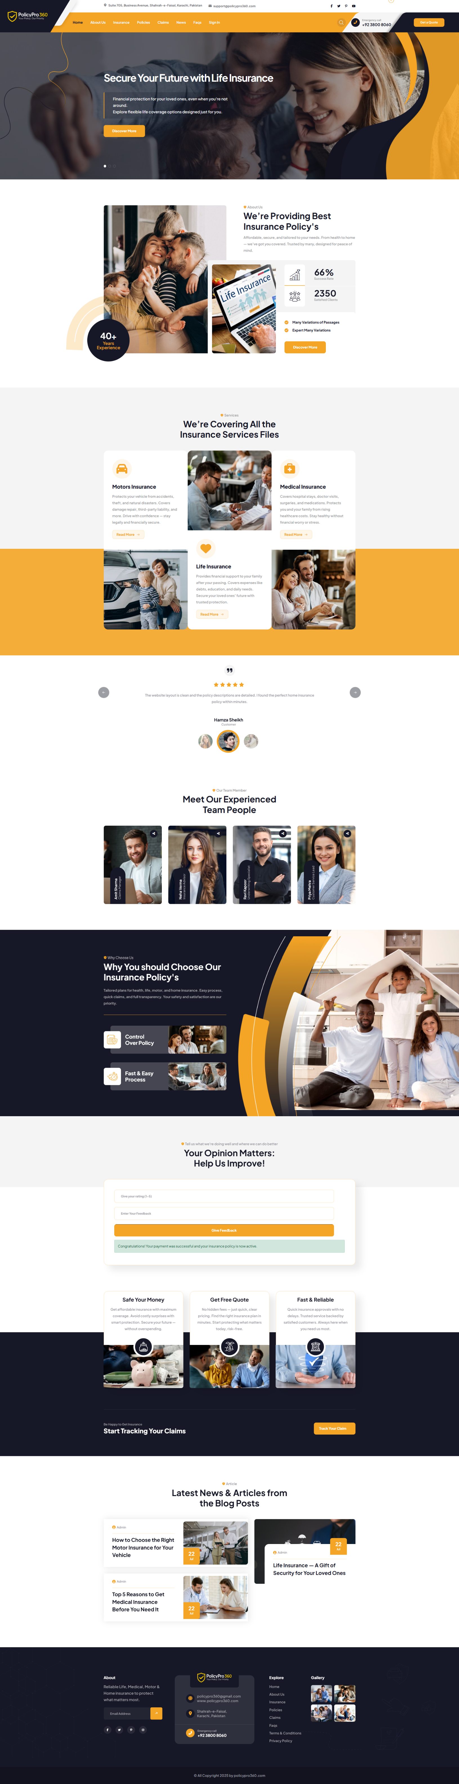

### **About**

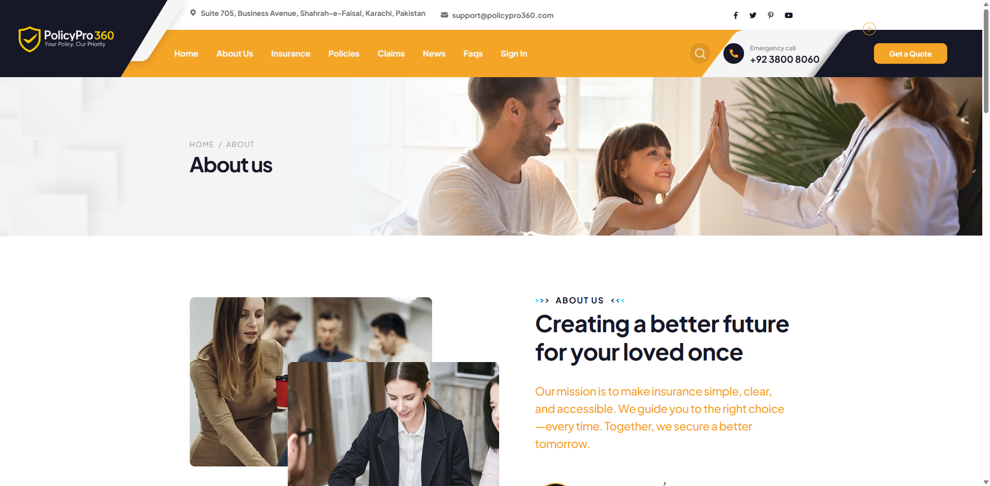

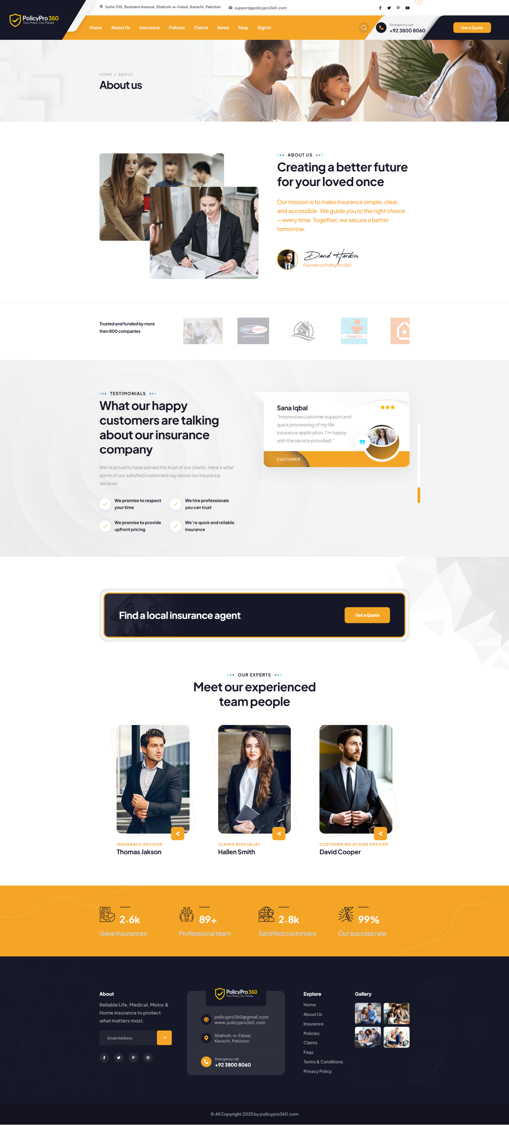

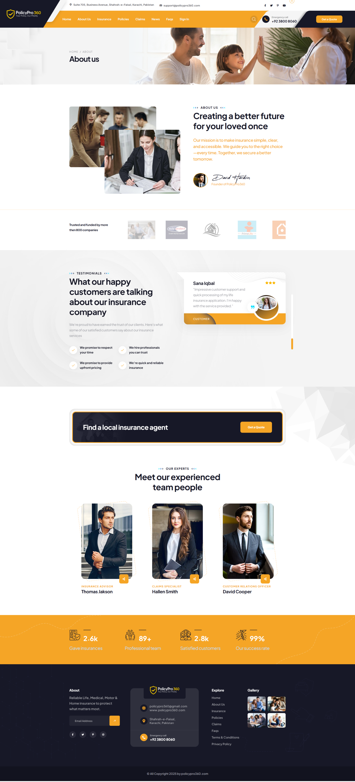

### **Insurance**

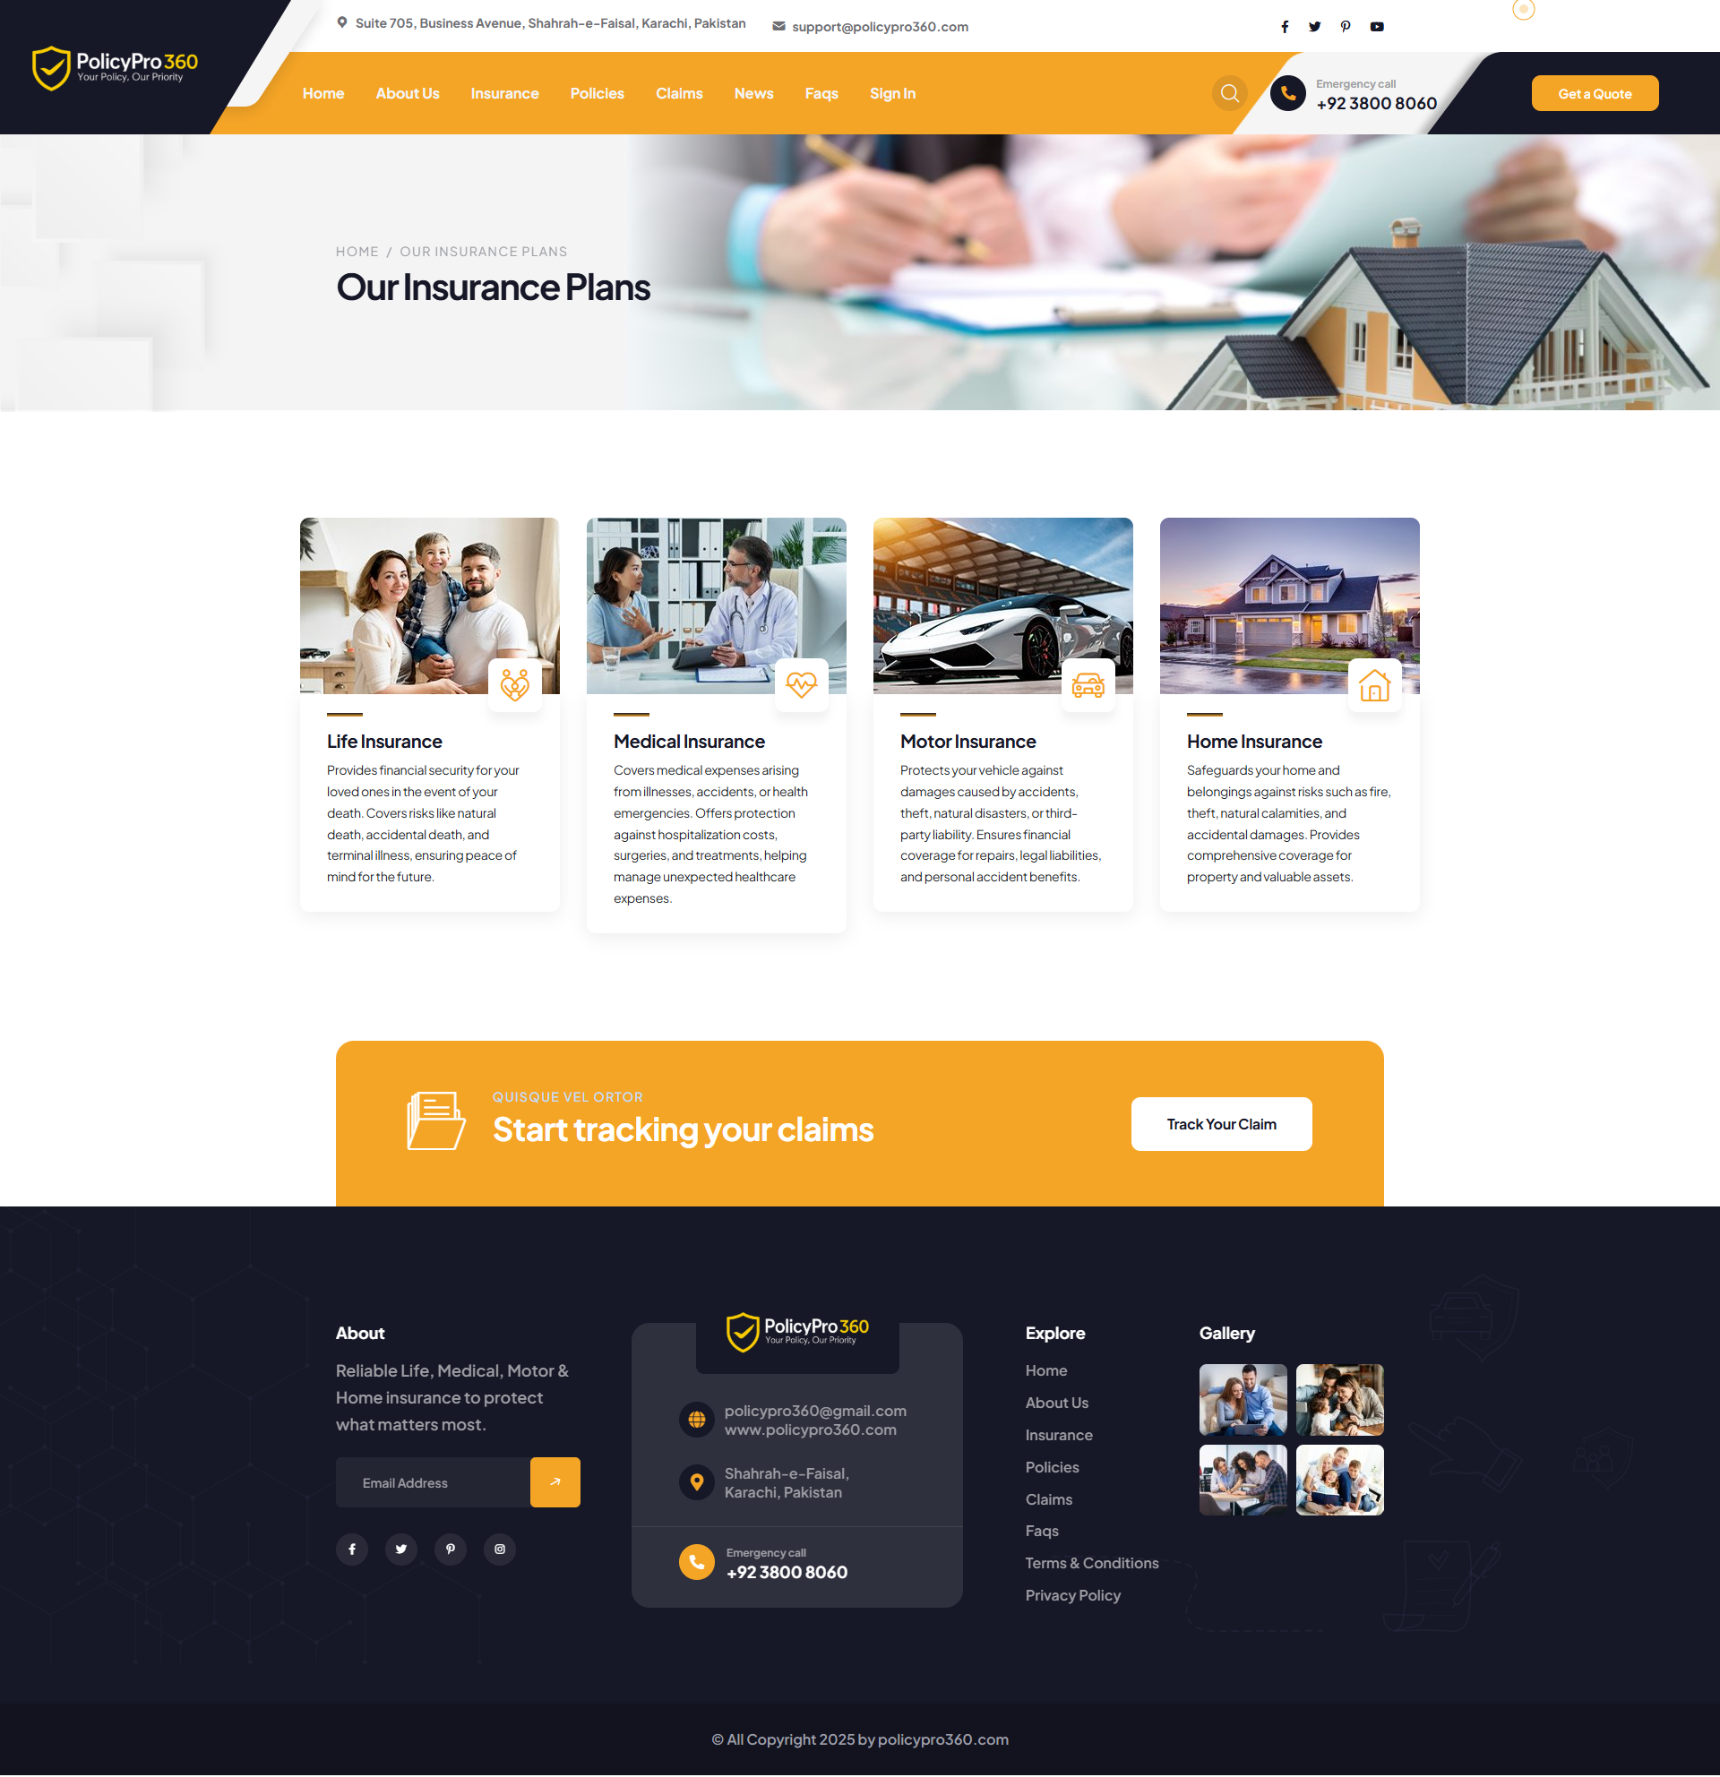

### **A screenshot of a phone AI-generated content may be incorrect.Home Insurance**

### **Motor Insurance**

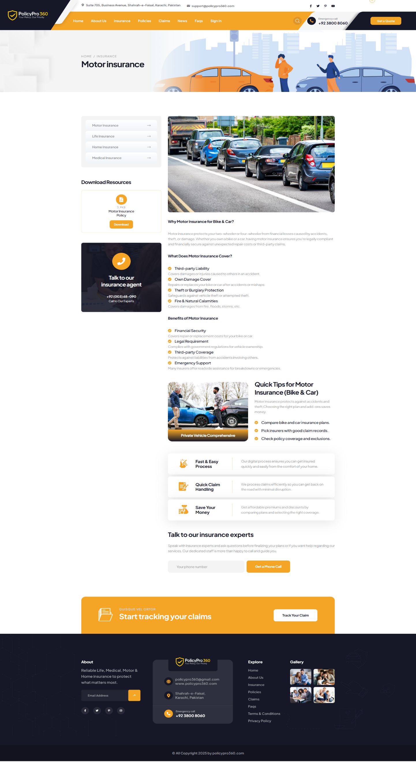

### **Life Insurance**

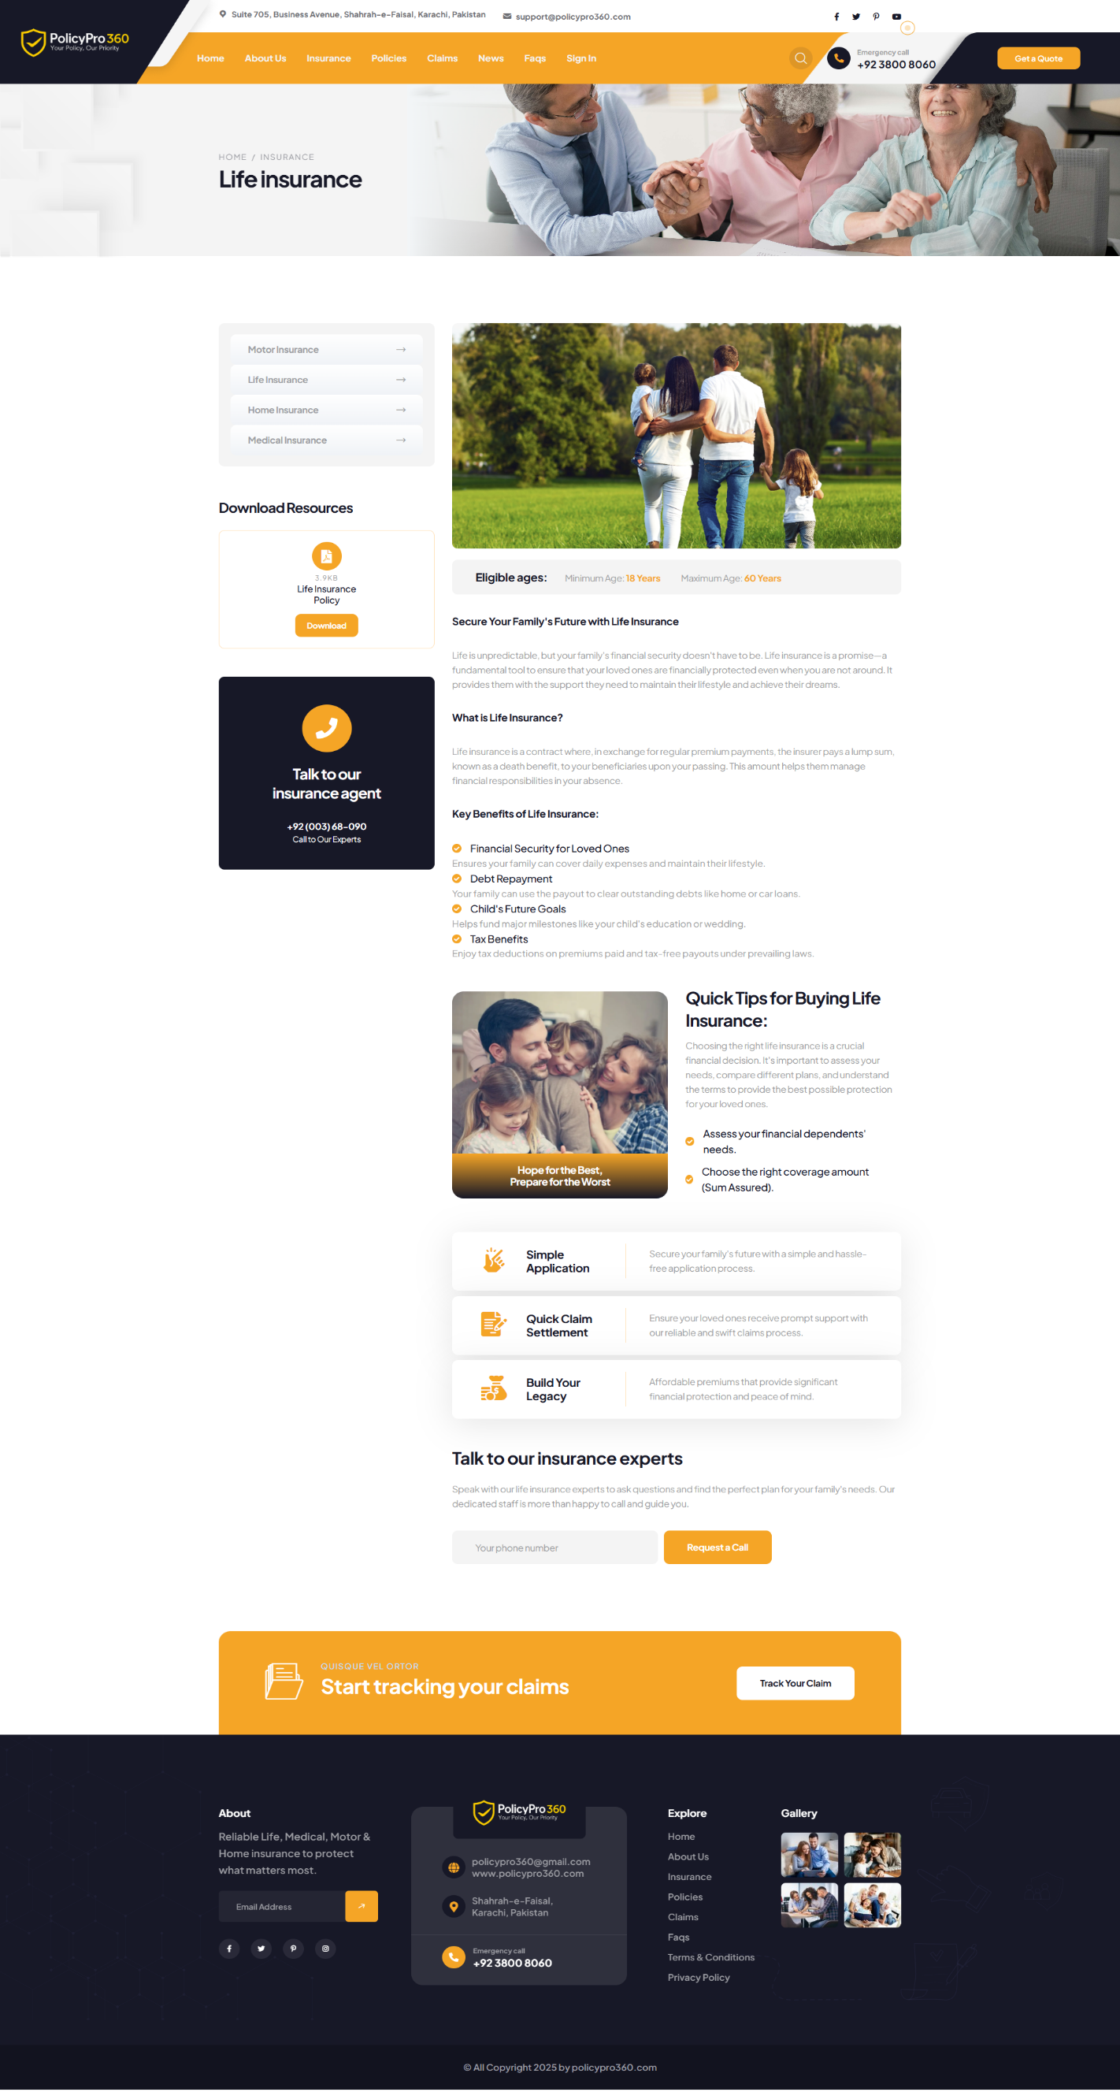

### **Medical Insurance**

### **Policies**

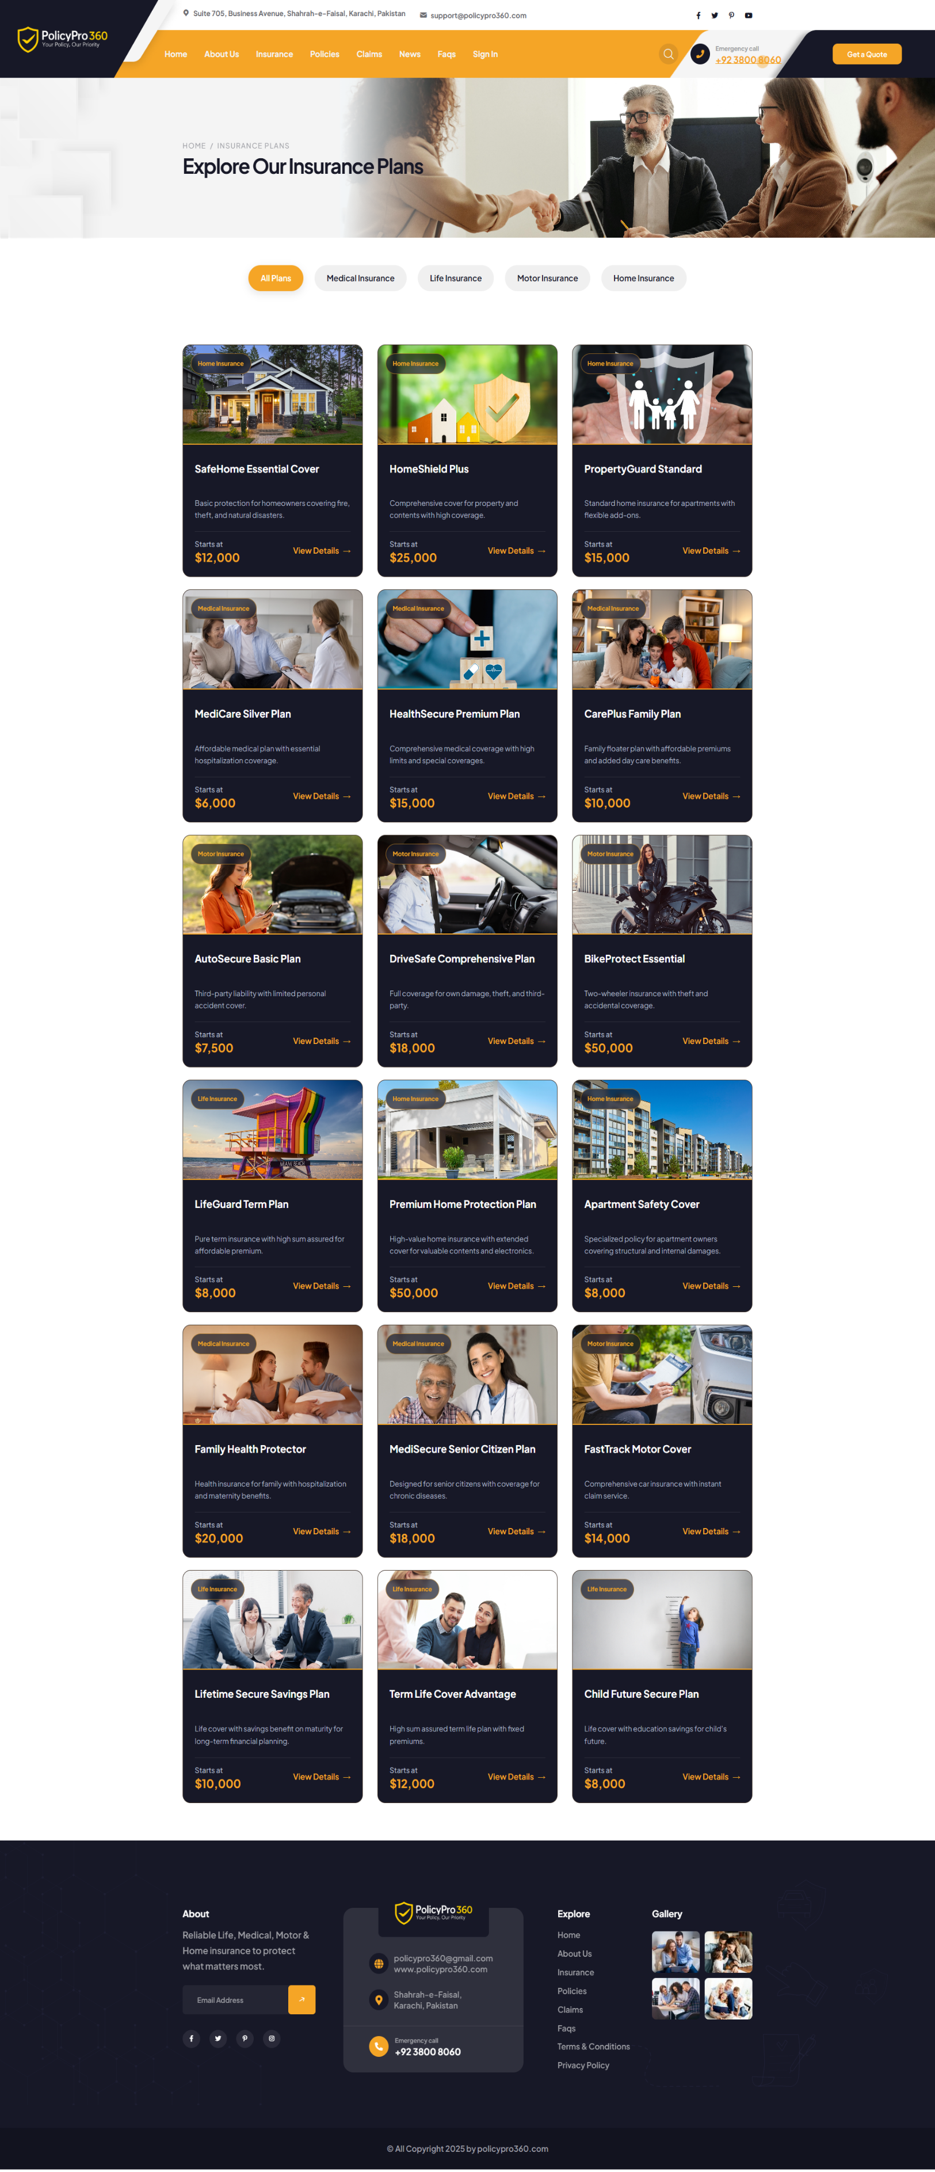

### **Medical Insurance Policies**

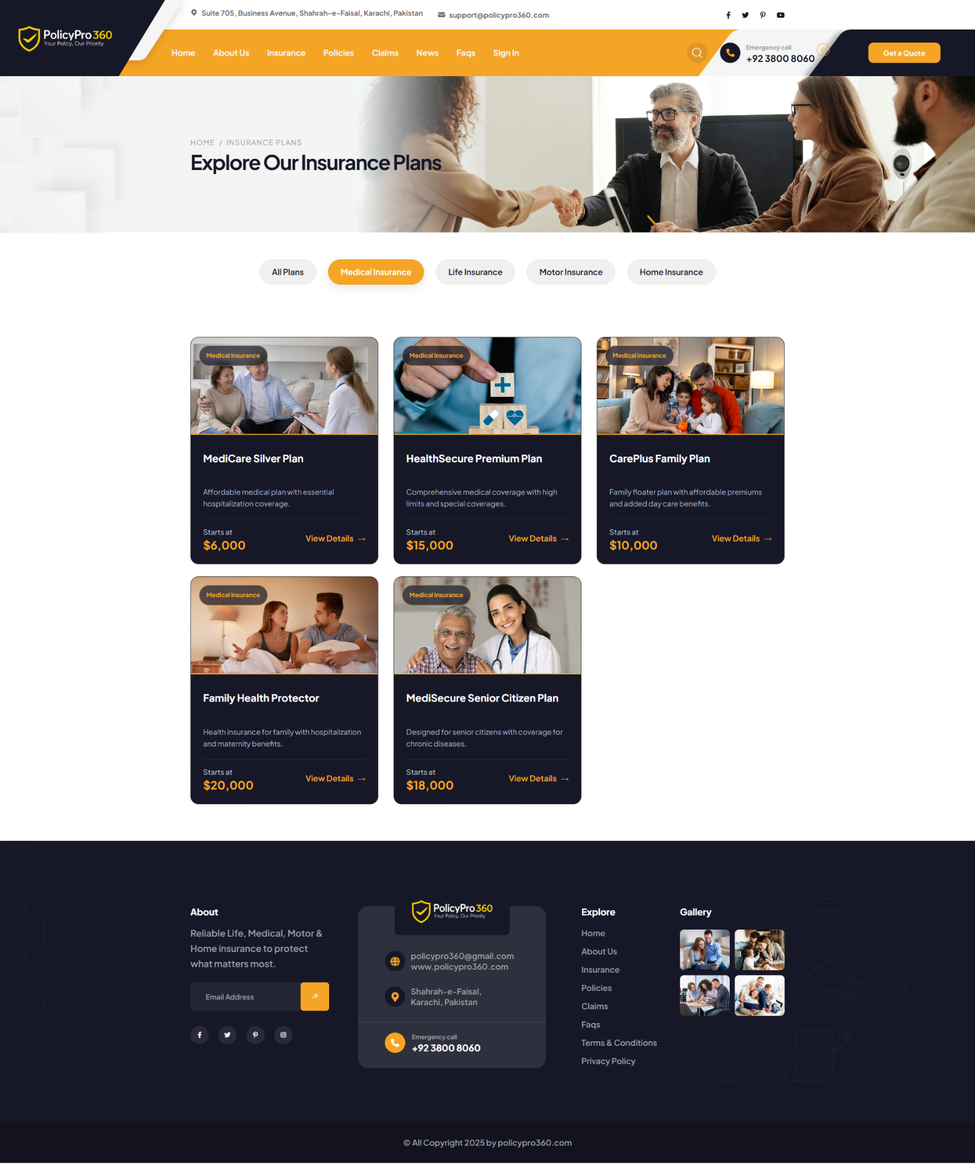

### **Medical Policy Premium Calculator & Premium Quote**

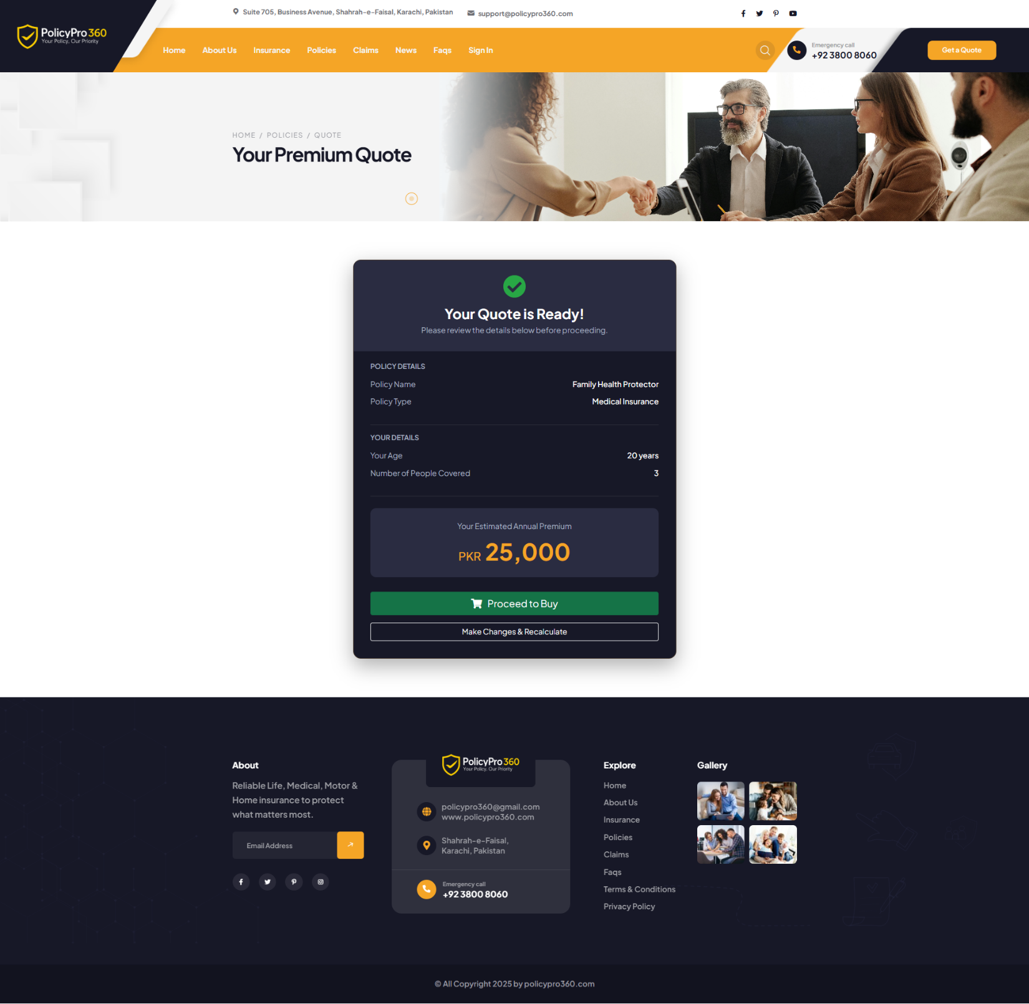

### **Policy Proceed to Checkout**

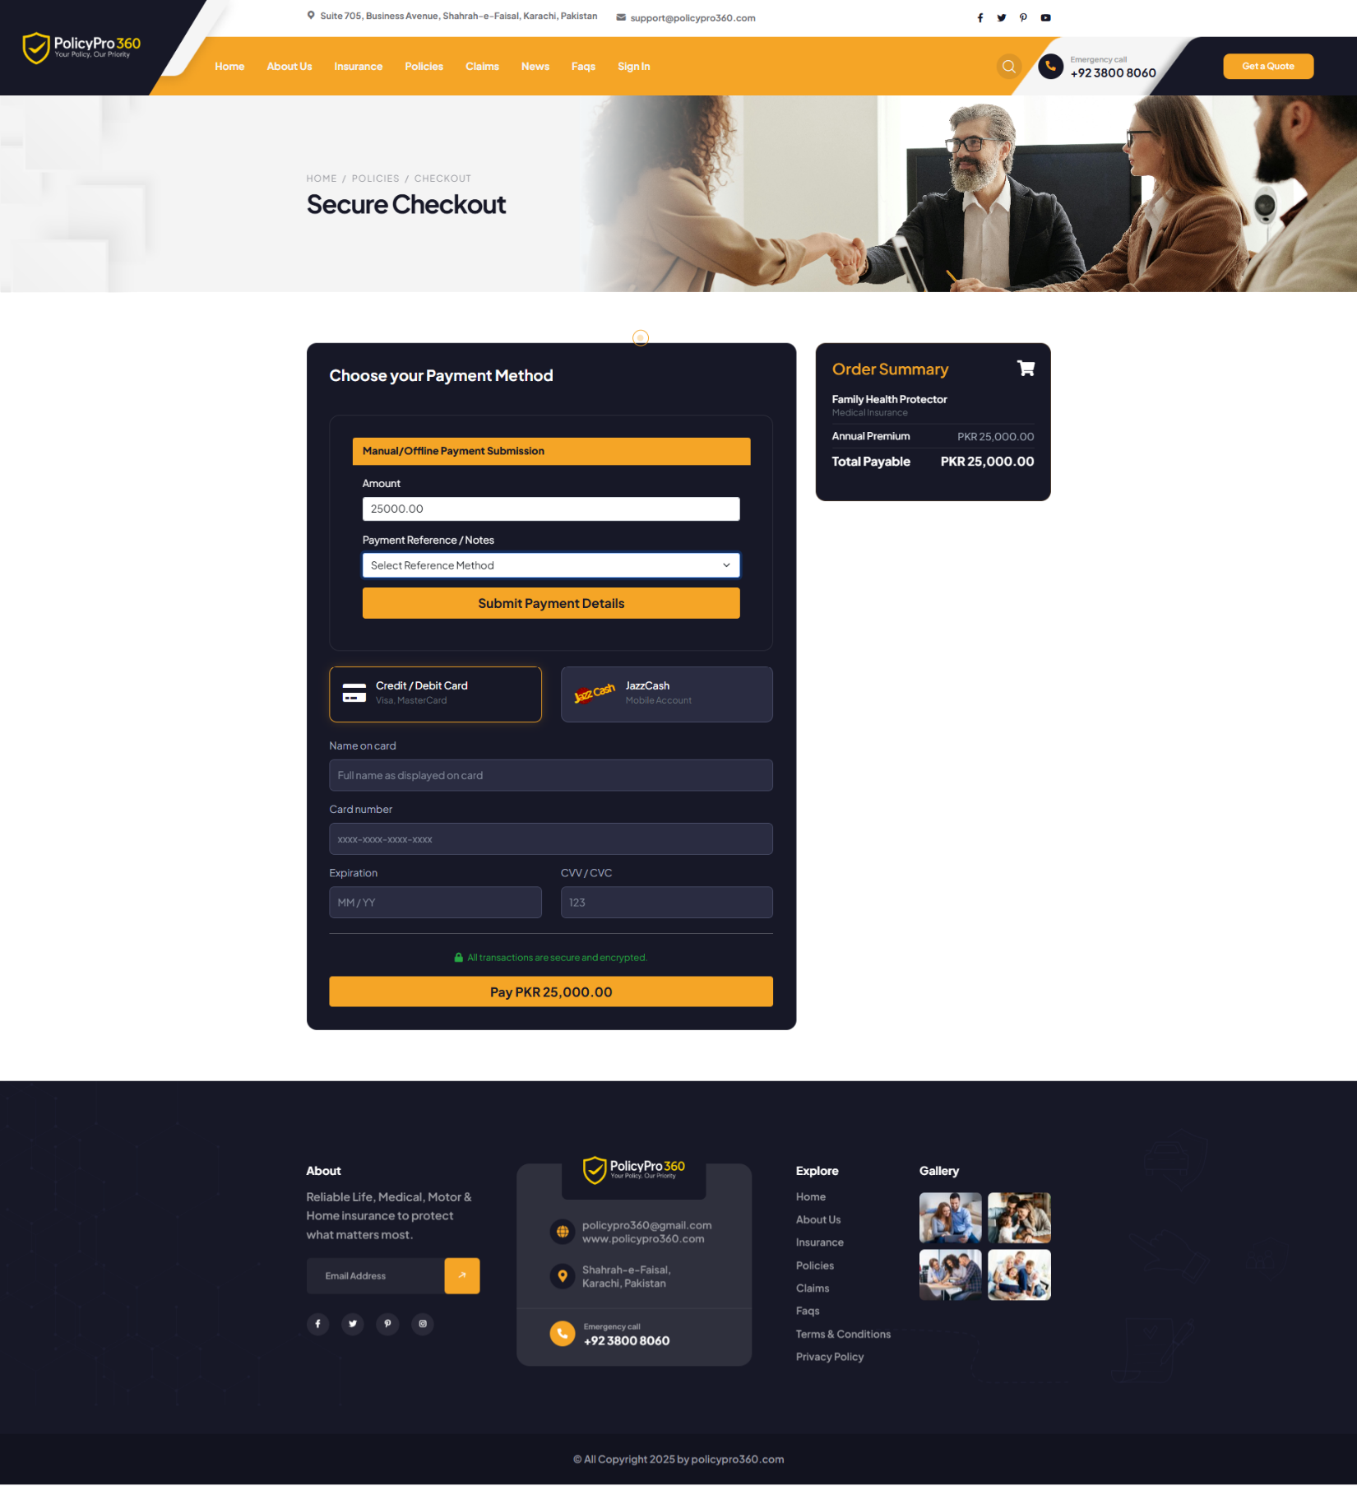

### **Life Insurance Policies**

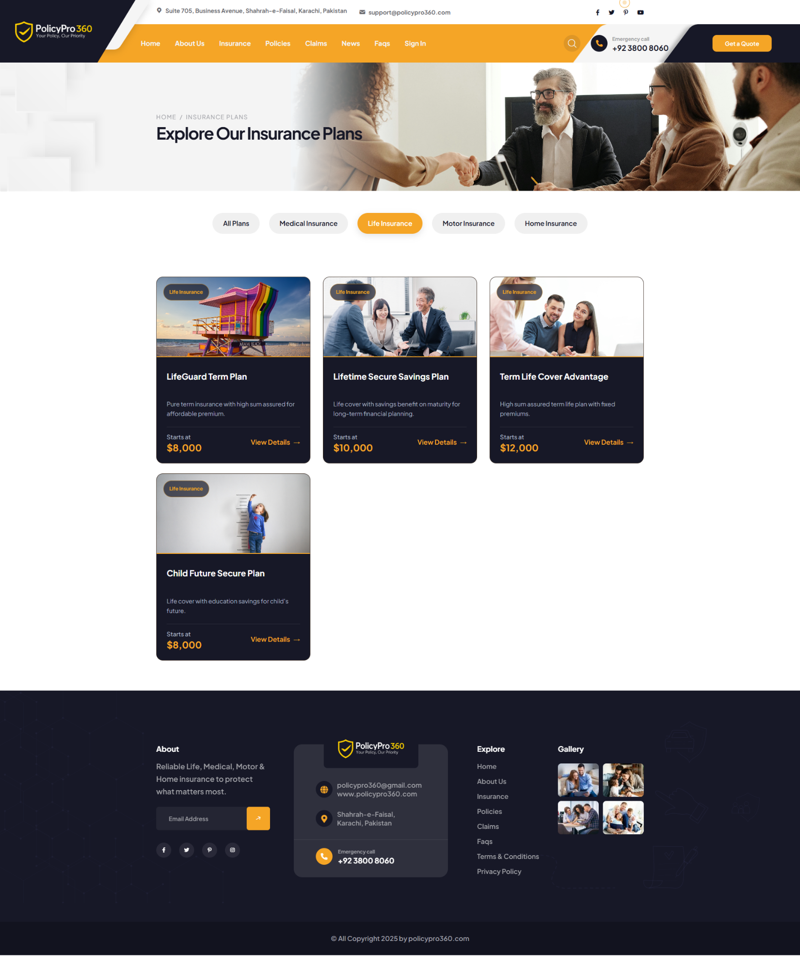

### **Life Policy Premium Calculator & Premium Quote**

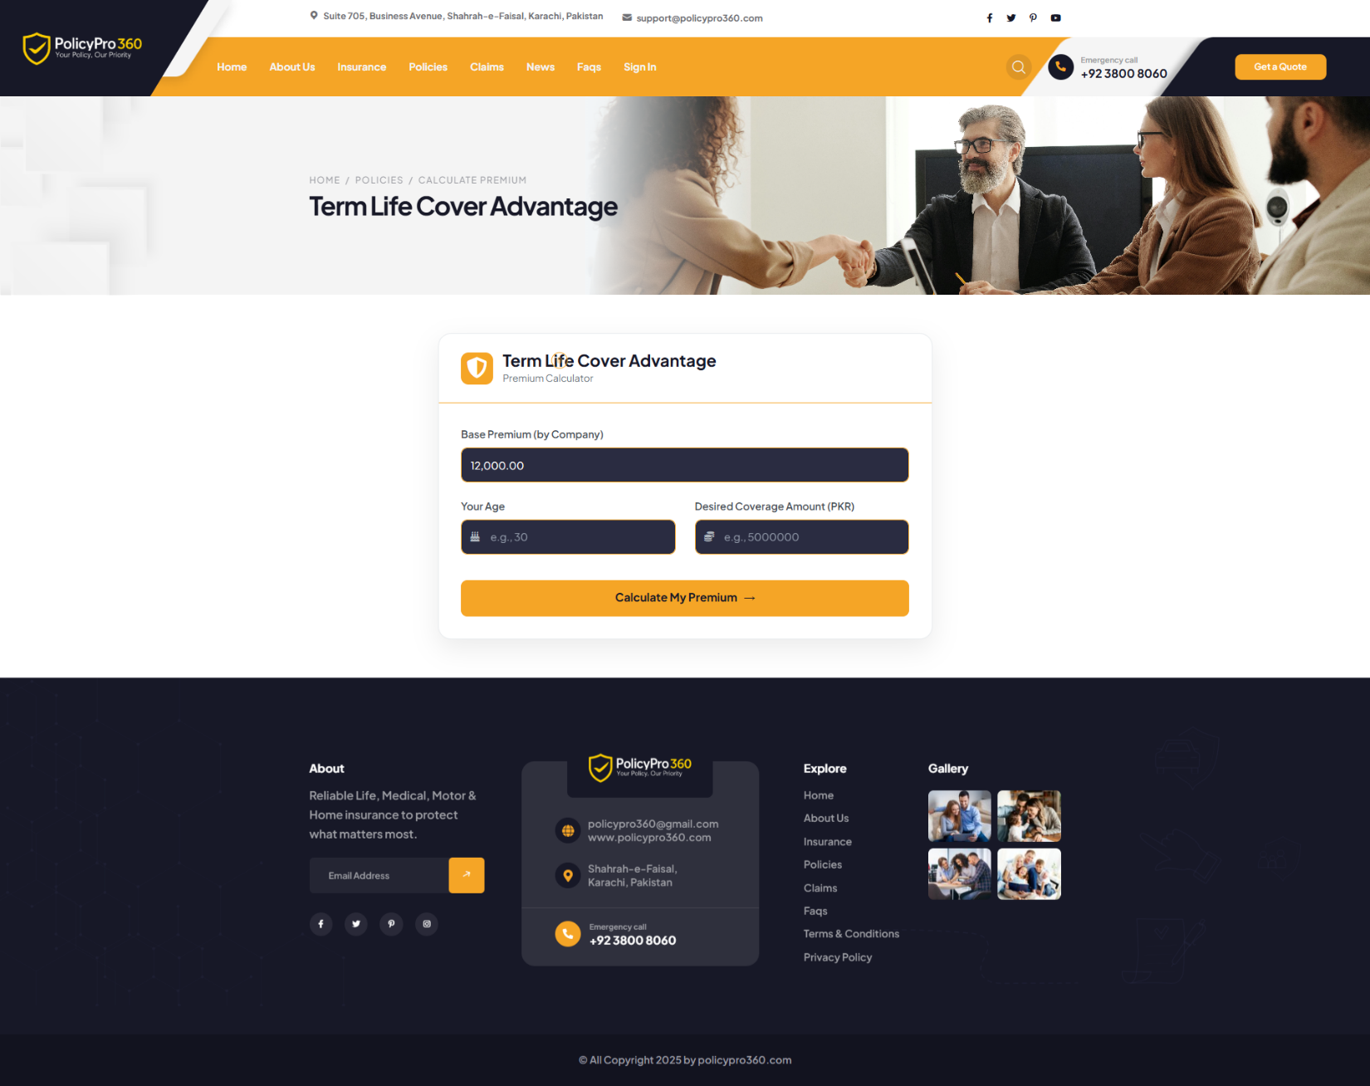

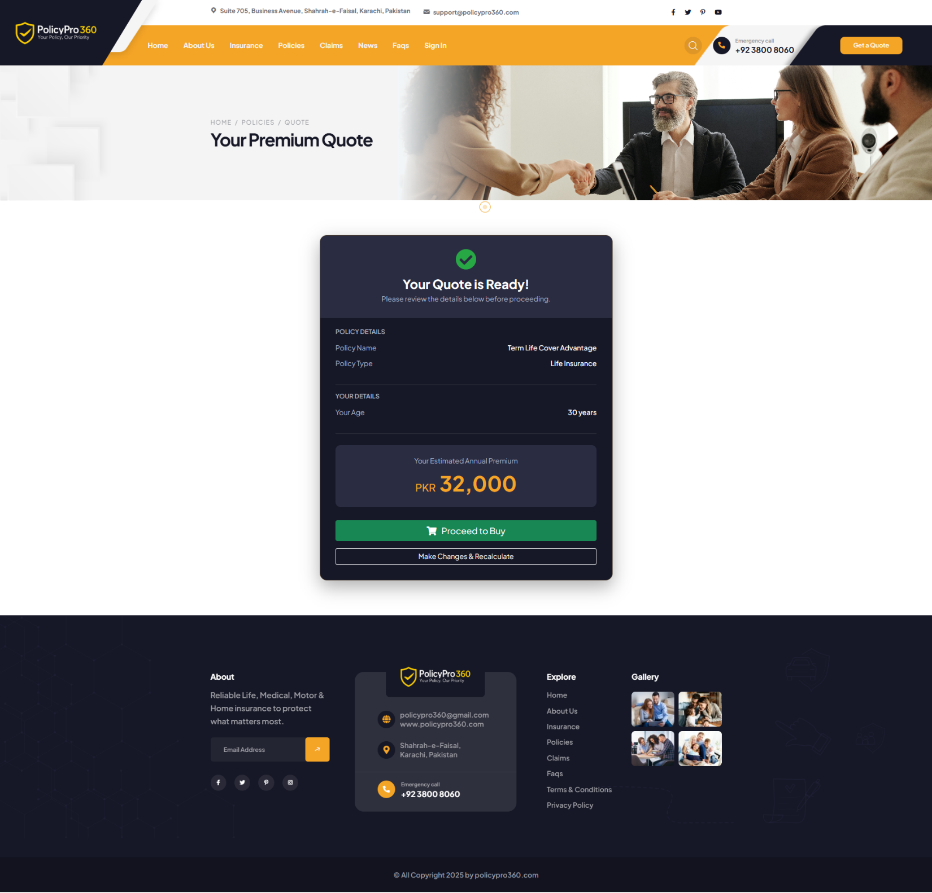

### **Motor Insurance Policies**

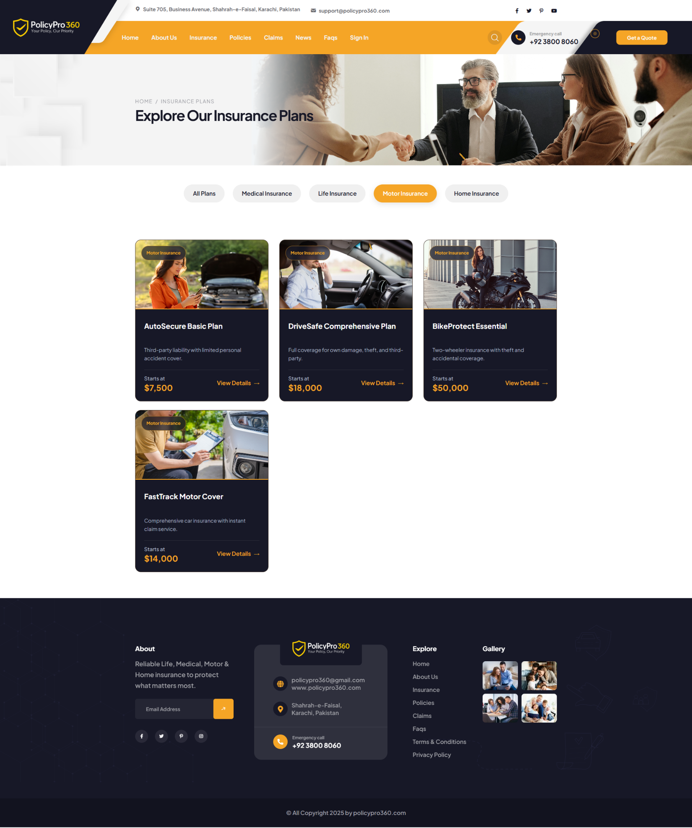

### **Motor Policy Premium Calculator & Premium Quote**

### **Home Insurance Policies**

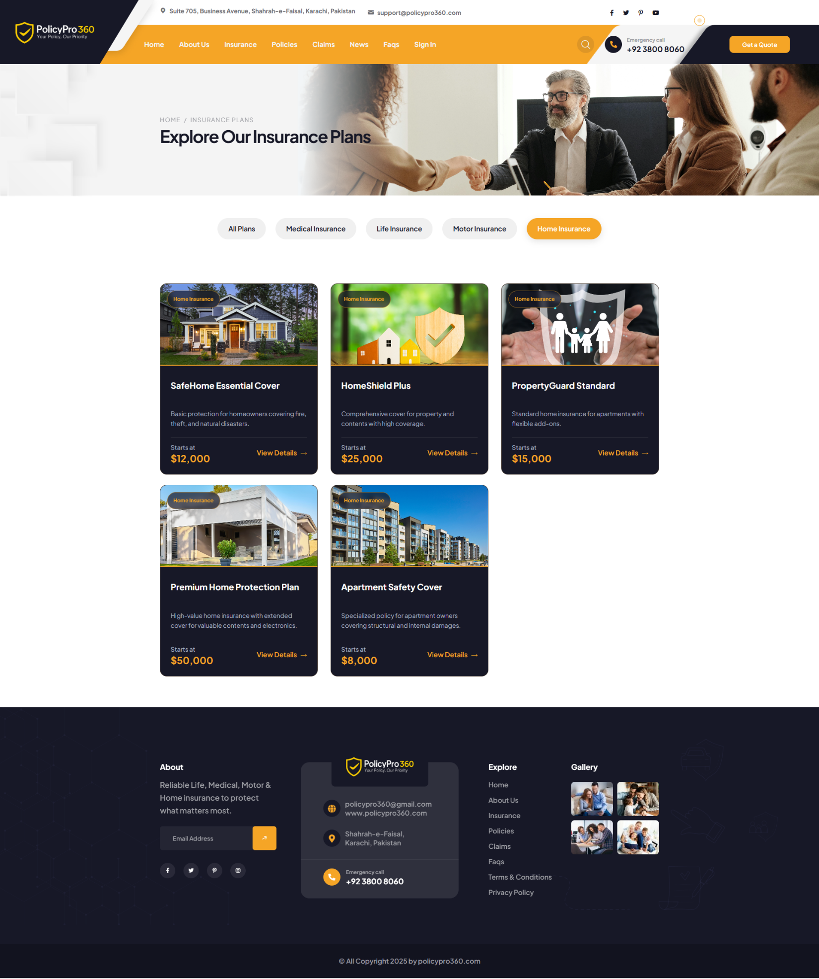

### **Home Policy Premium Calculator & Premium Quote**

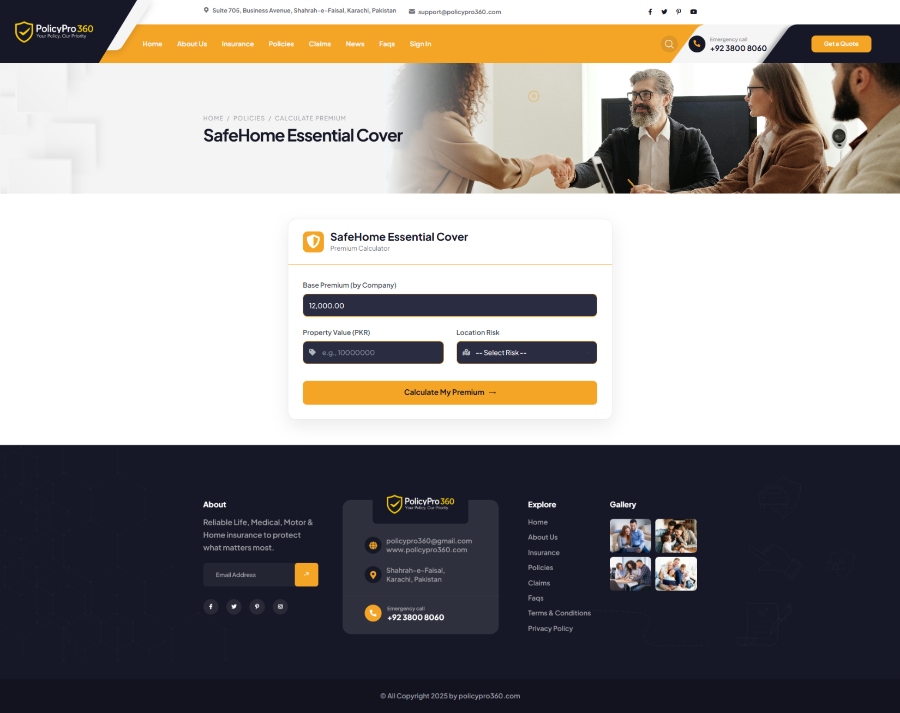

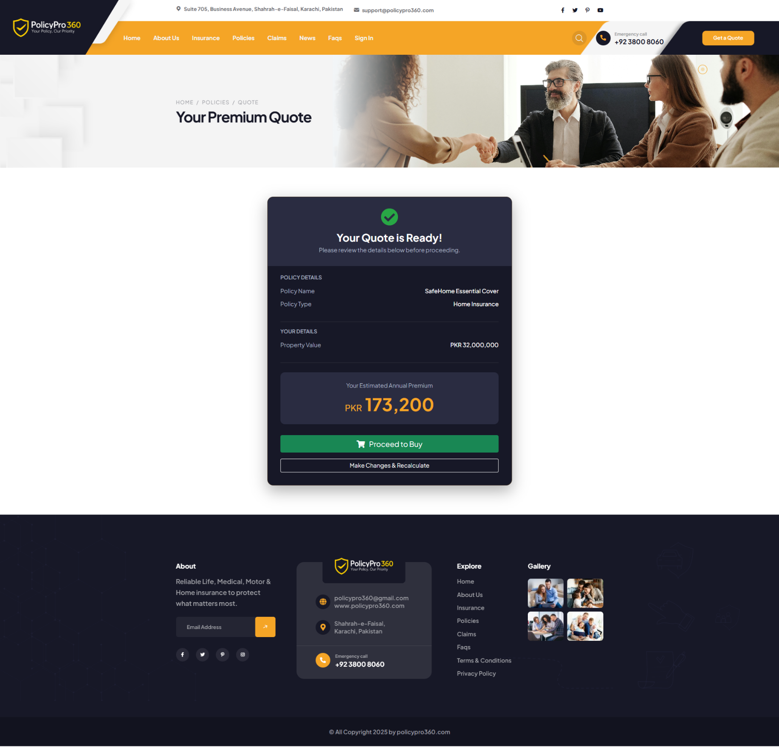

### **How to File a Claim**

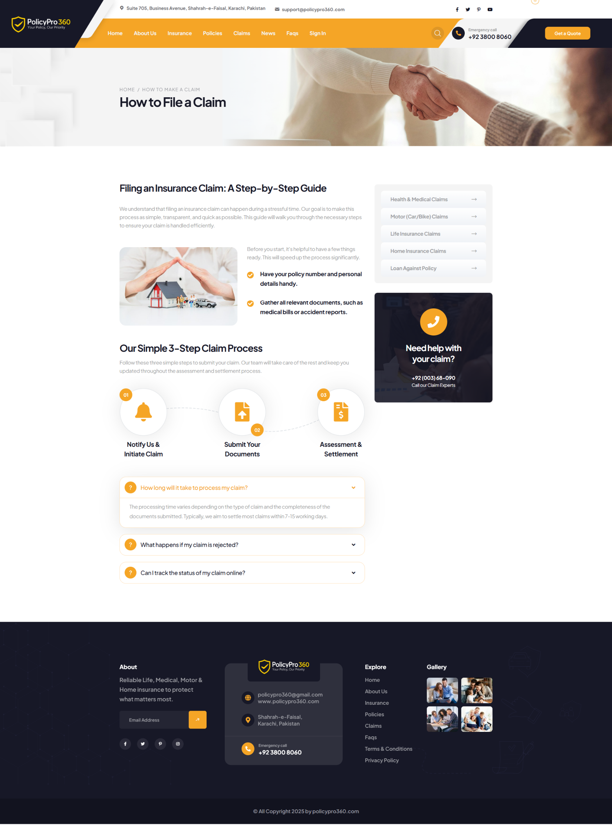

### **Health & Medical Claims**

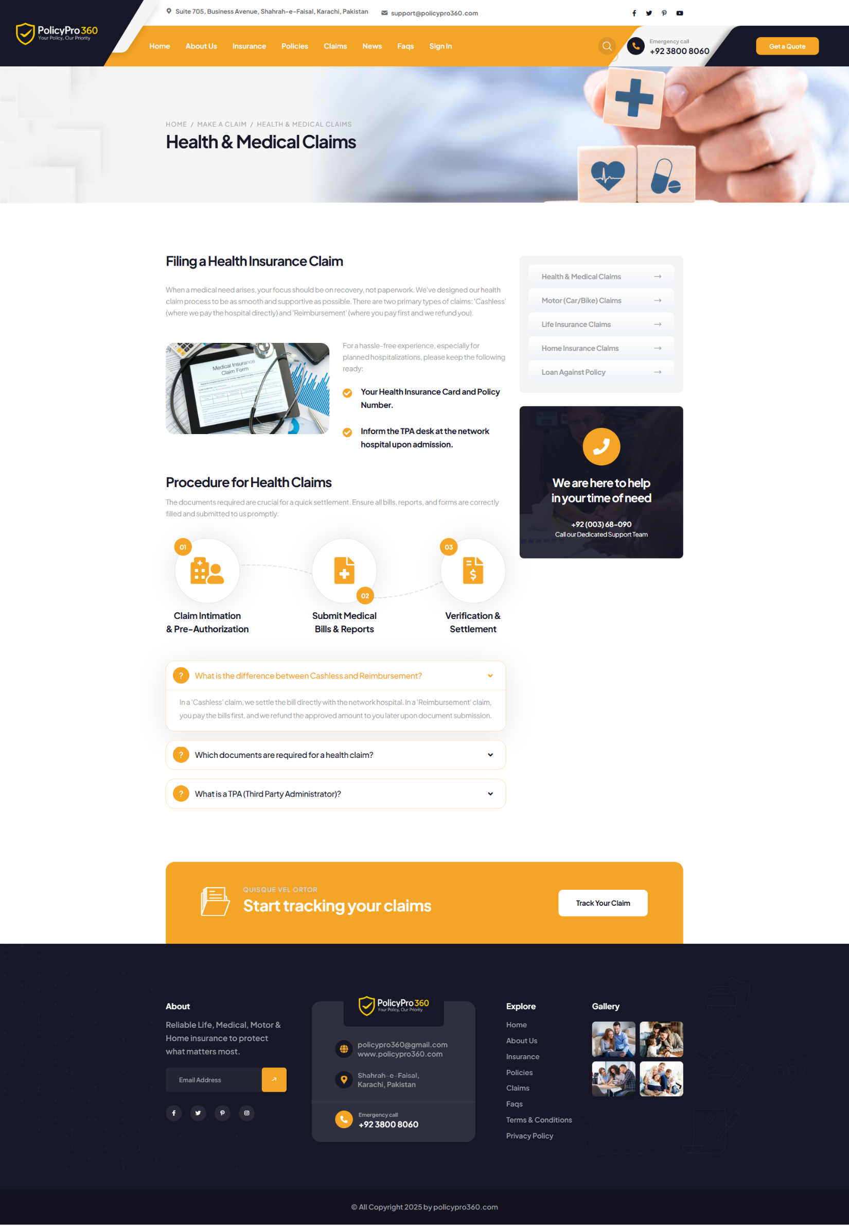

### **Home Insurance Claims**

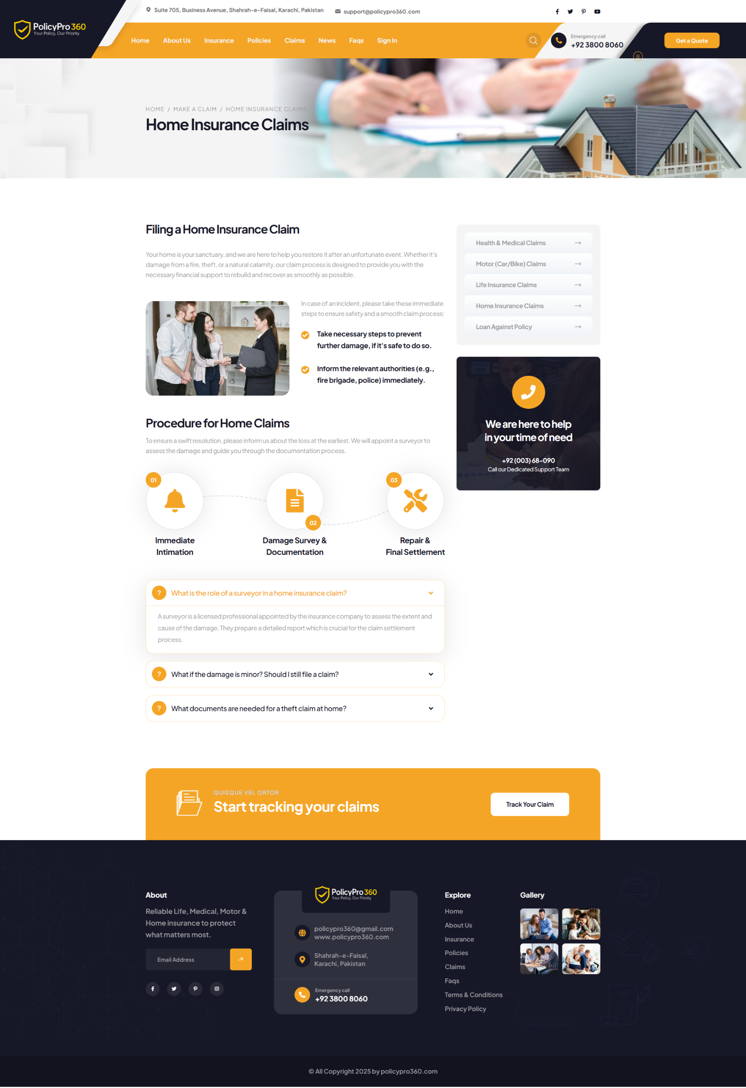

### **Motor (Car/Bike) Claims**

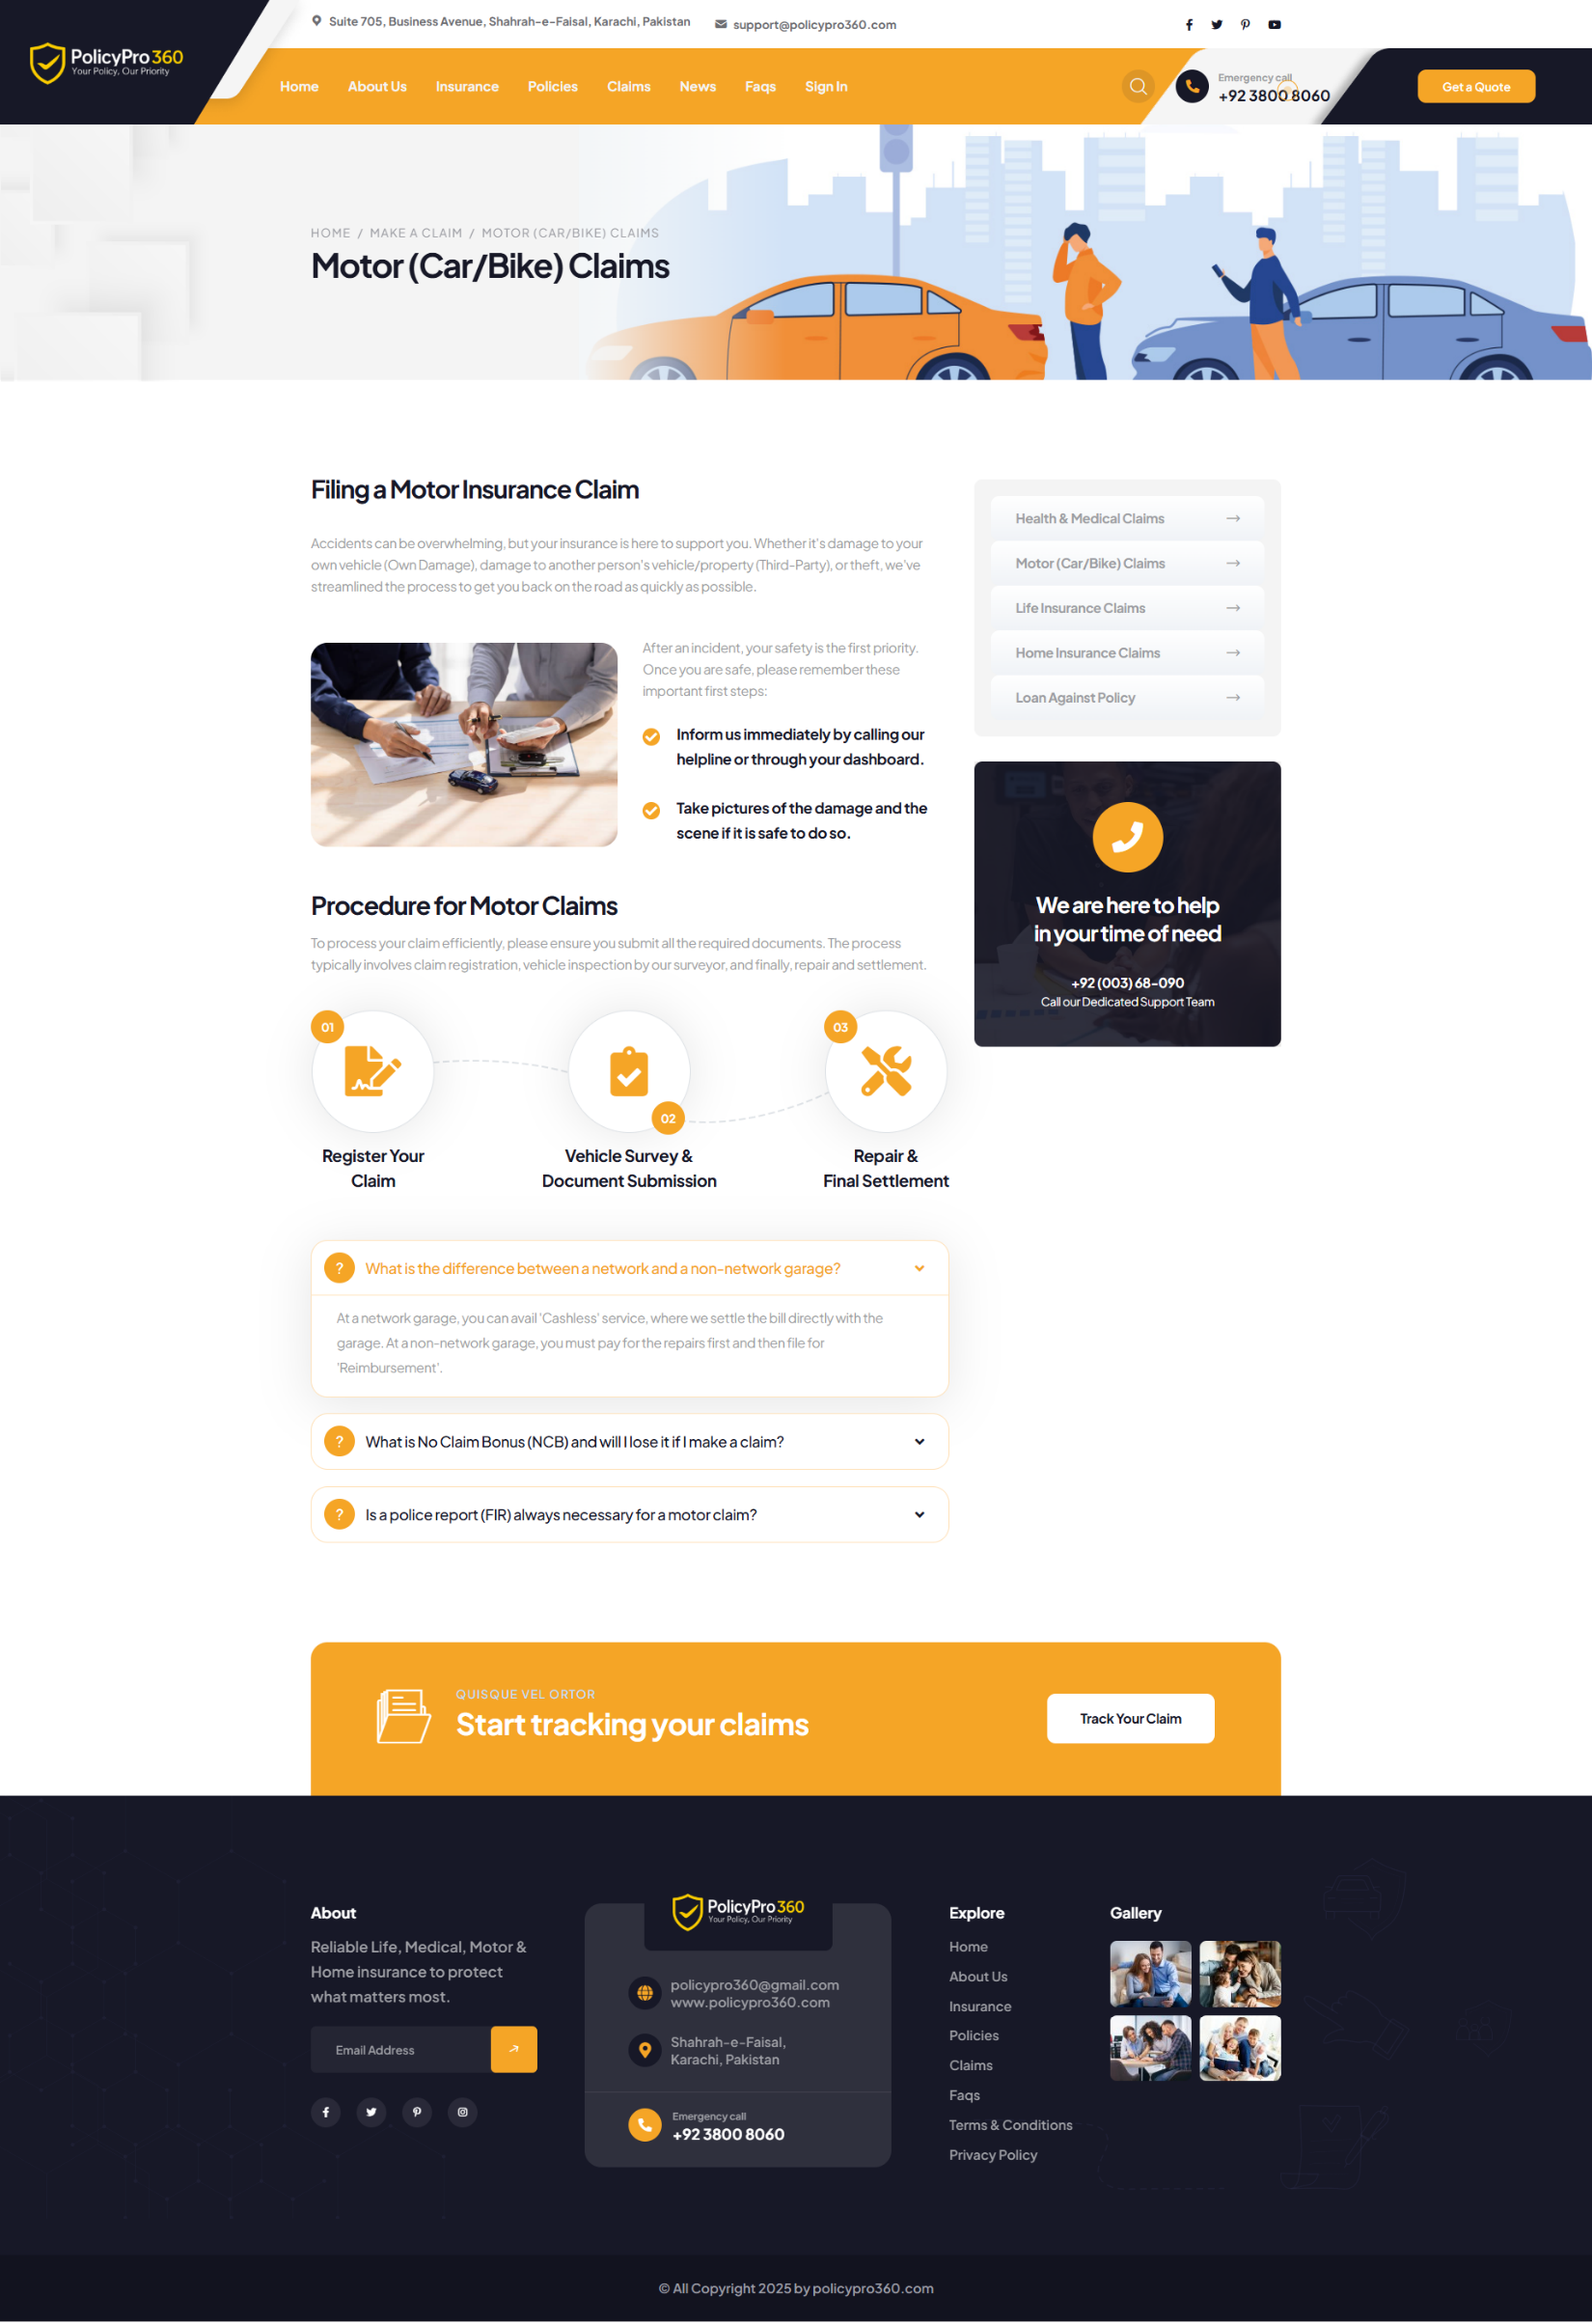

### **Life Insurance Claims**

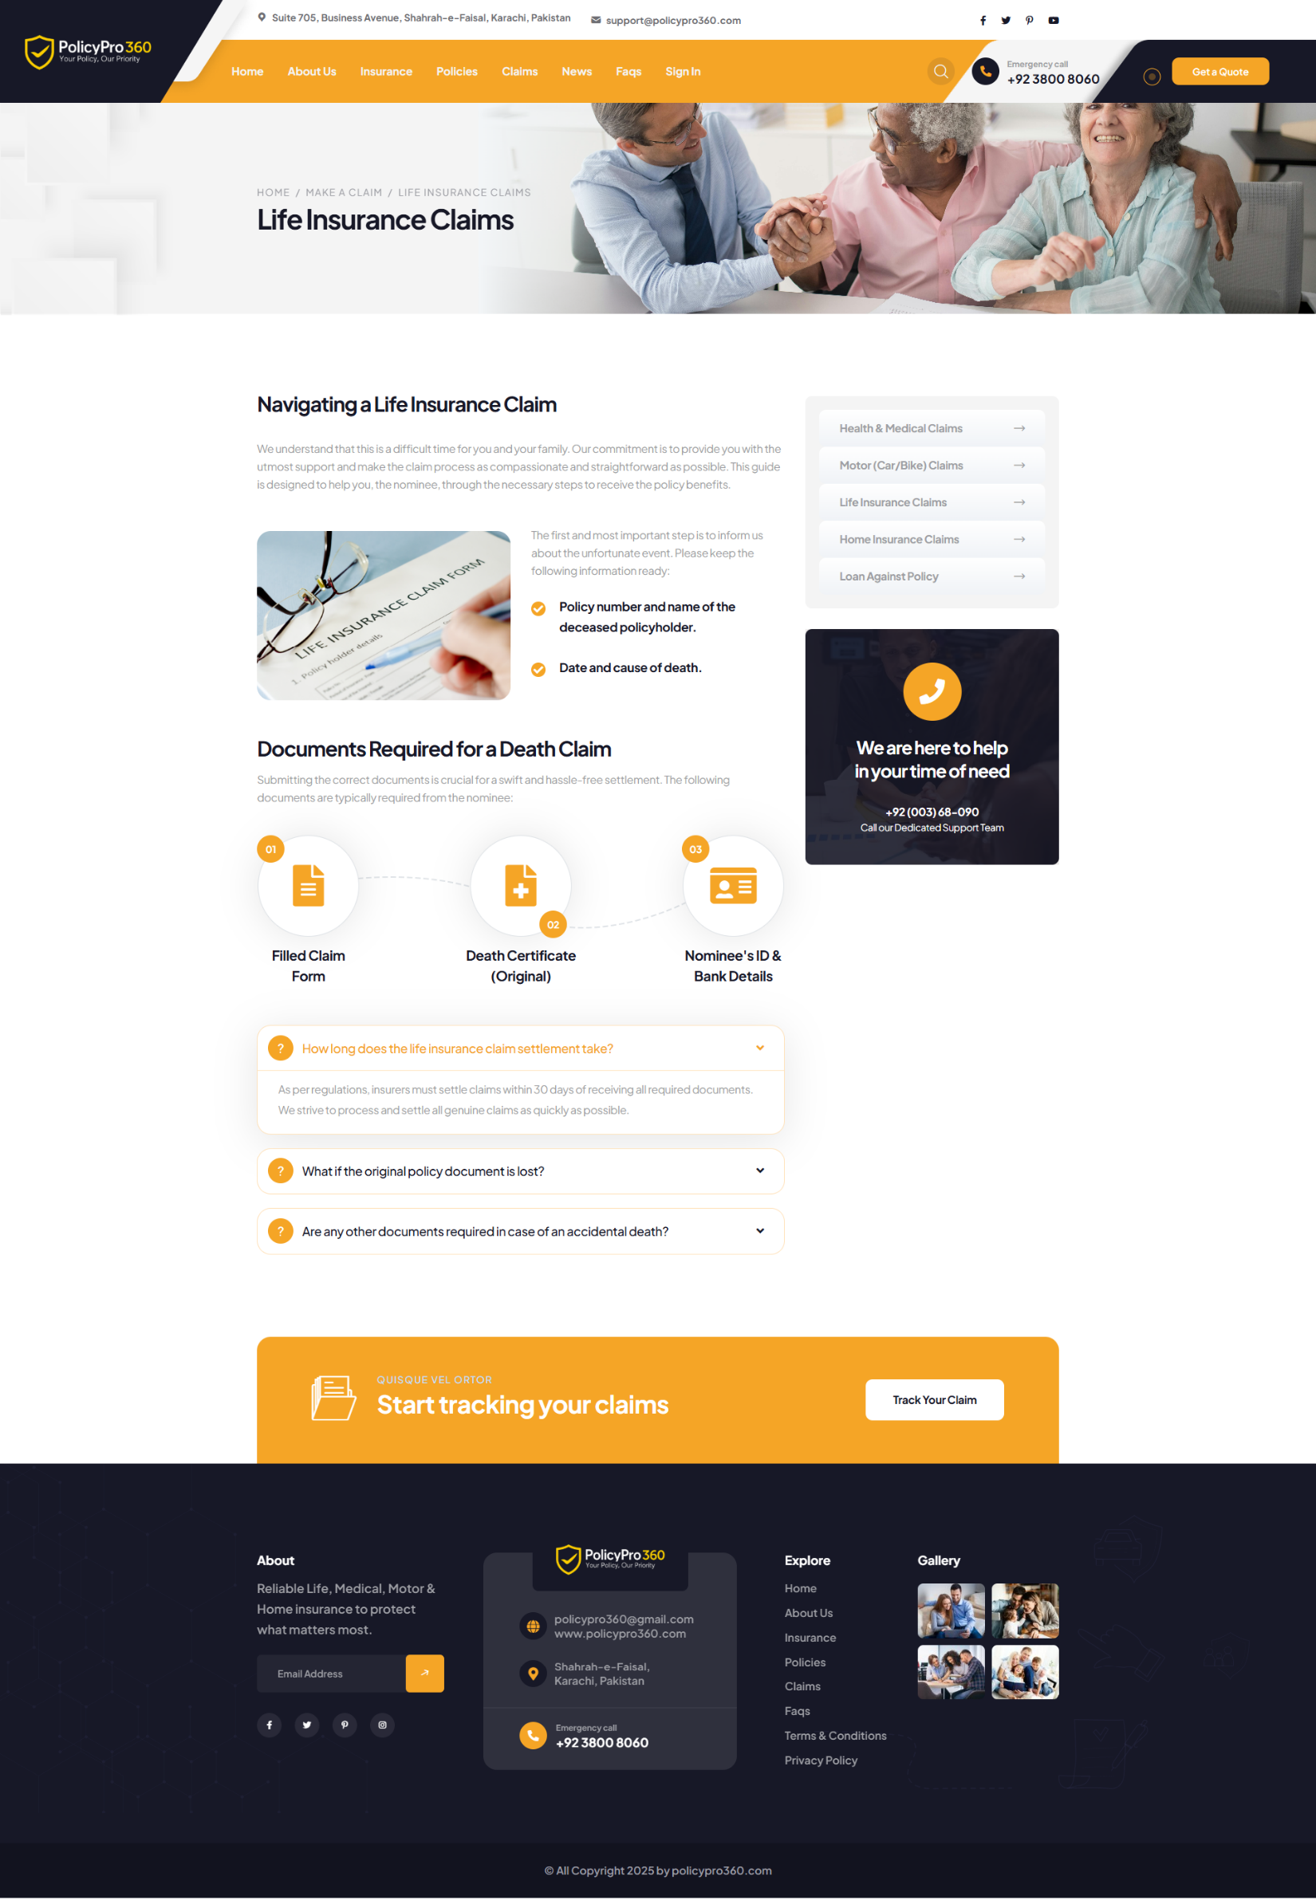

### **Loan Against Policy**

### **News**





### **News Detail 1**



### **News Detail 2**



### **Frequently Asked Questions**

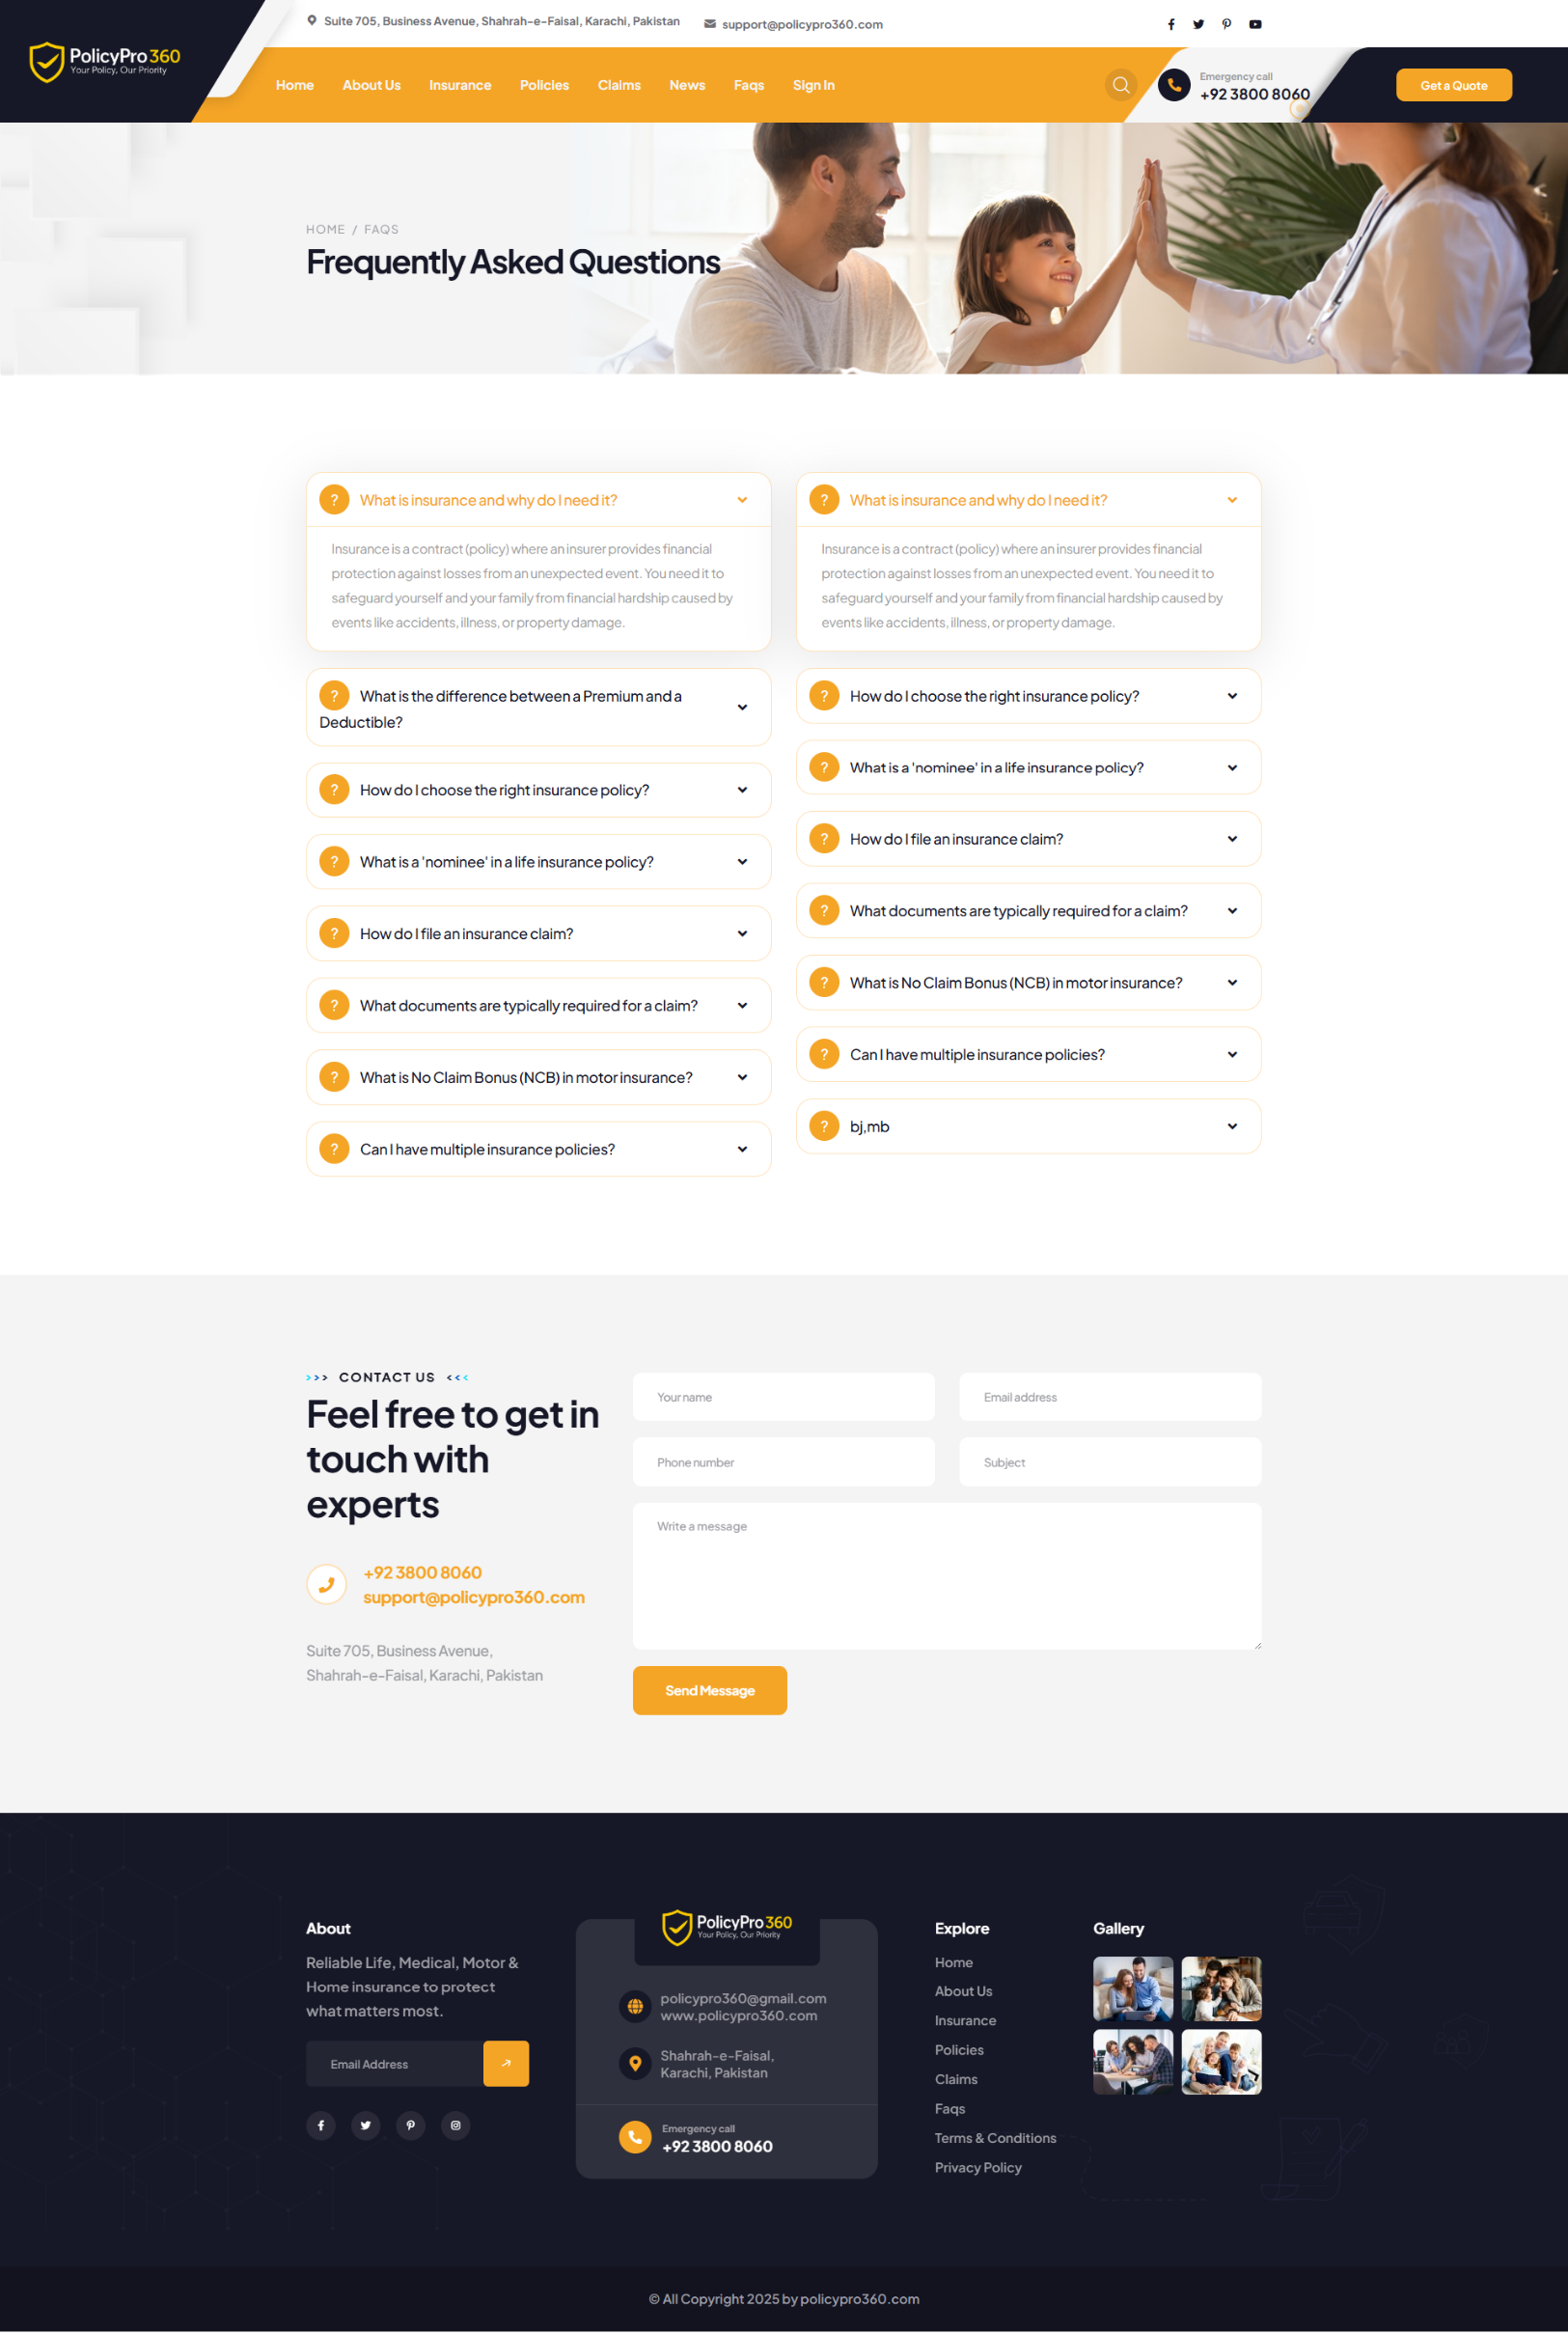

### **Privacy Policy**

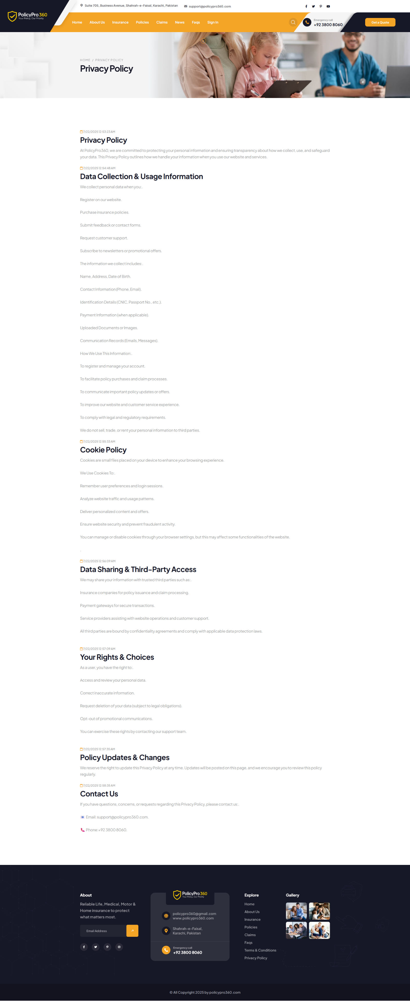



### **Terms & Conditions**

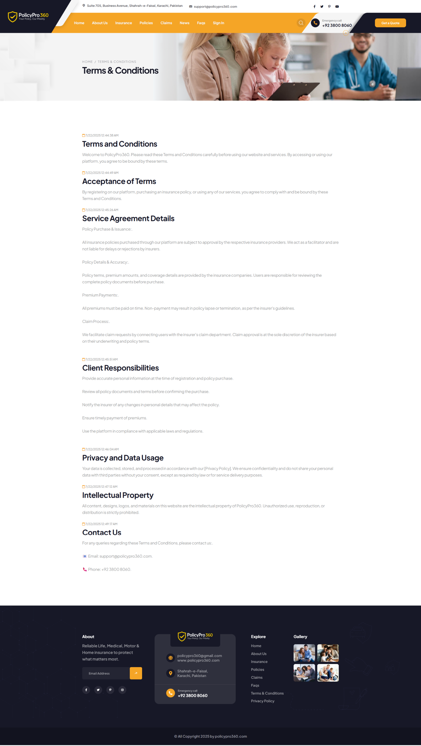

### **Sign In**

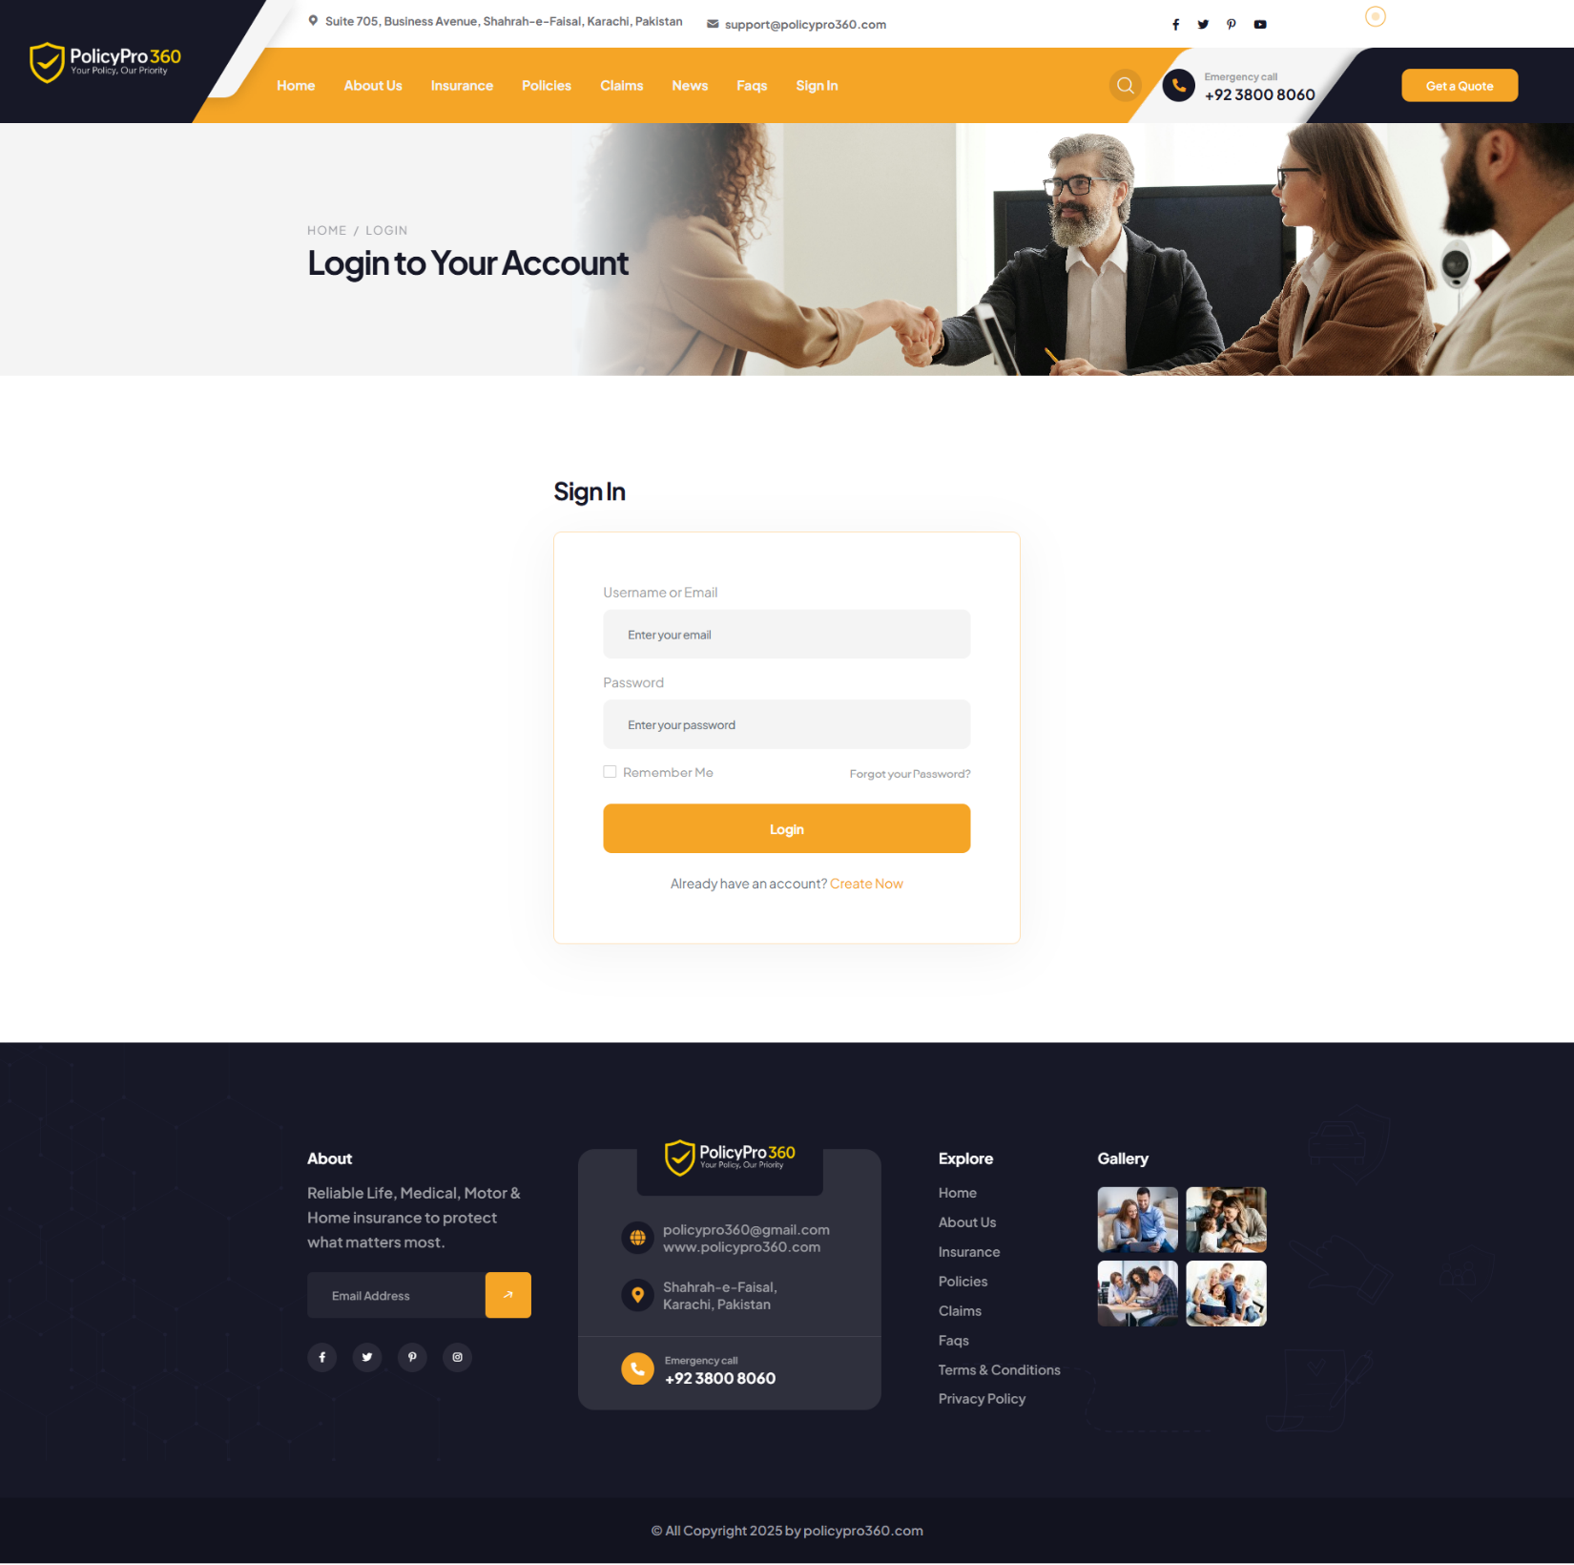

### **Sign Up**

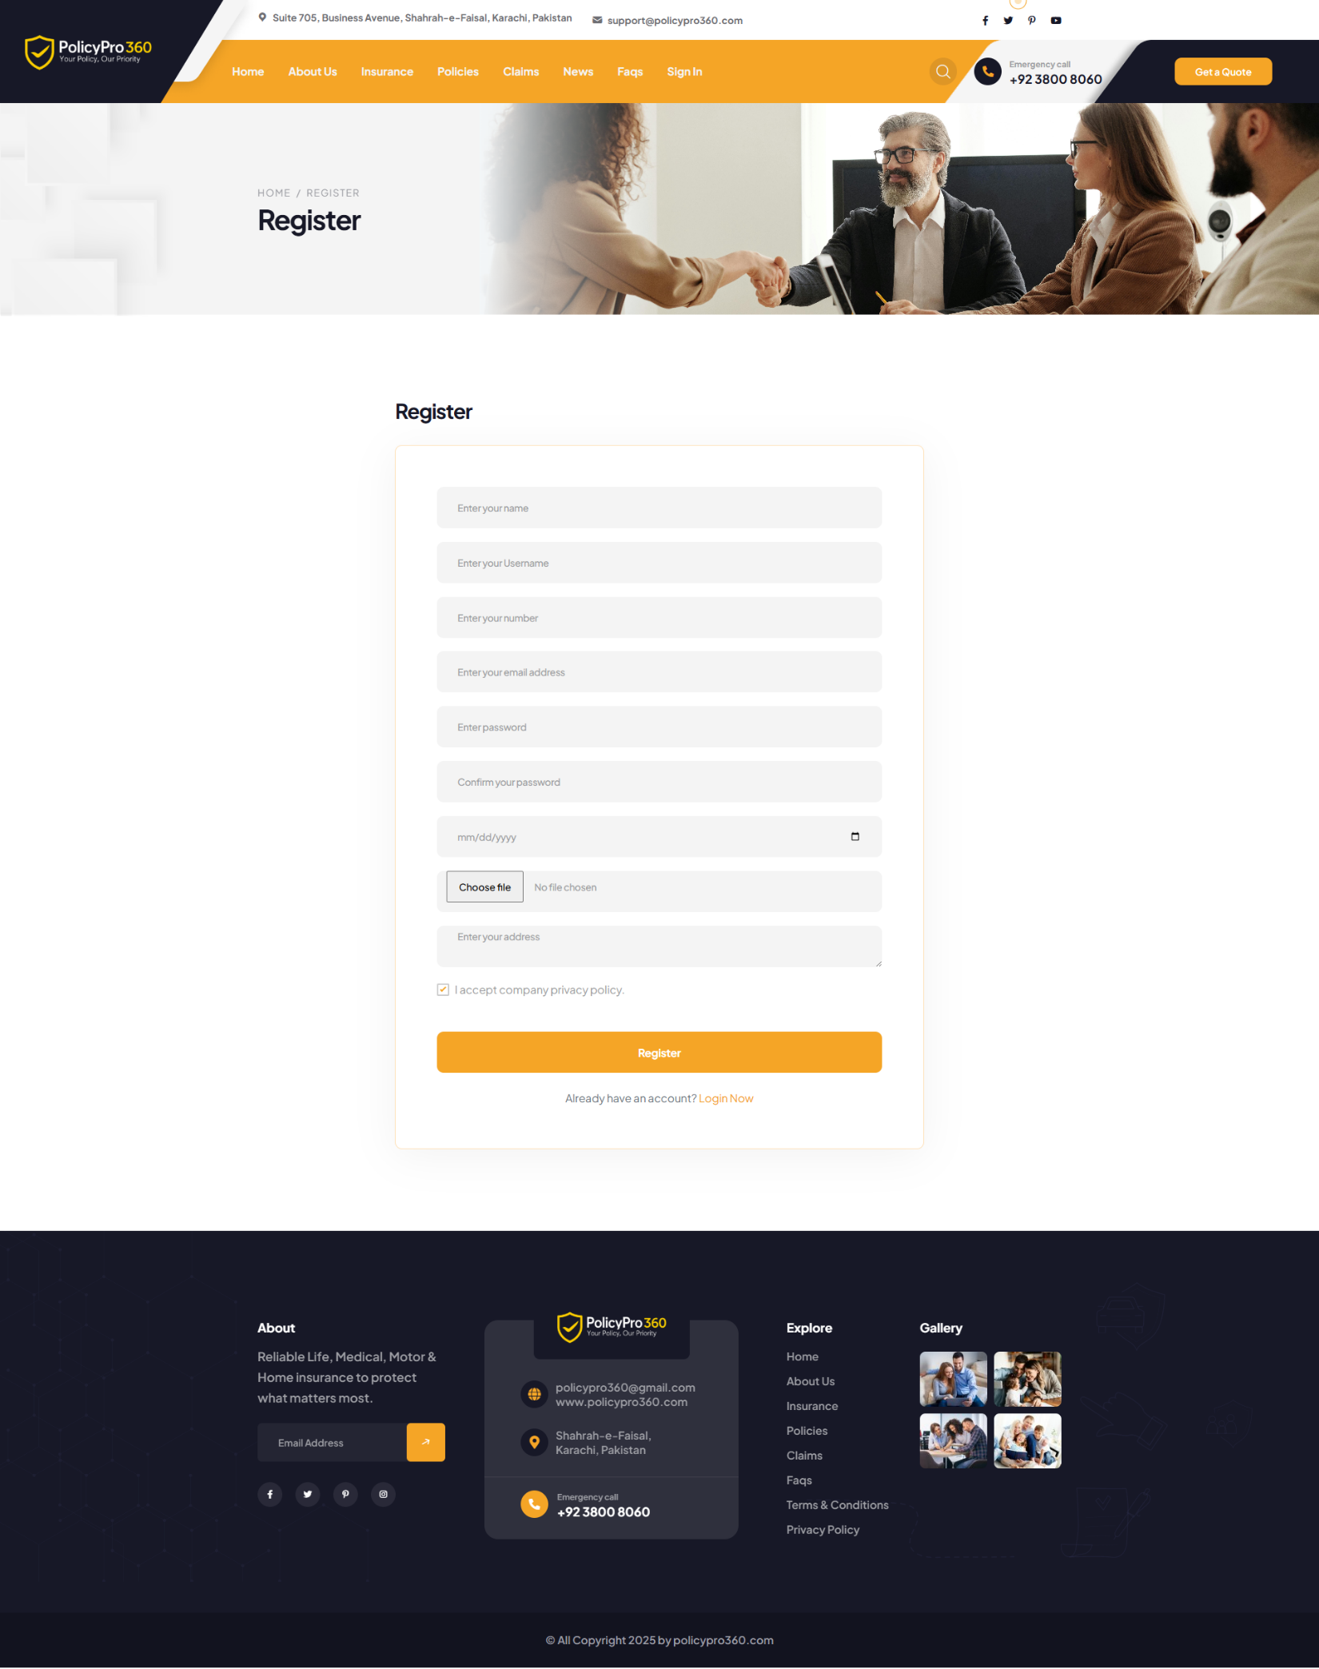

### **Contact Us**

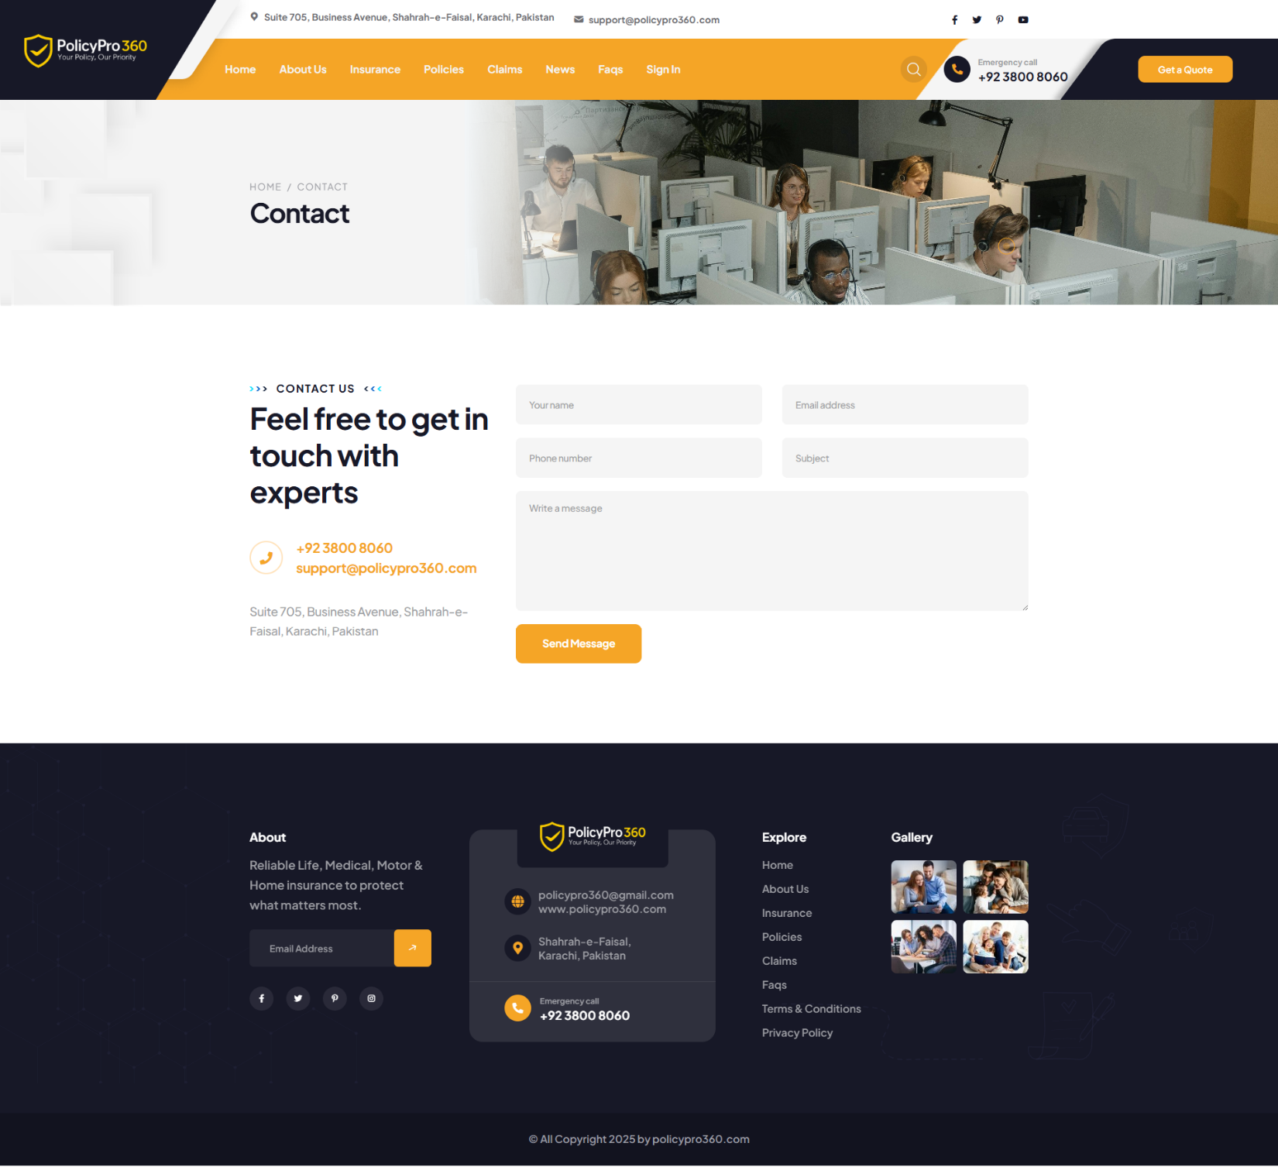

### **User Login**

### **User Dashboard**

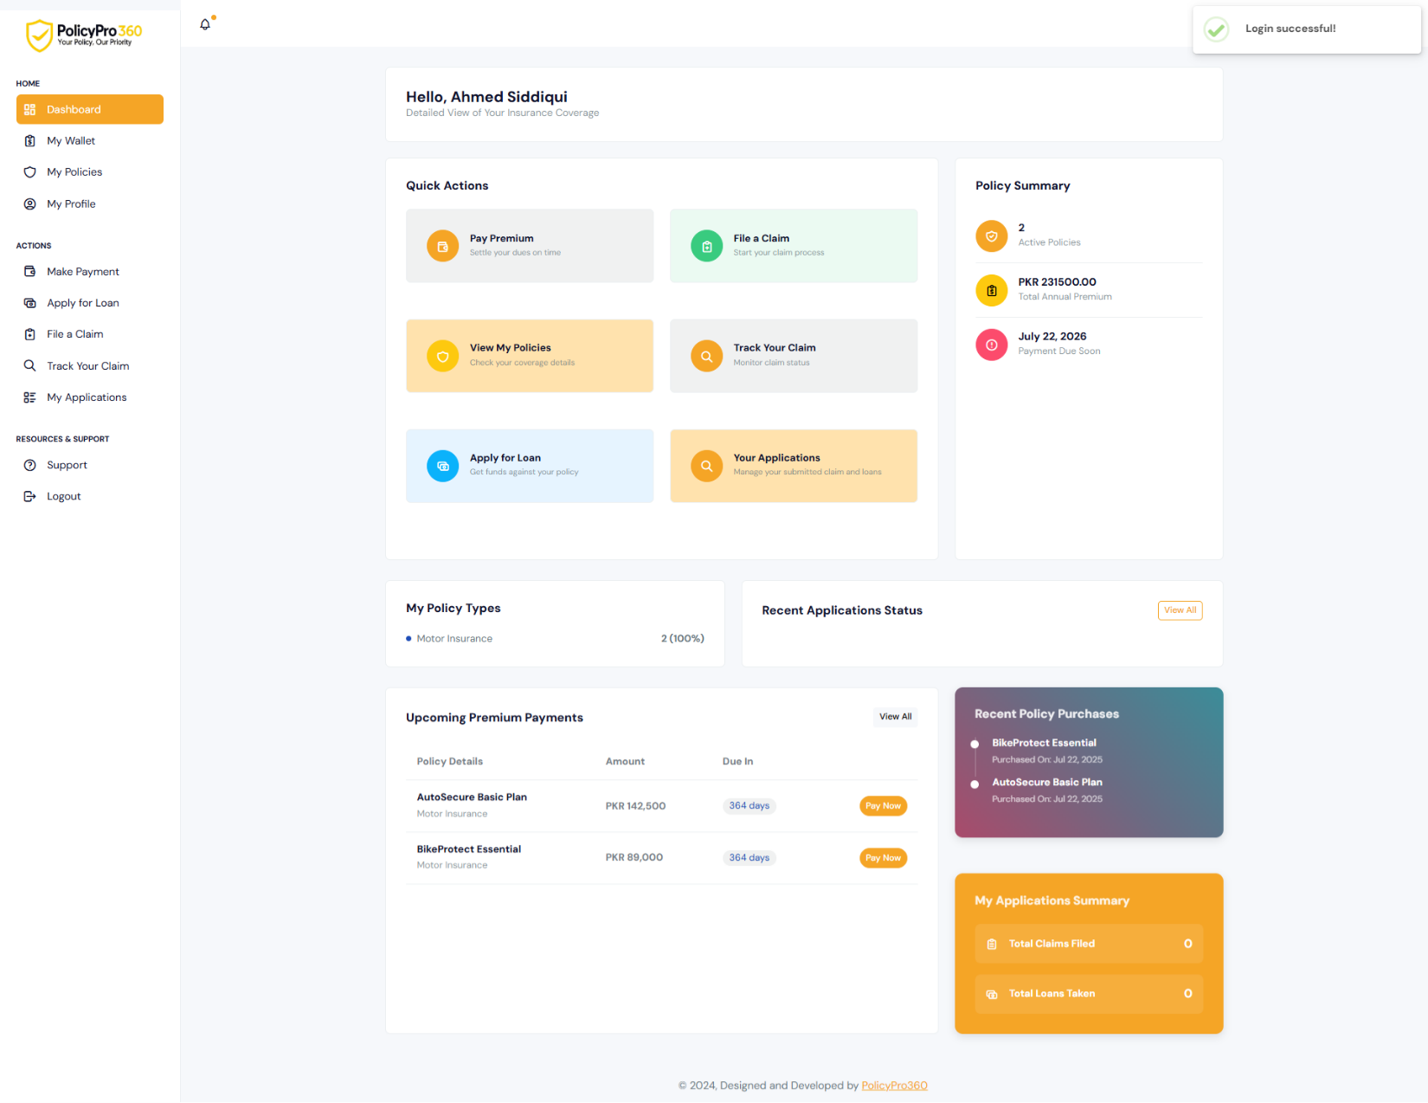

### **User Wallet**

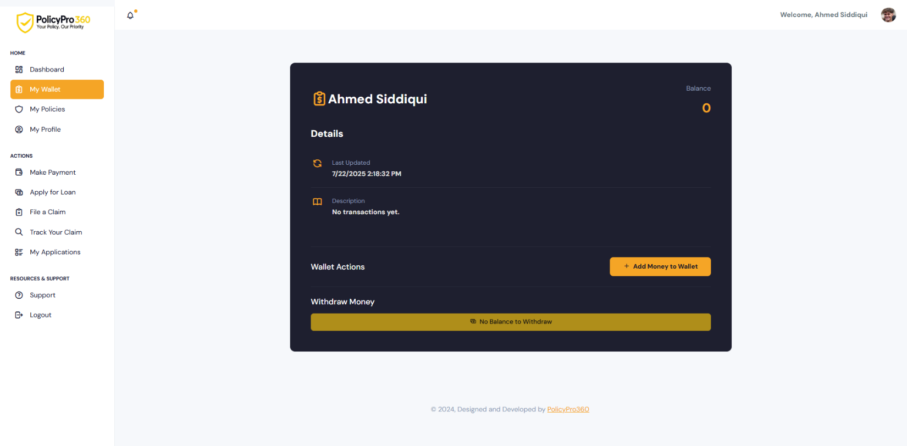

### **Add Money to Wallet**

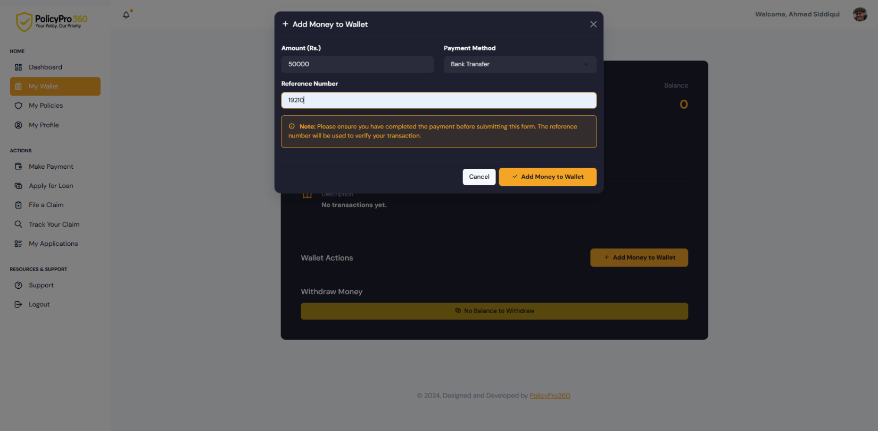

### **User Profile**

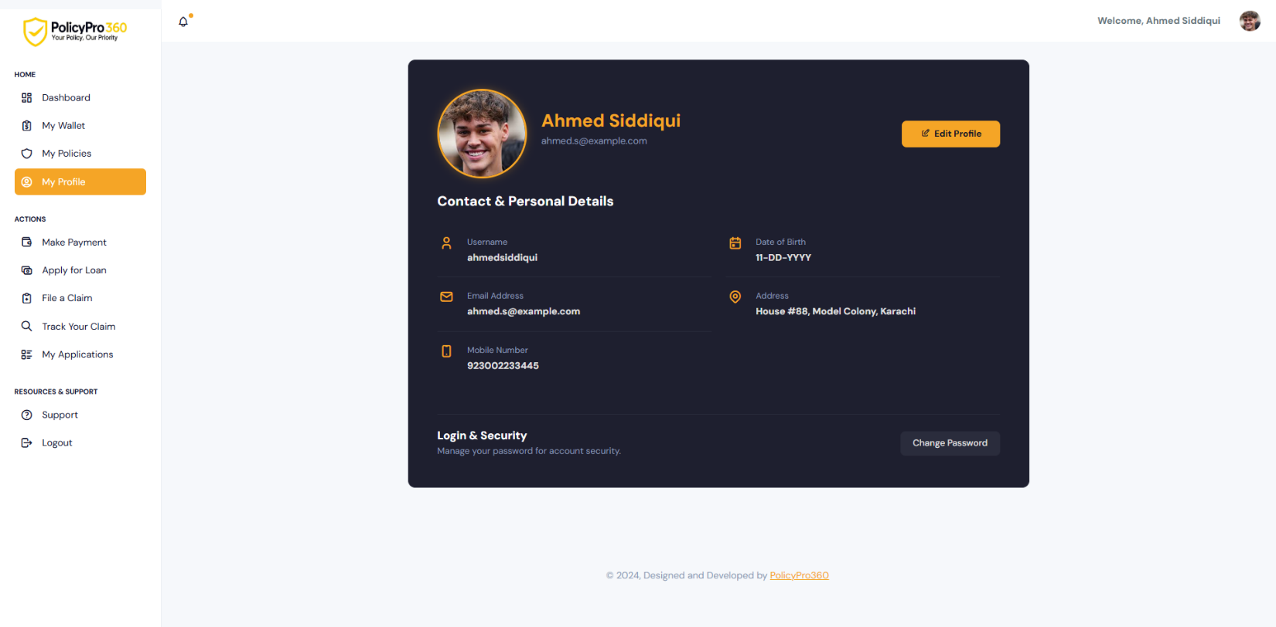

### **User Edit Profile**

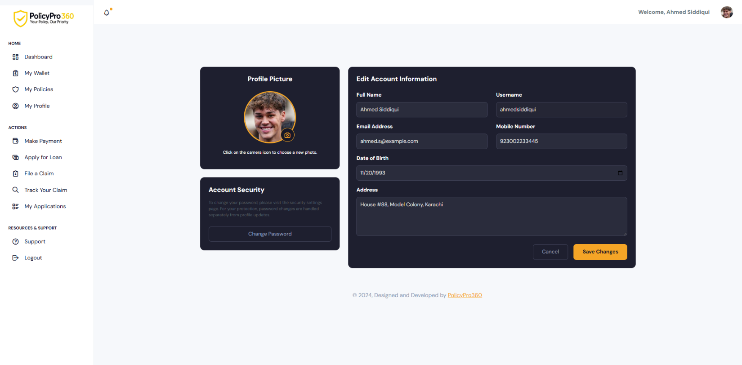

### **User Change Password**

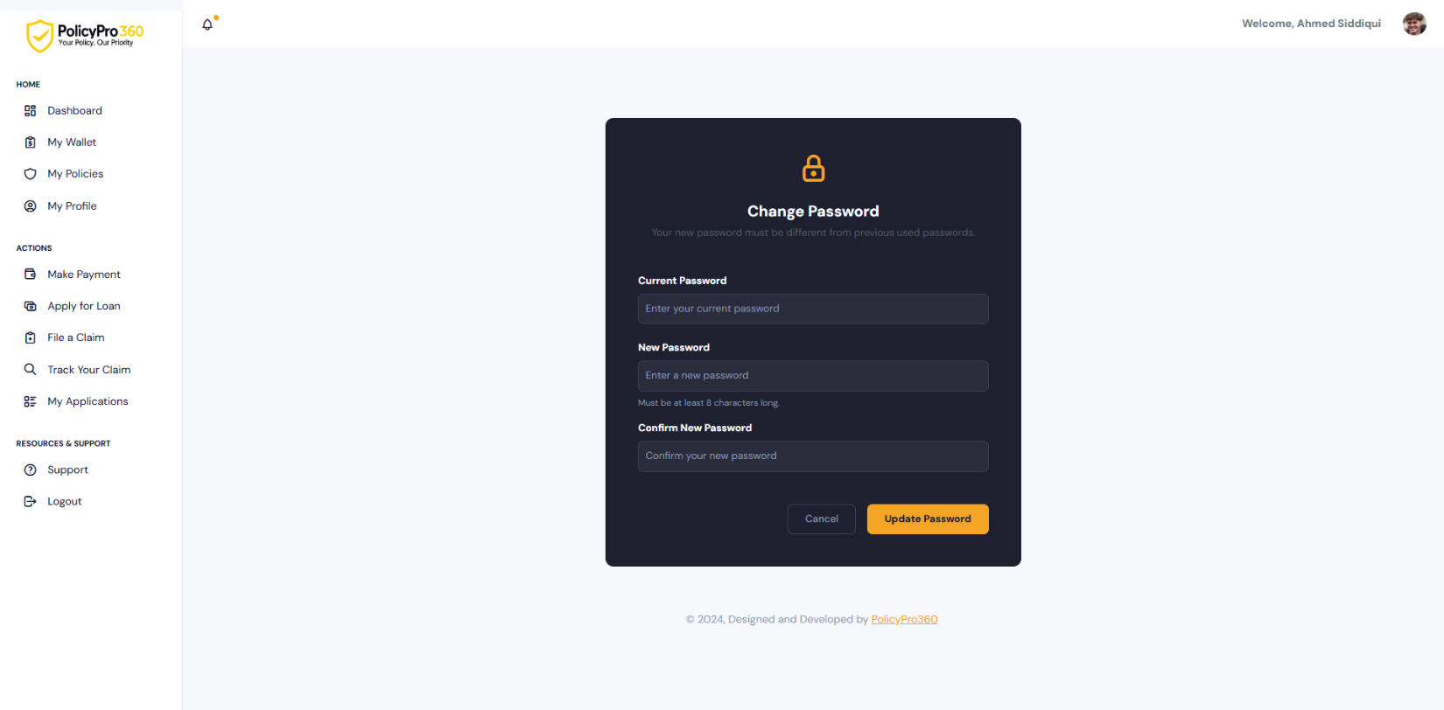

### **User Policy View Details 1**

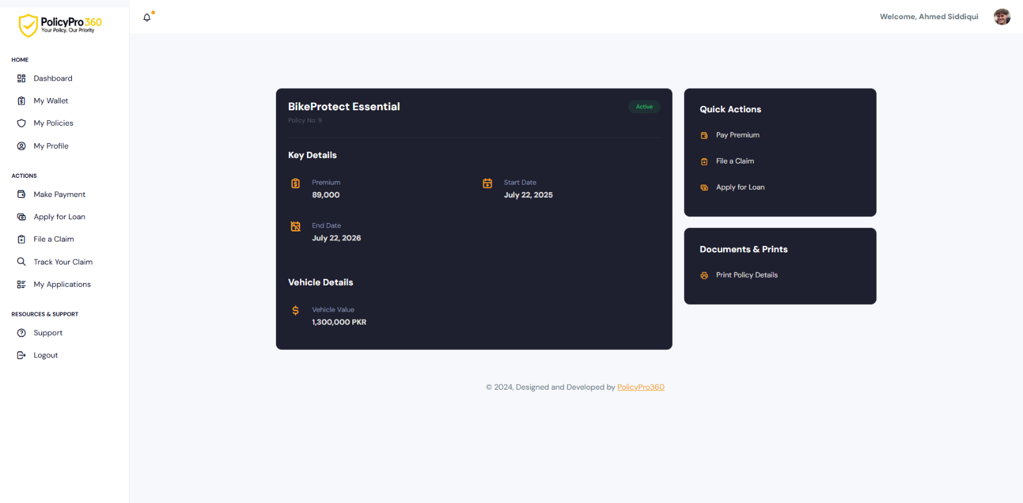

### **User Policy View Details 2**

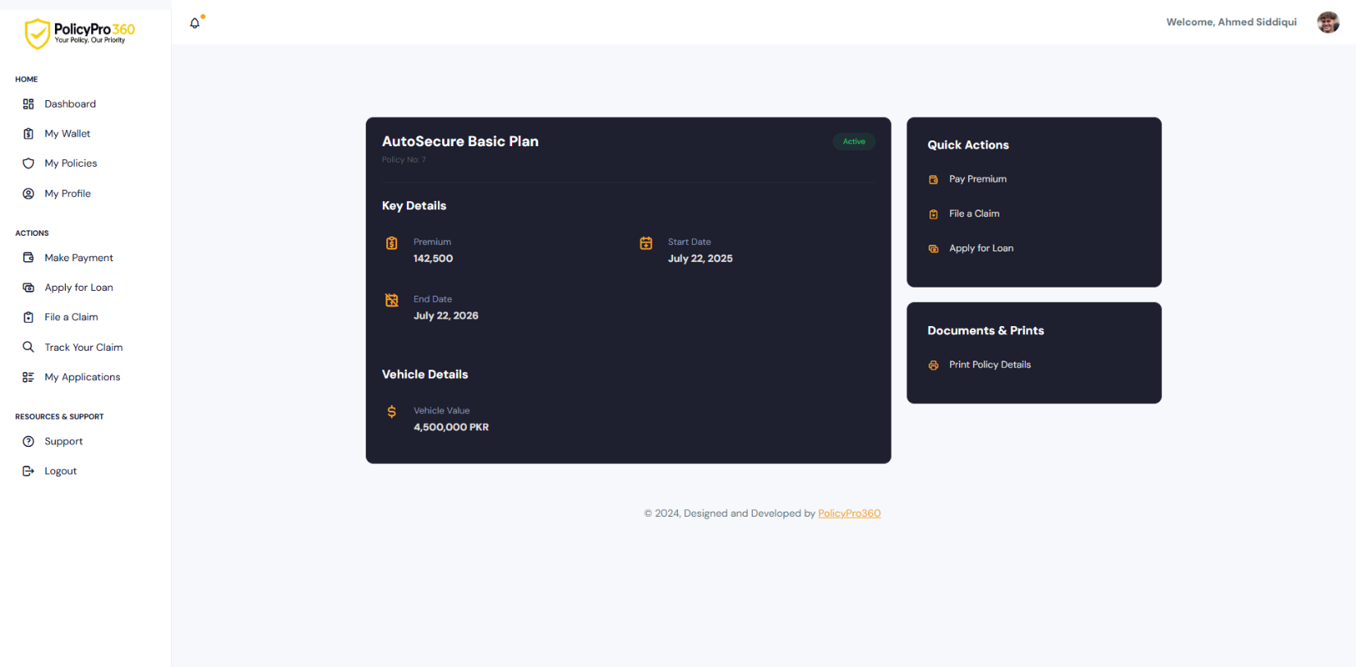

### **User Policy View Details Print**

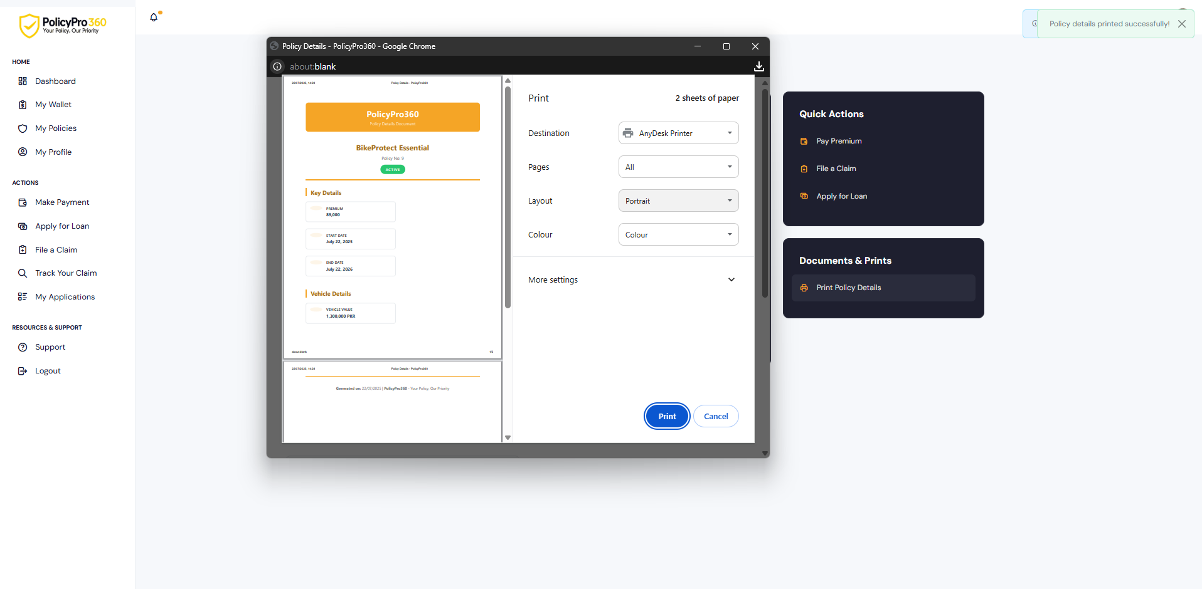

### **User Make Payment**

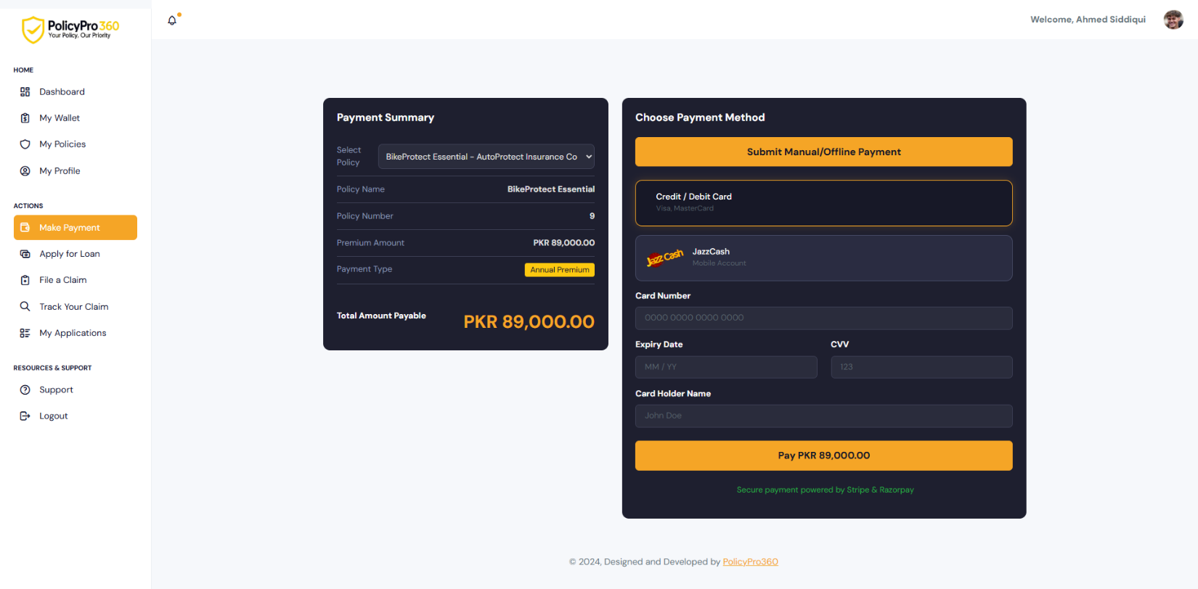

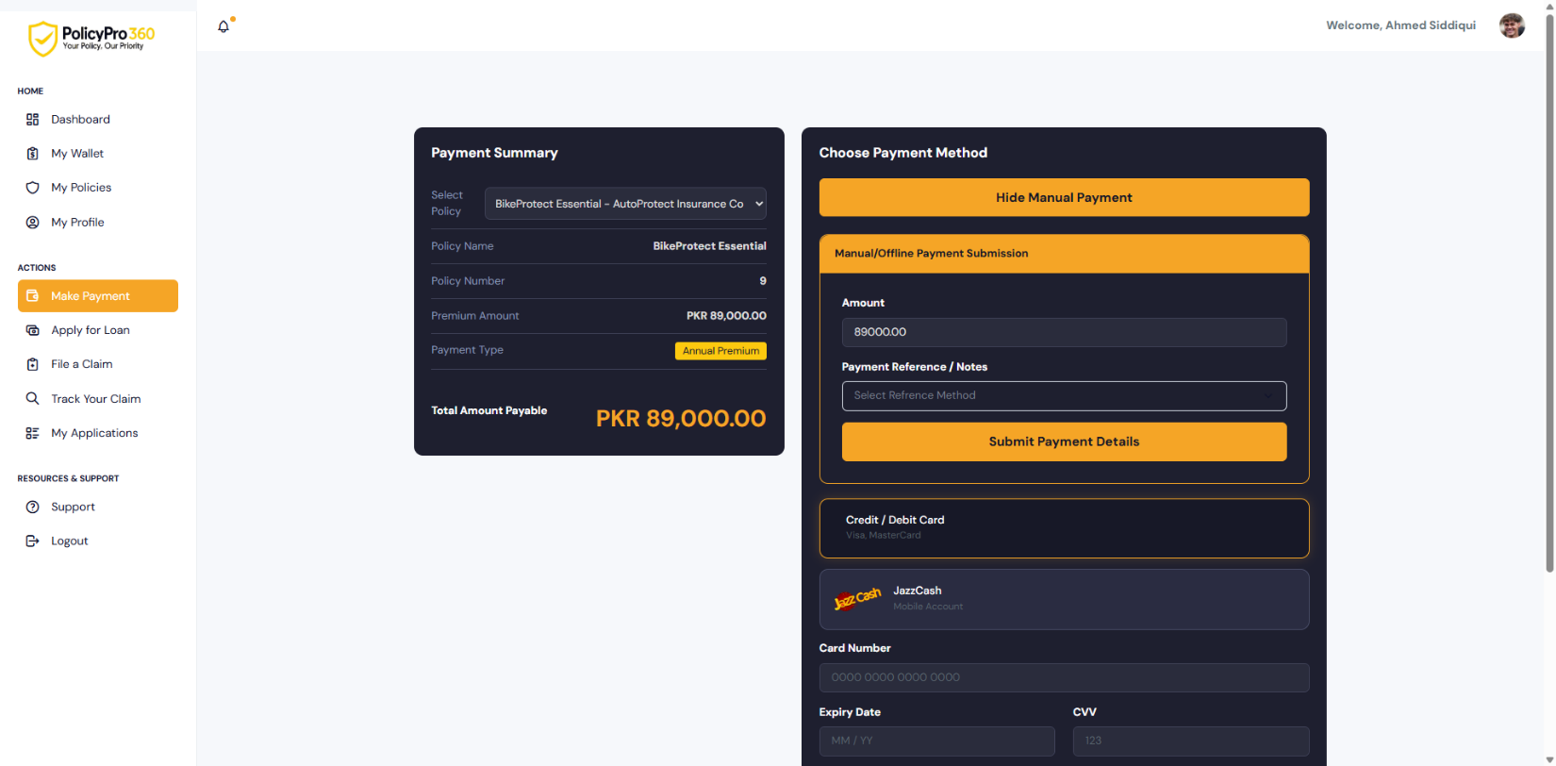

### **User File a Claim**

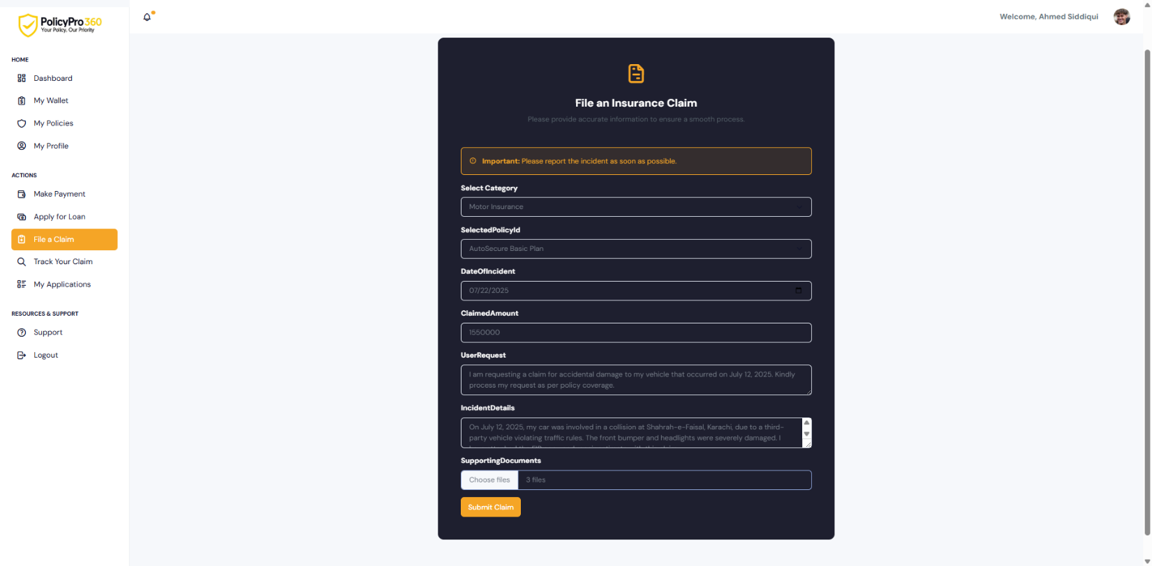

### **User Track Your Claim**

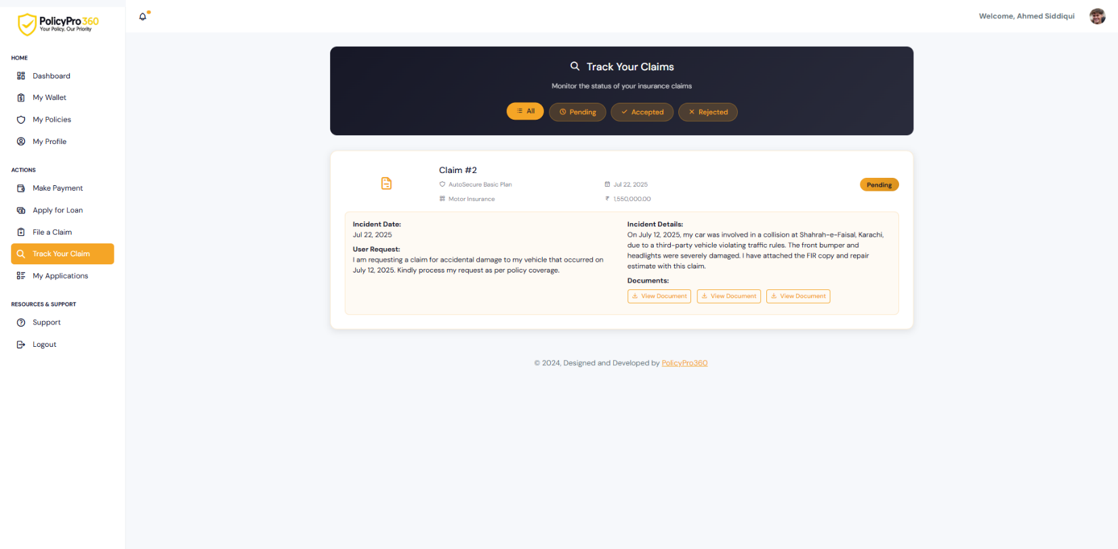

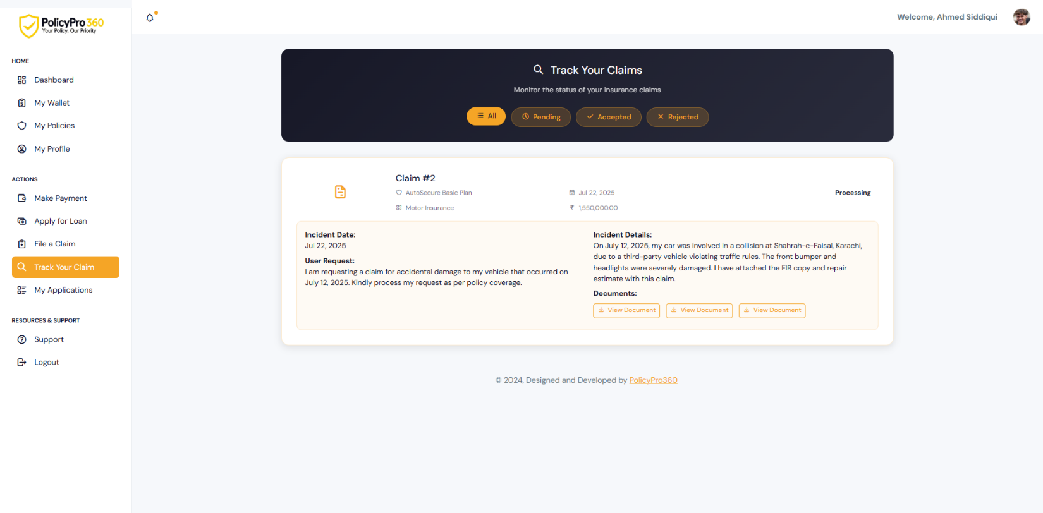

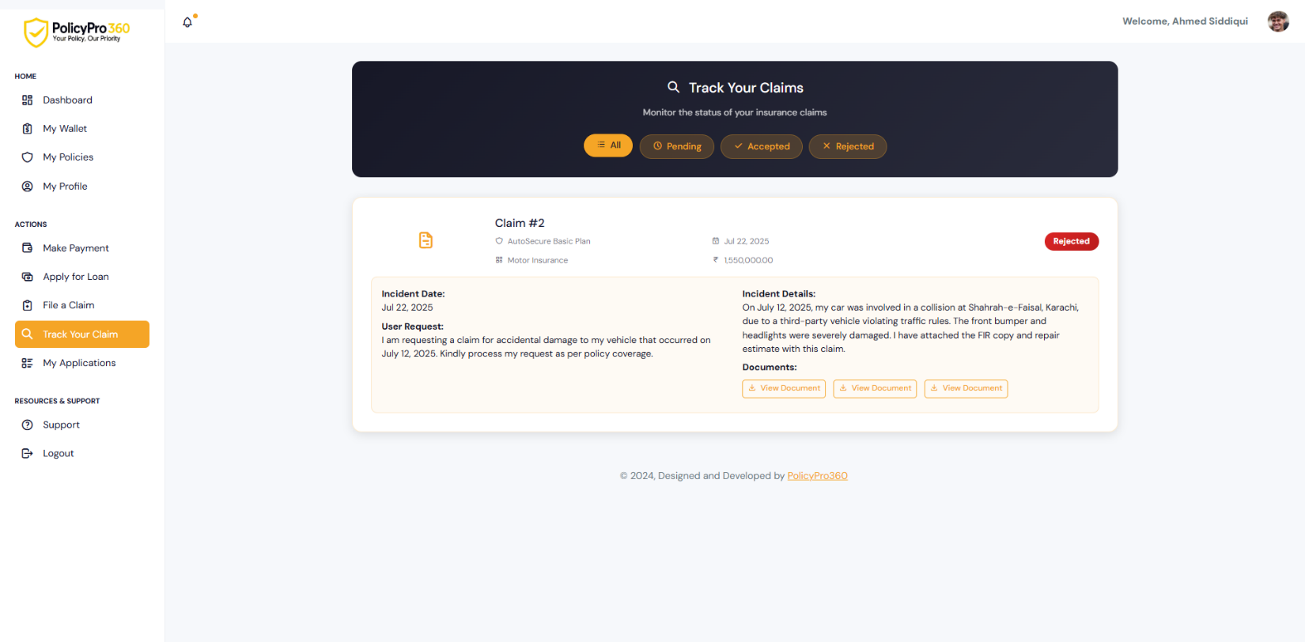

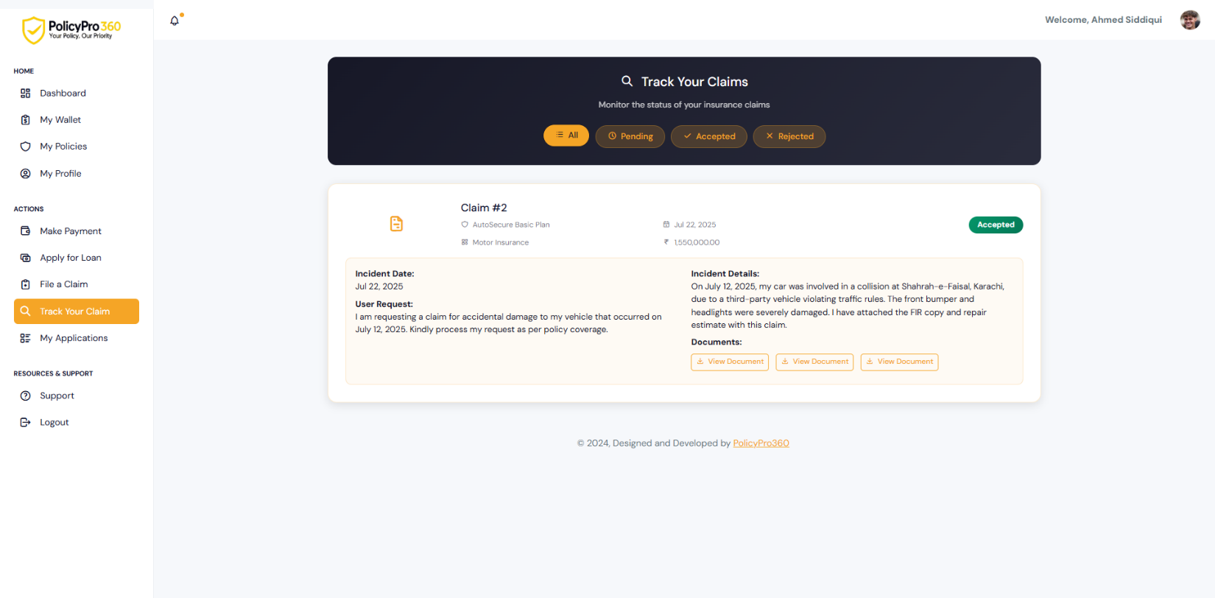

### **User Apply Loans**

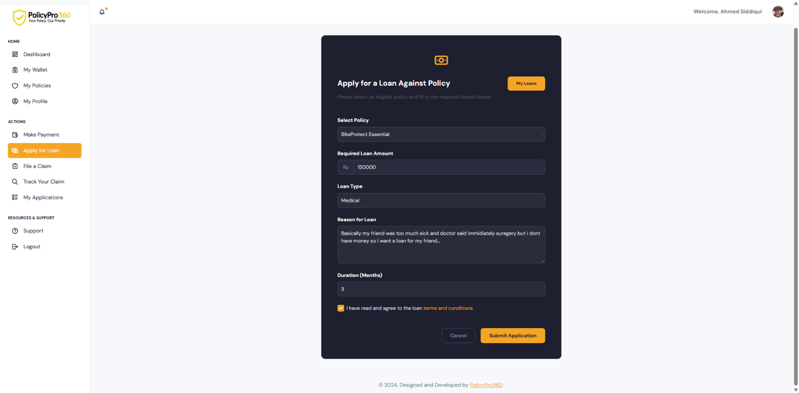

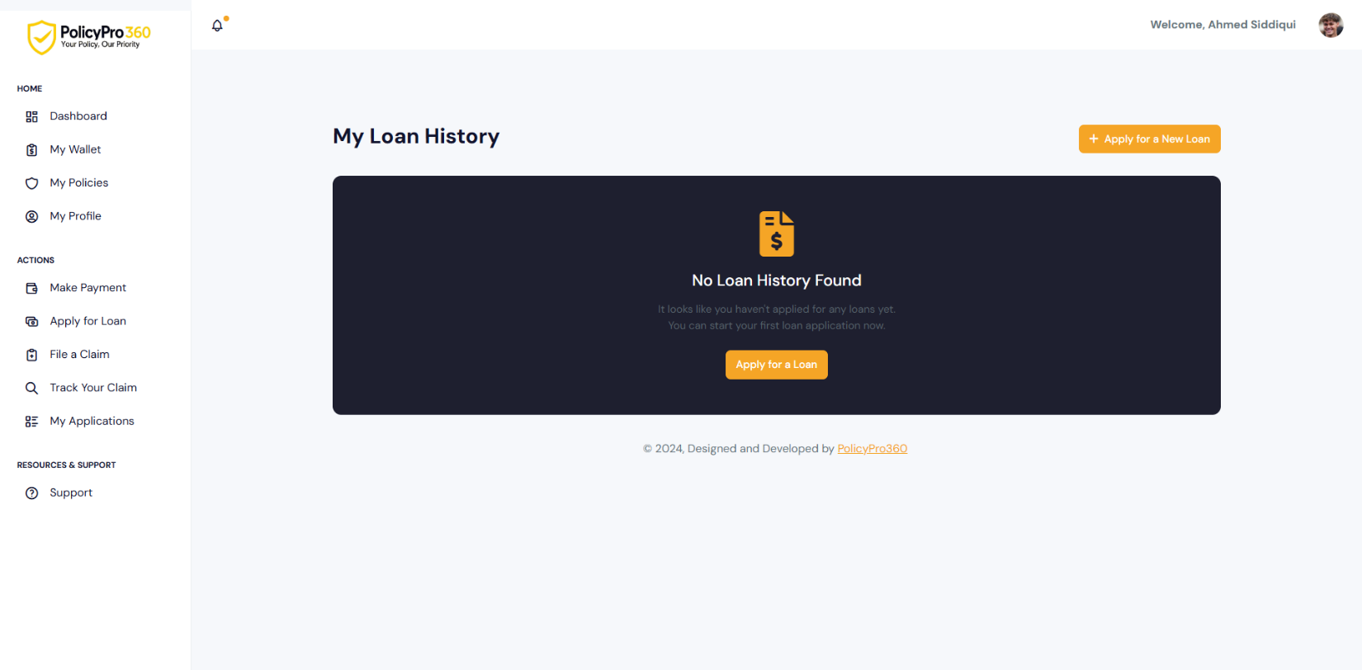

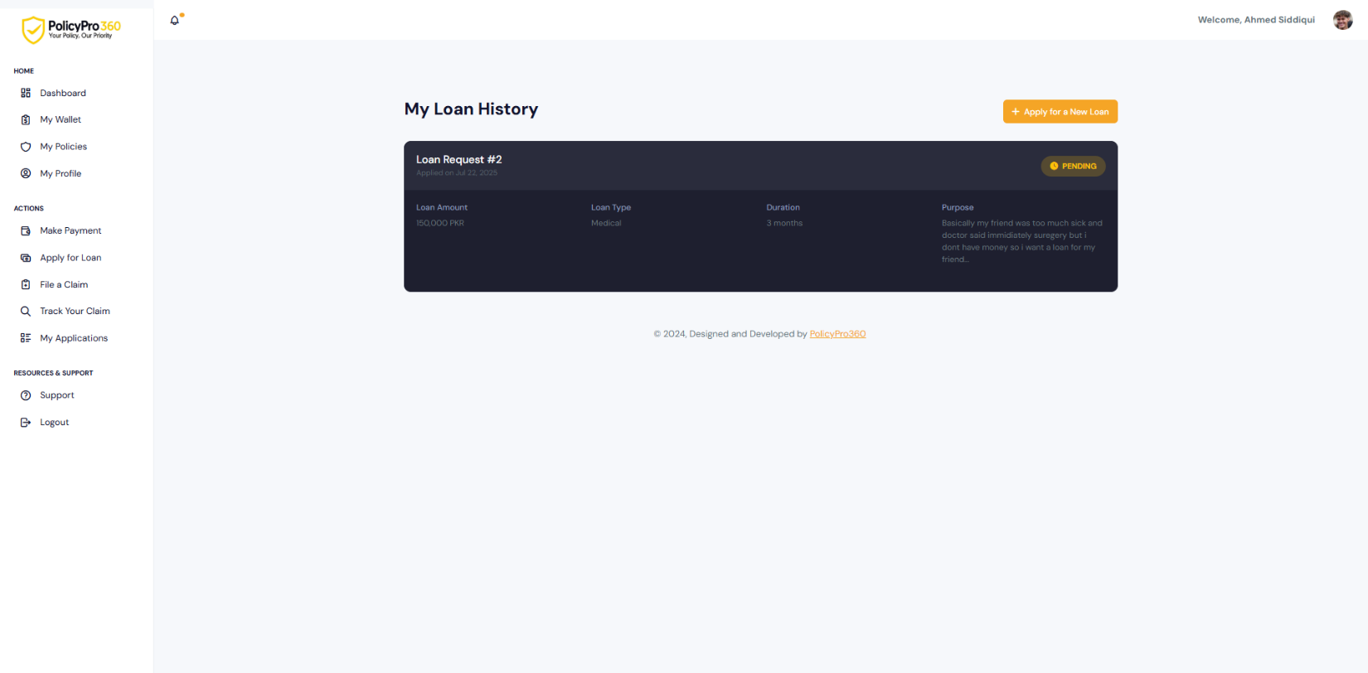

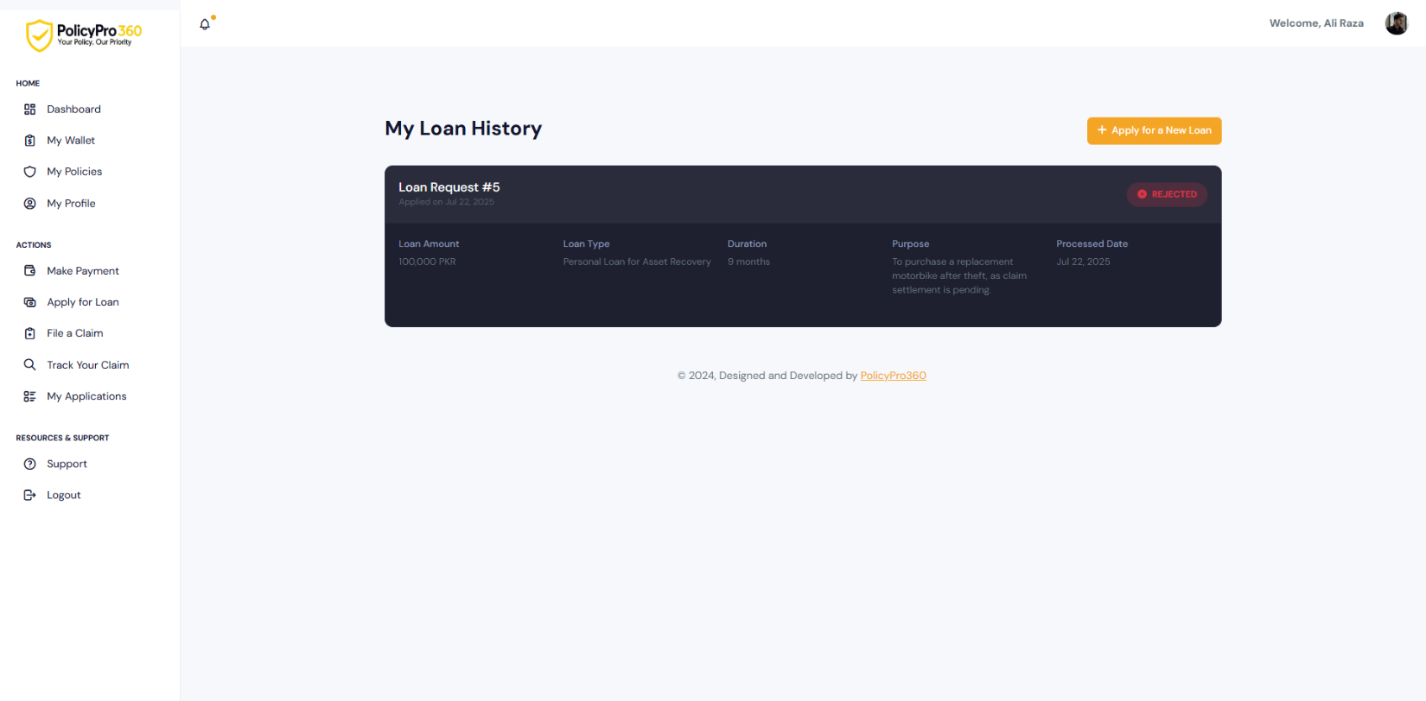

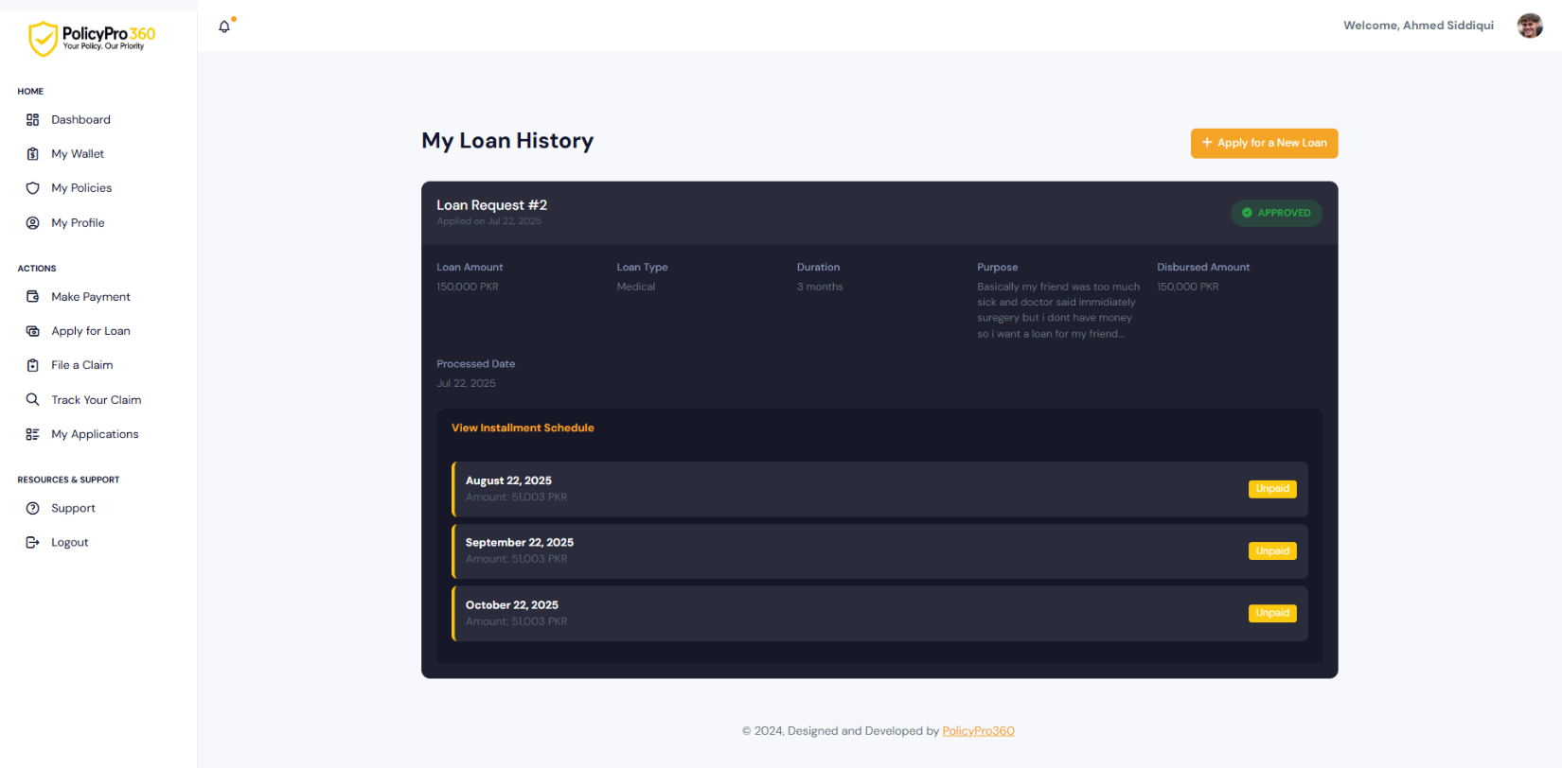

### **User Applications**

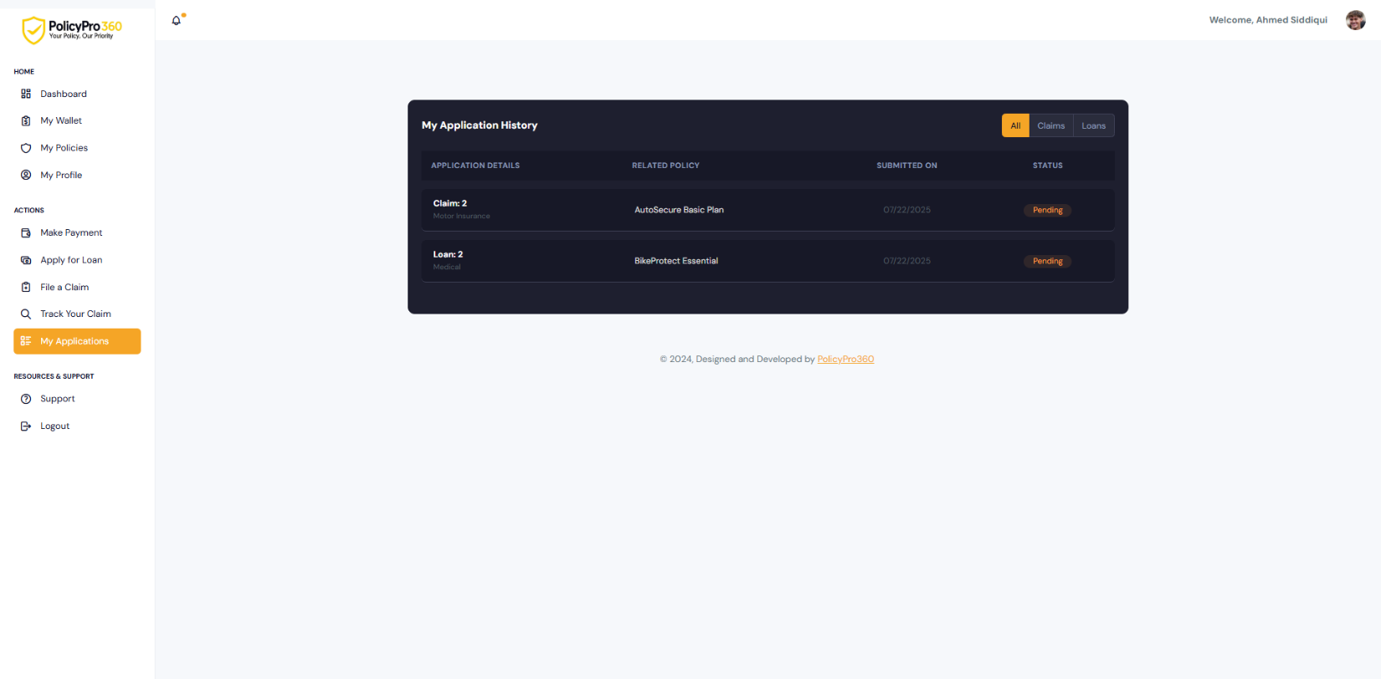

### **User Support**

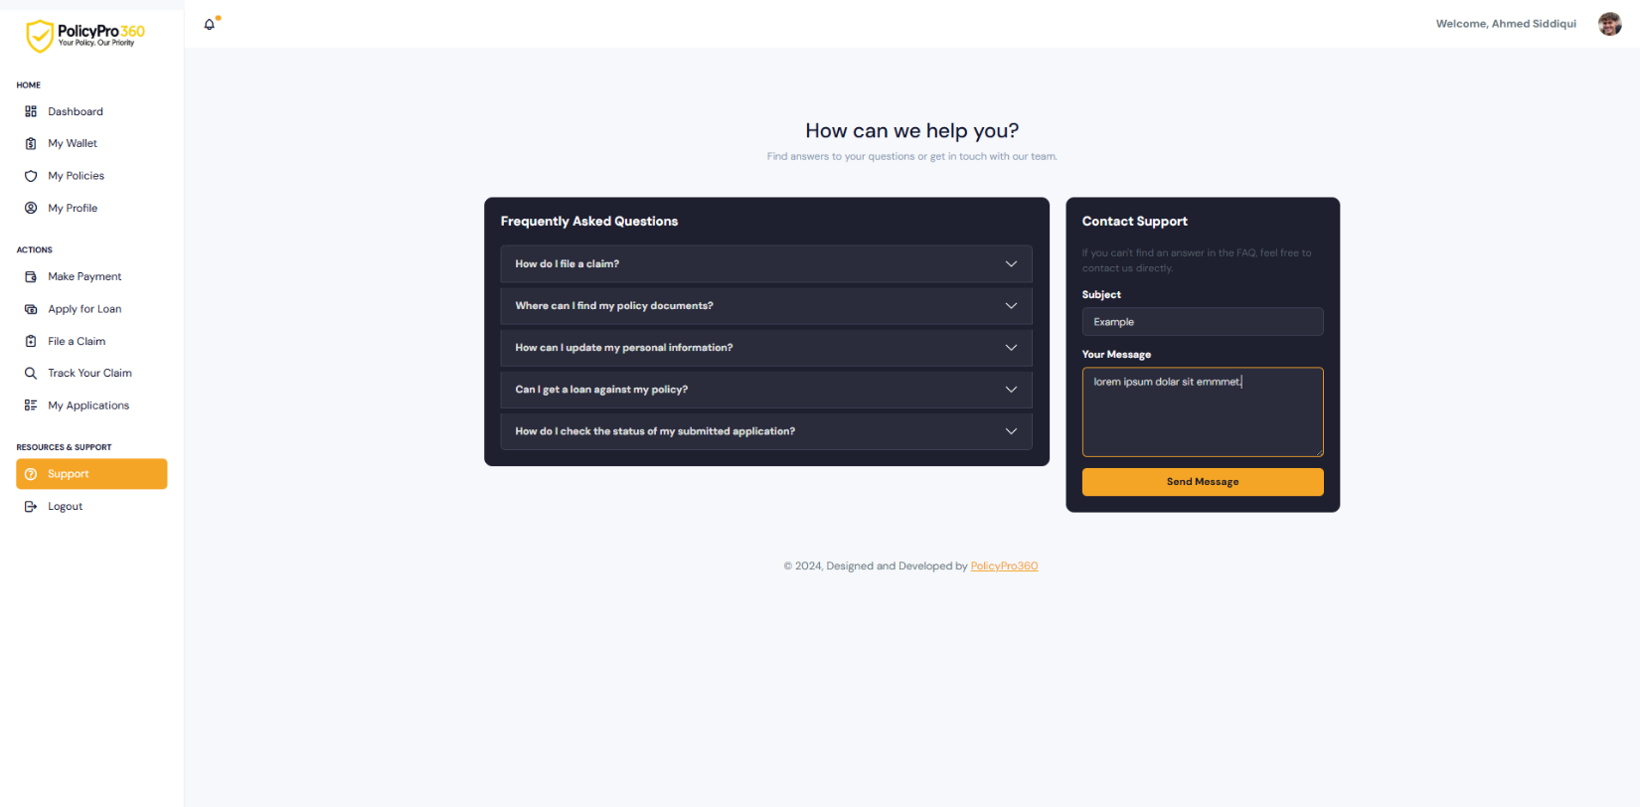

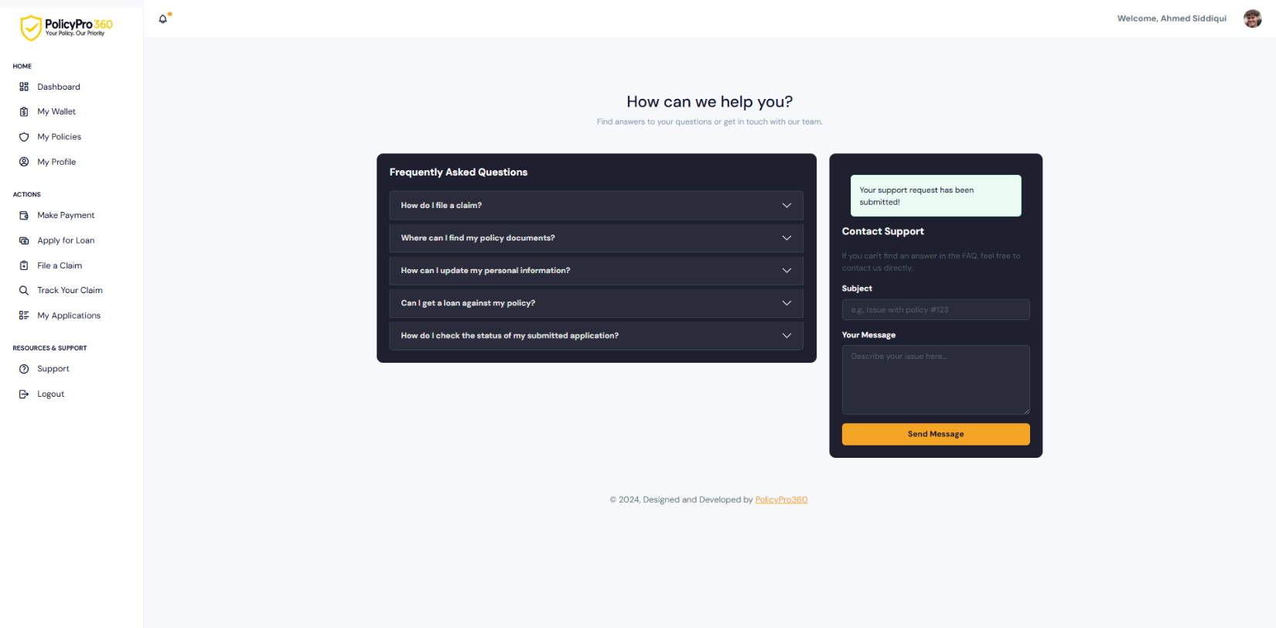

### **User Logout**



### **Company Register**

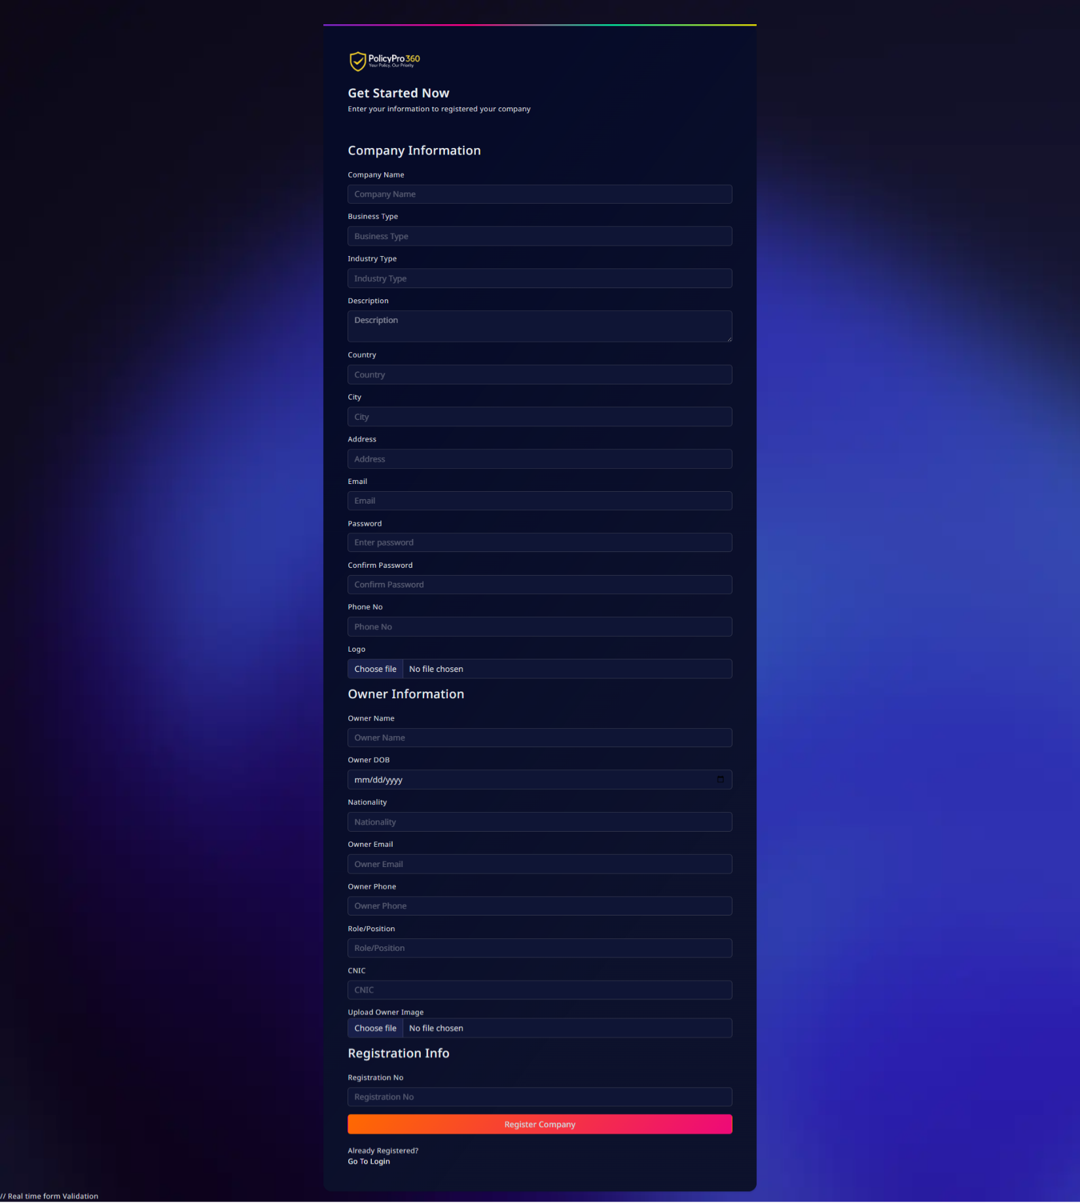

### **Company Login**

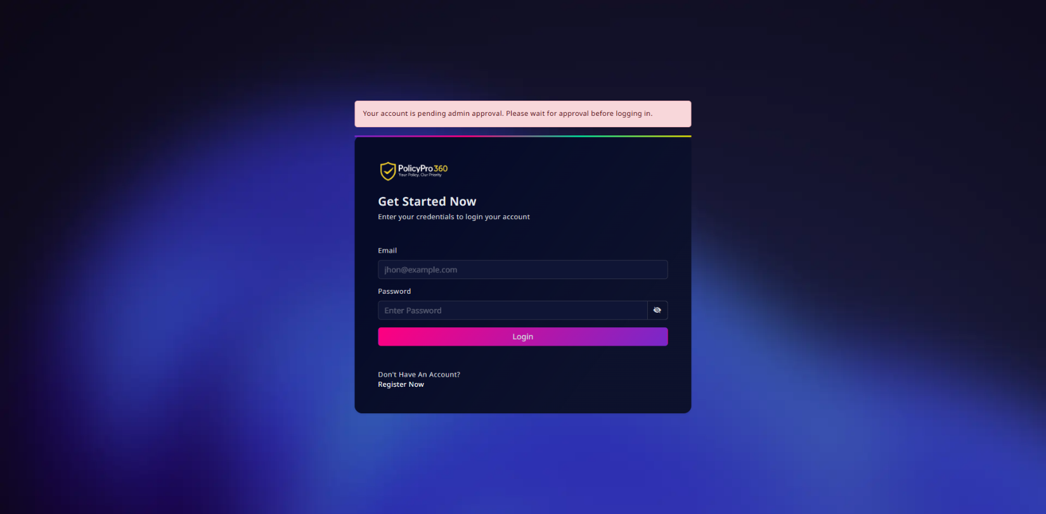

### **Company Login After Approval**

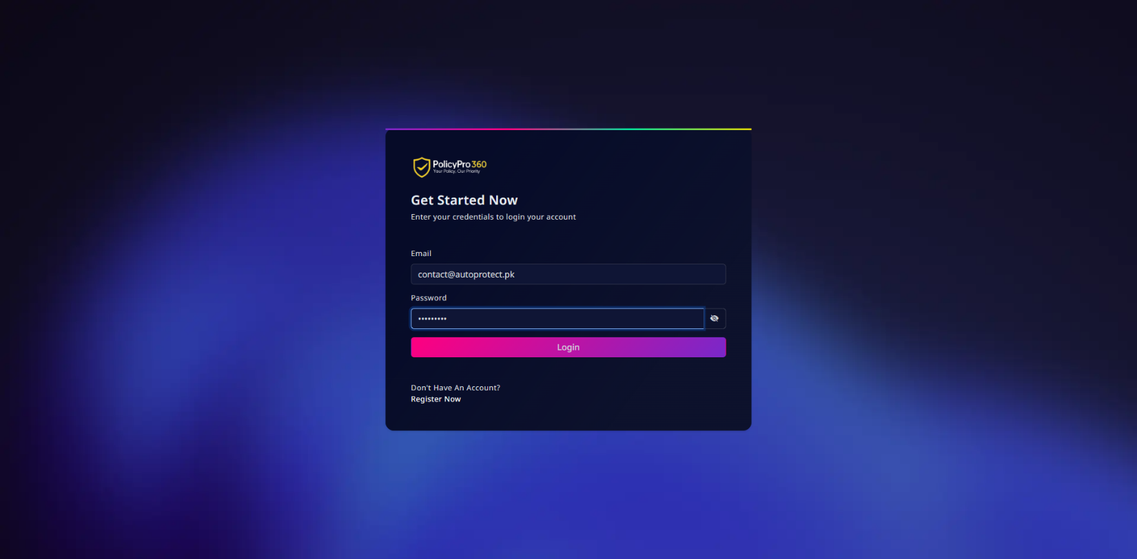

### **Company Dashboard**

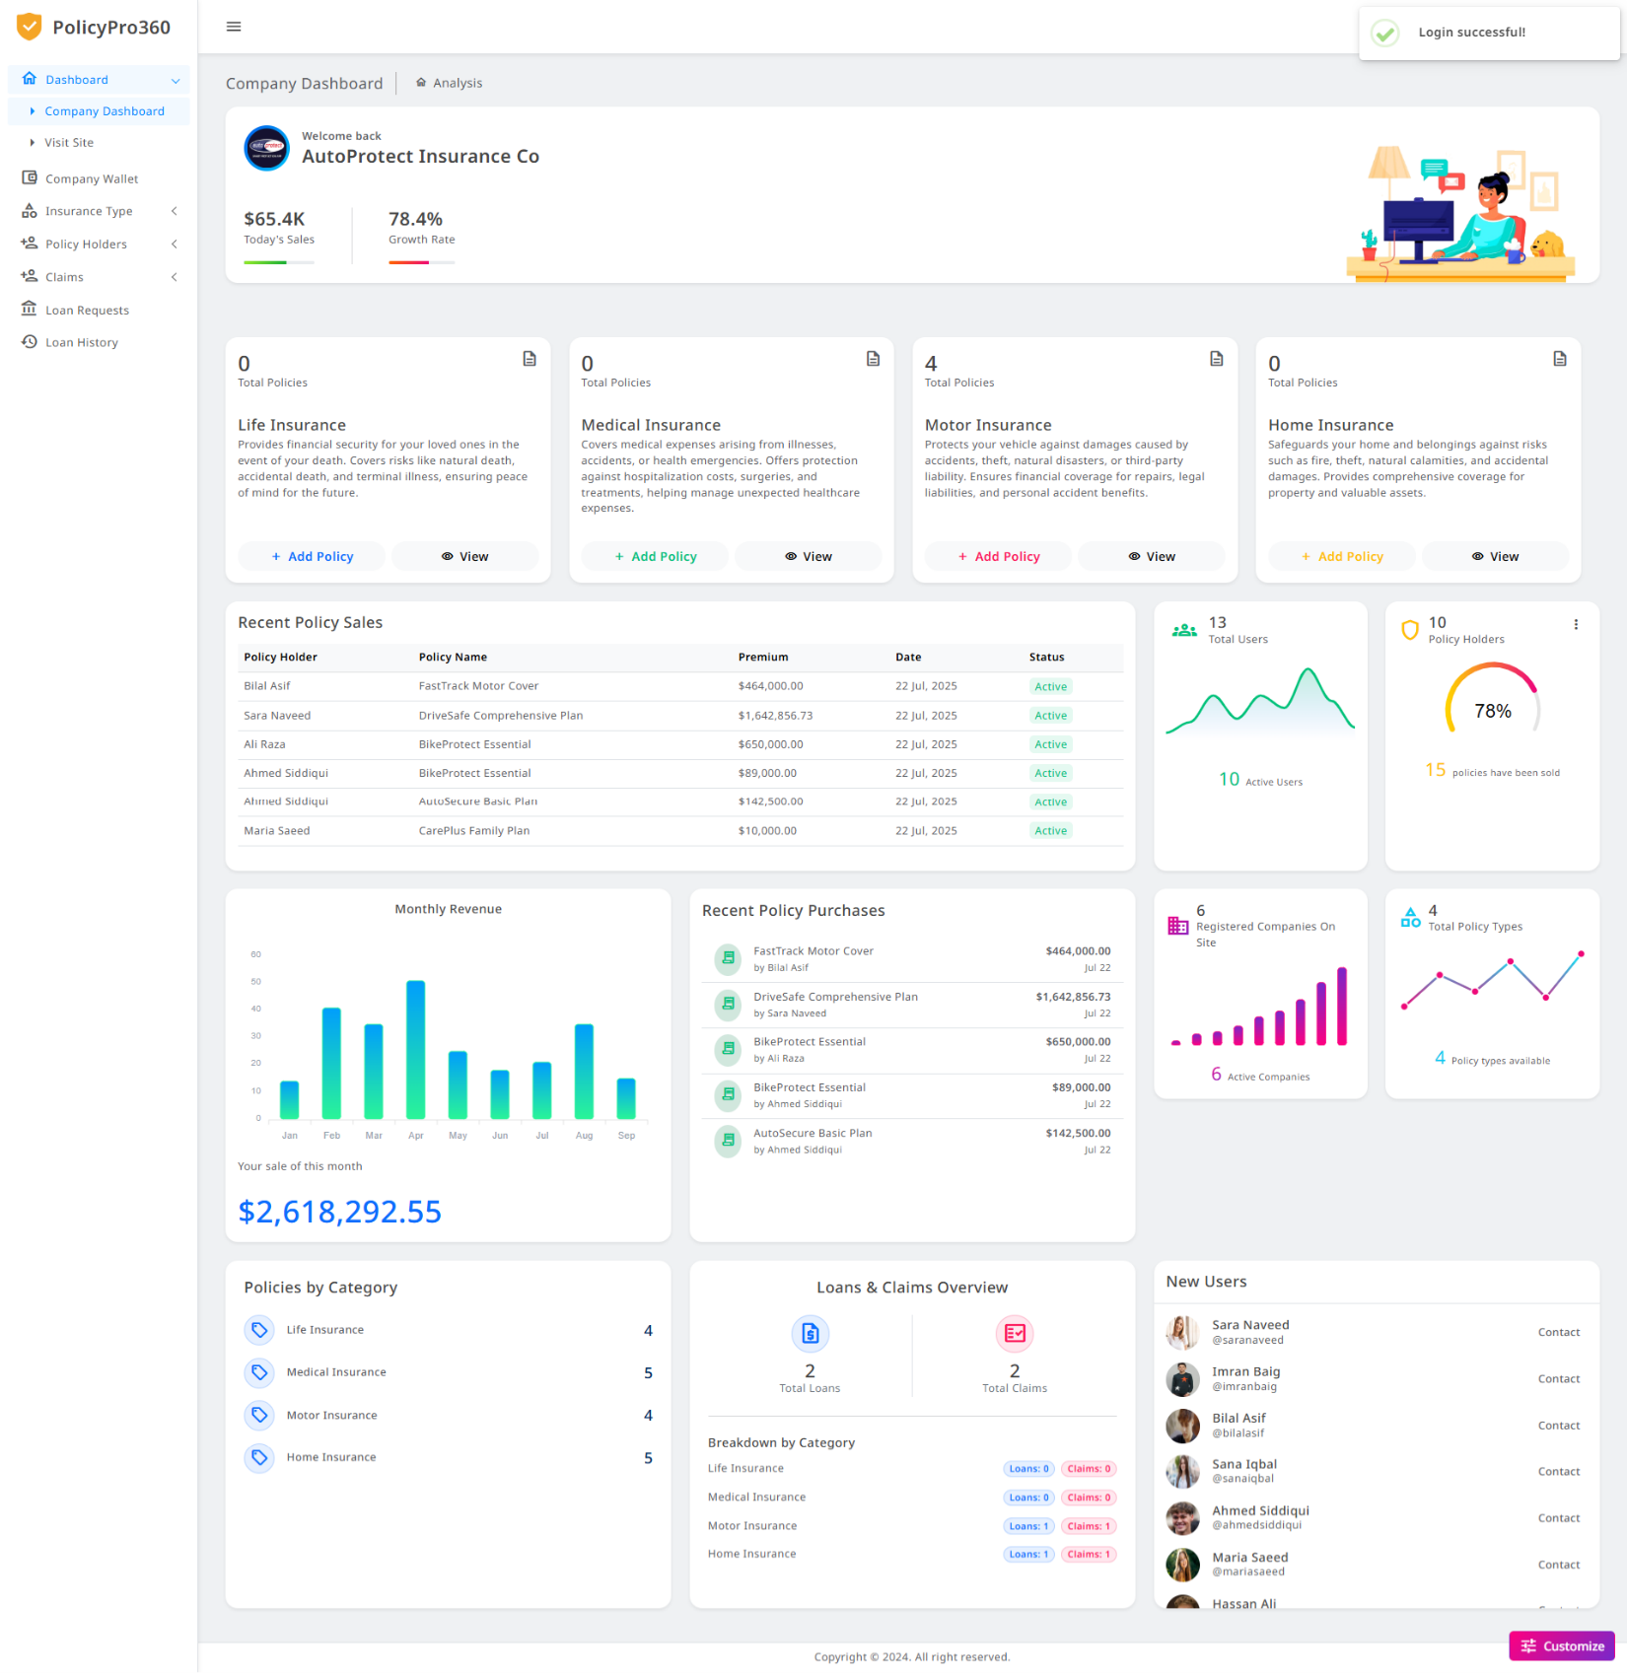

### **Company Wallet**

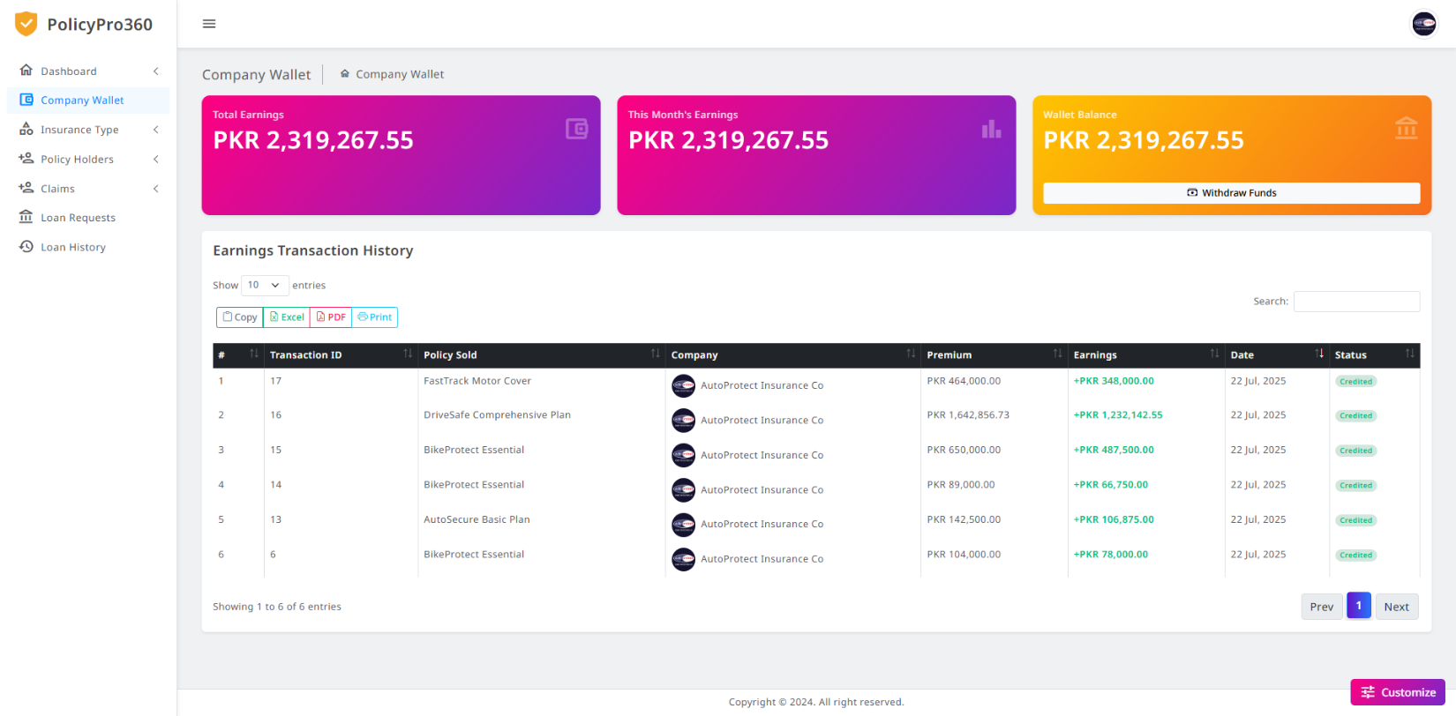

### **Company Withdraw**

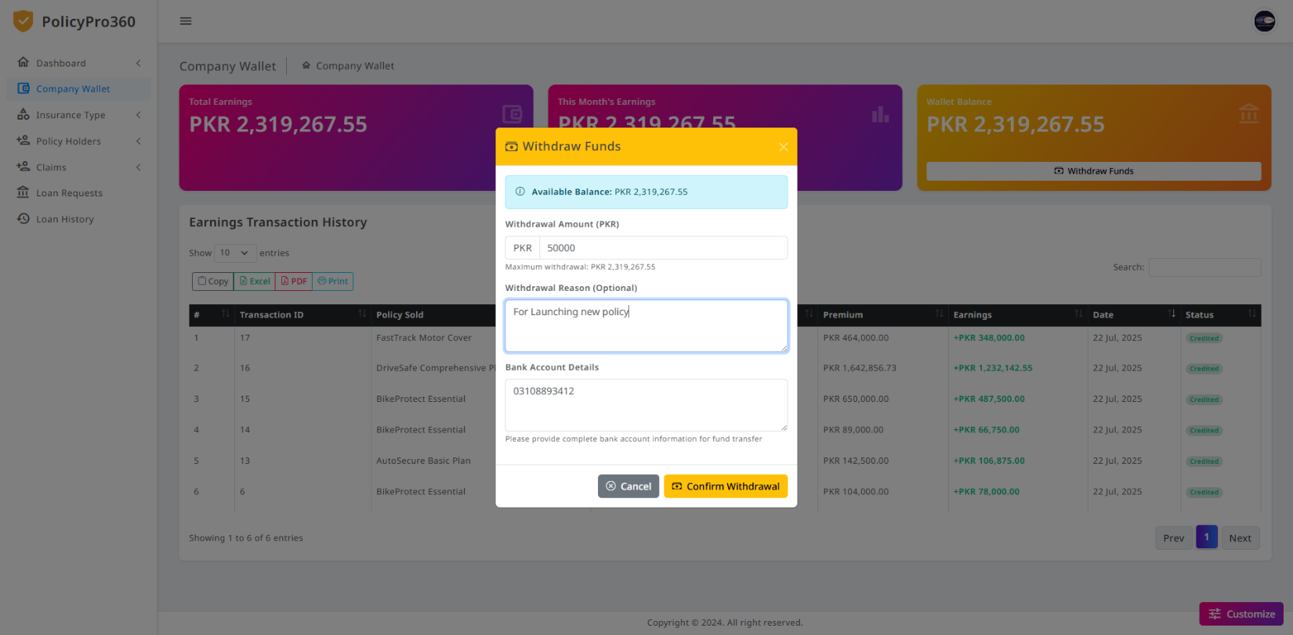

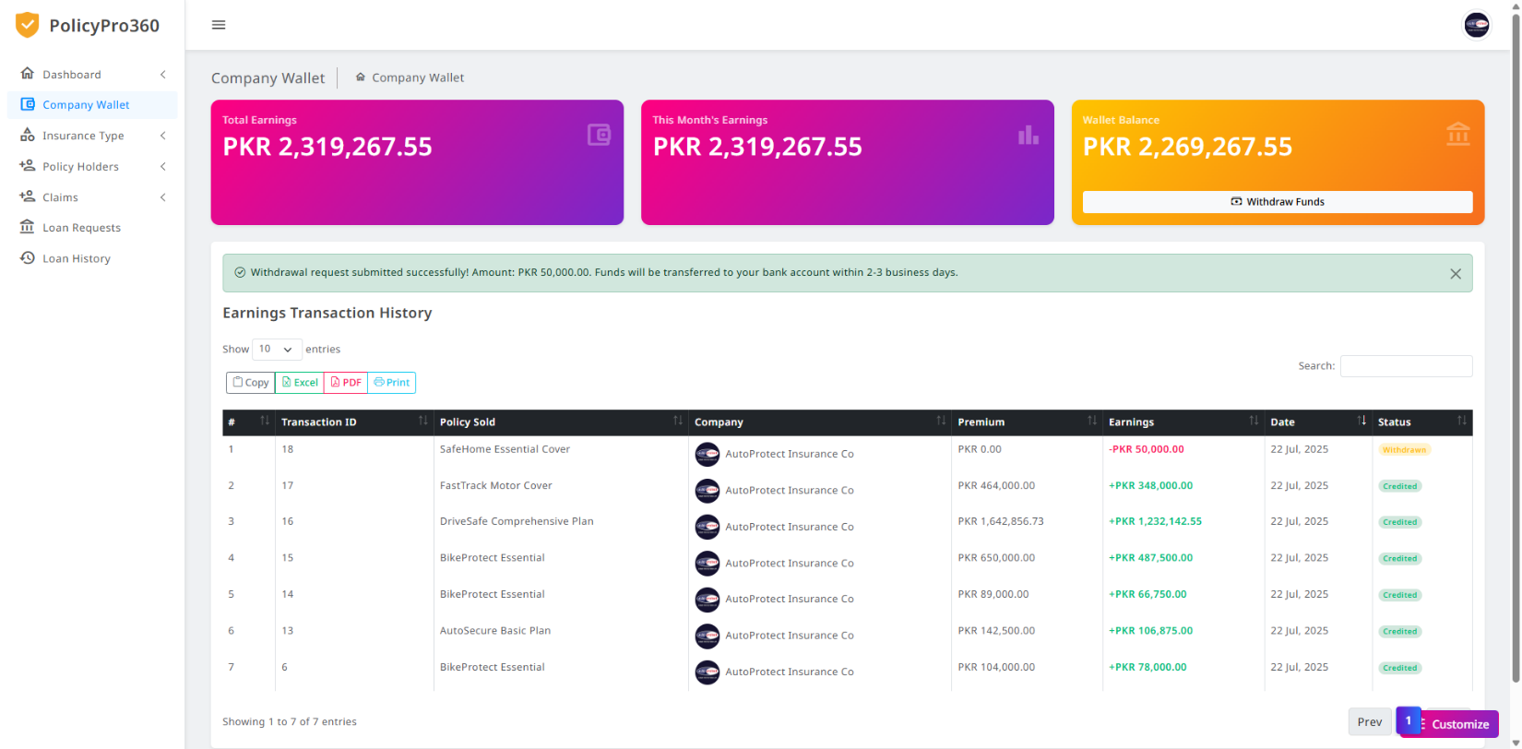

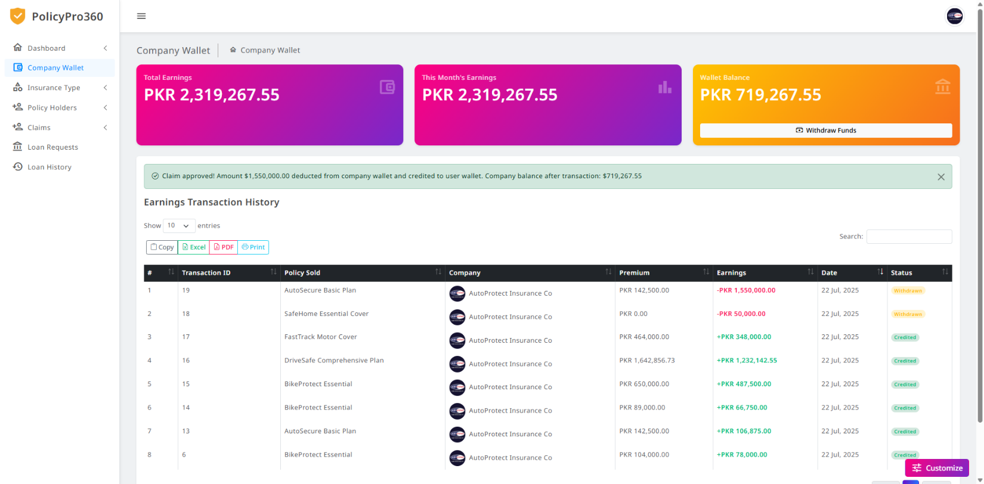

### **Company Insurance Policies**

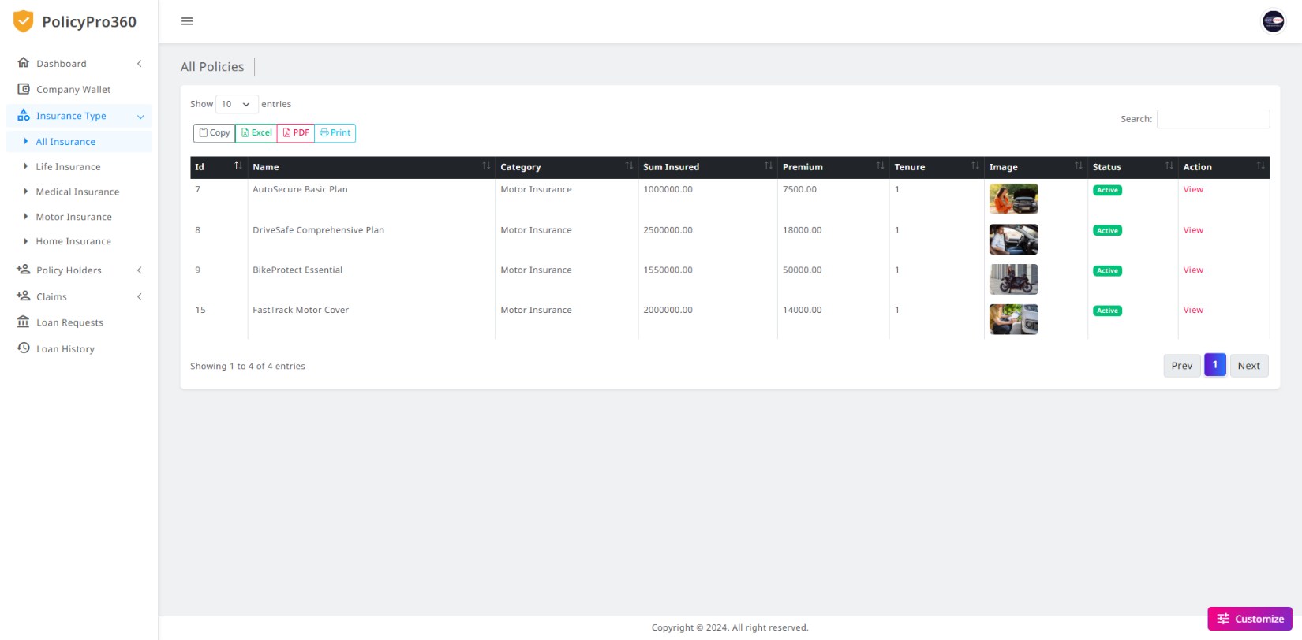

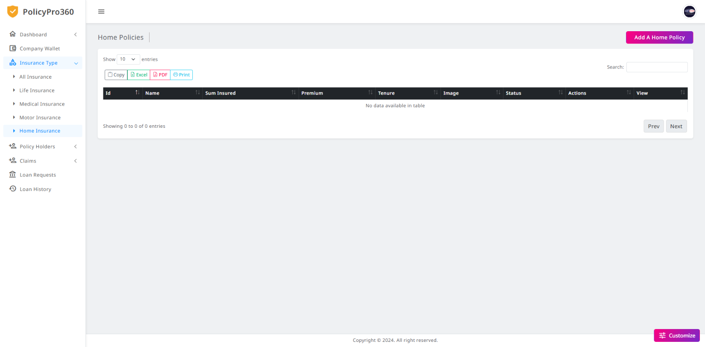

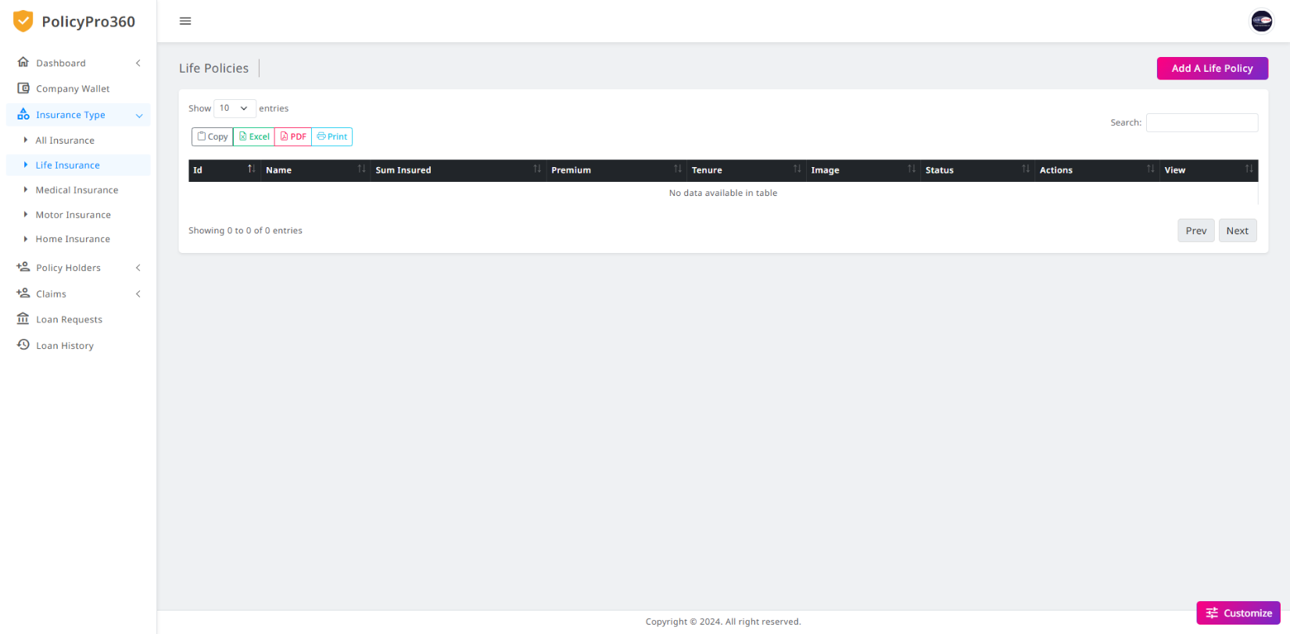

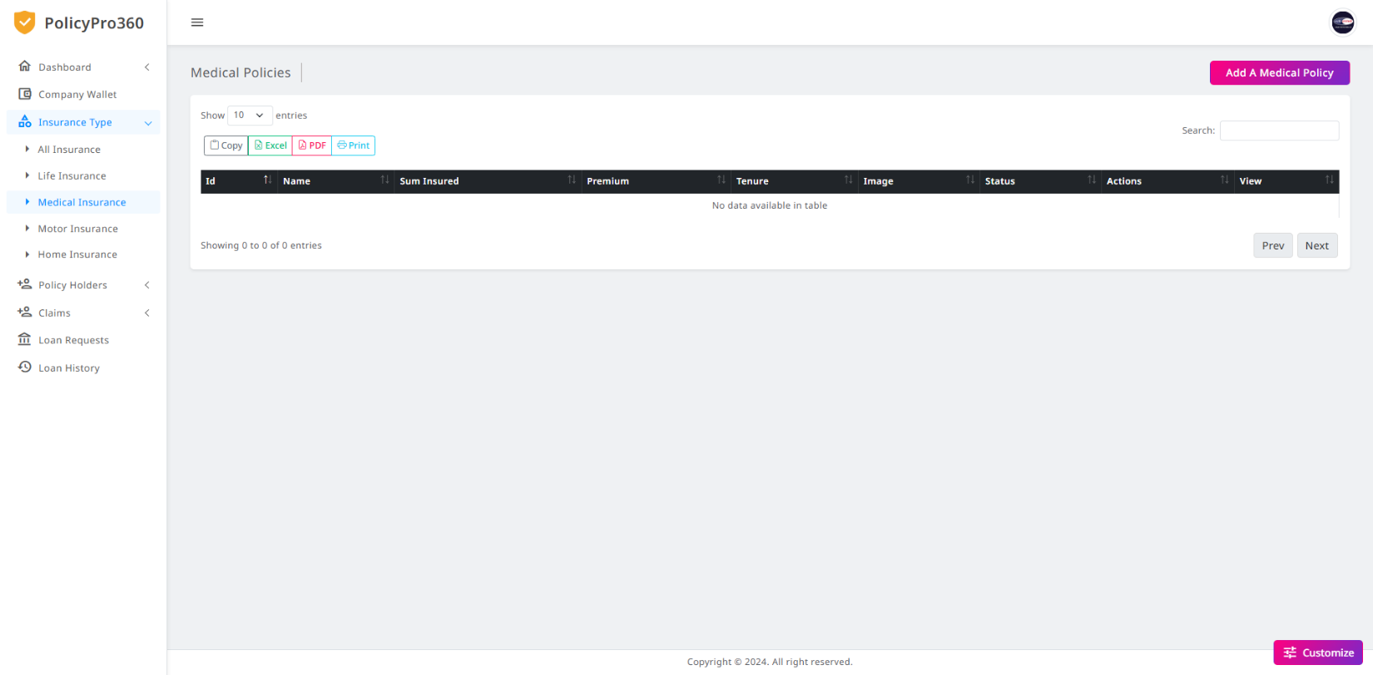

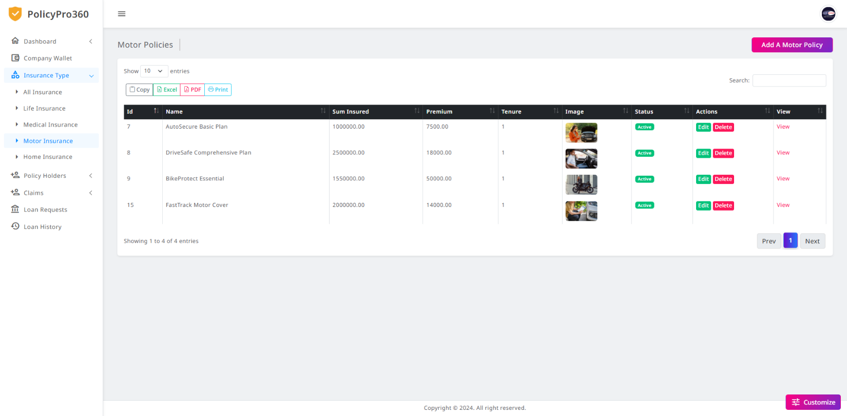

### **Company Policyholders**

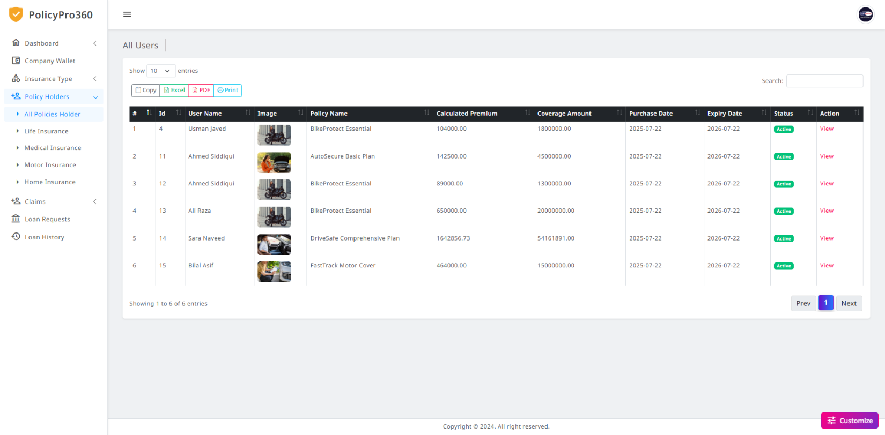

### **Company User Claims**

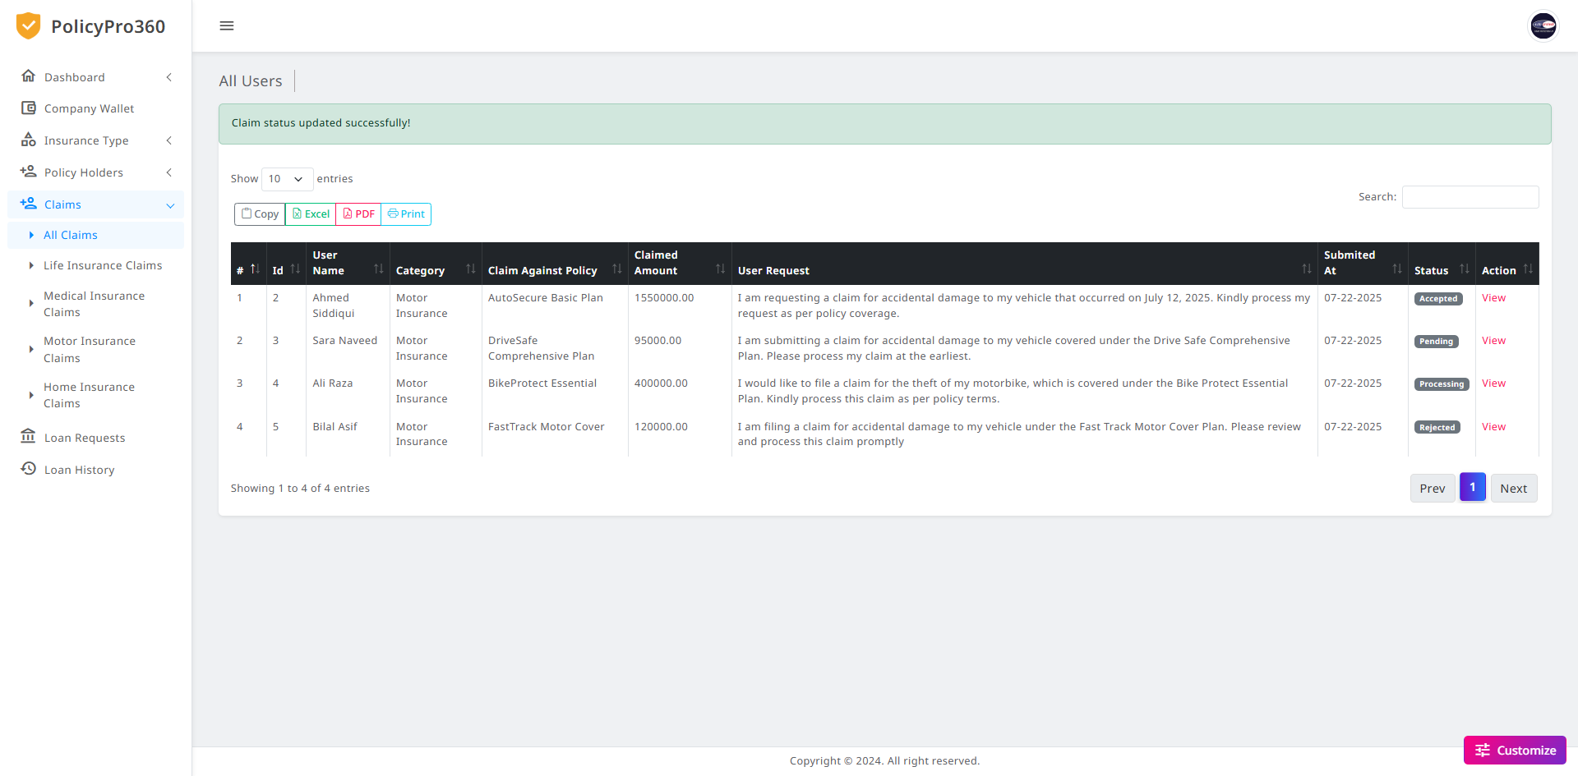

### **Company User Claims Views & Change Status**

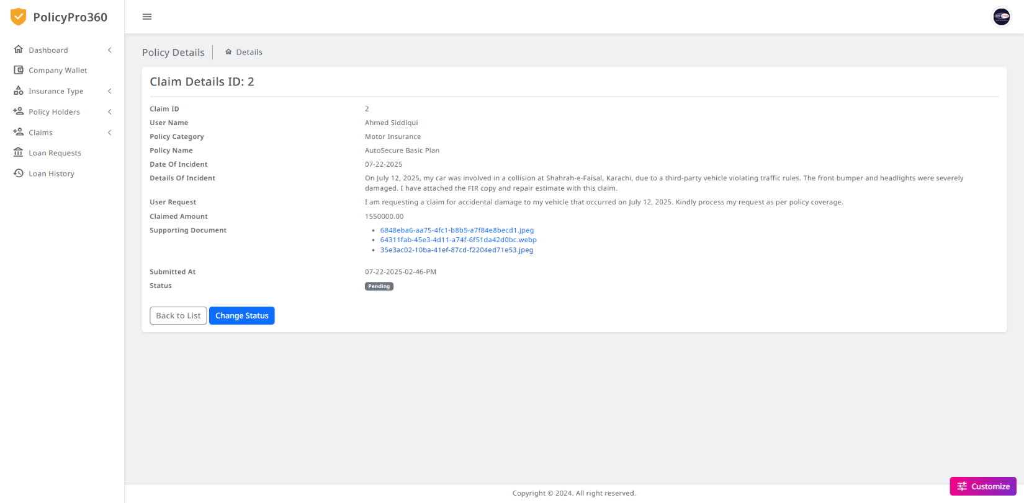

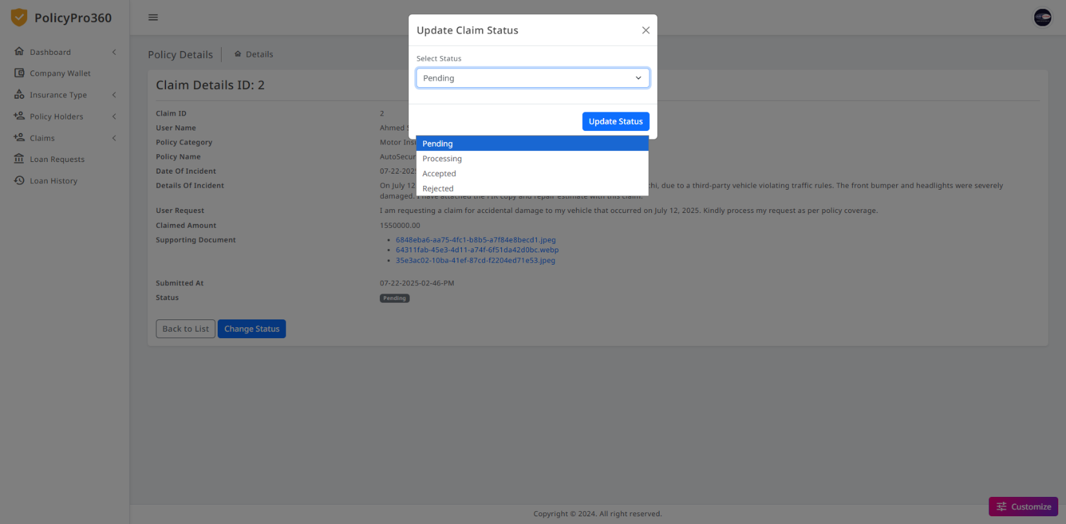

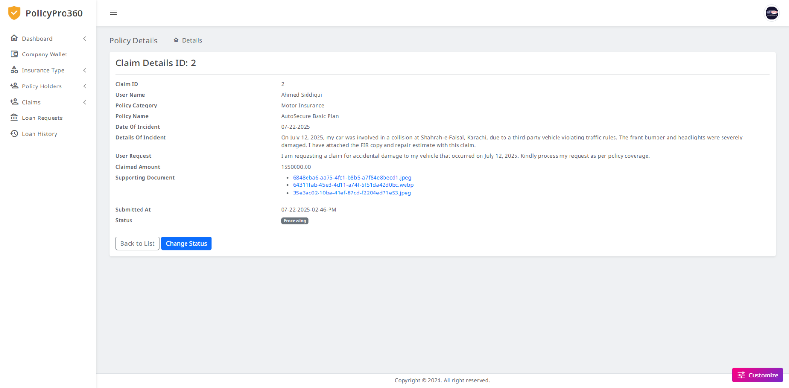

### **Company User Pending Loans**

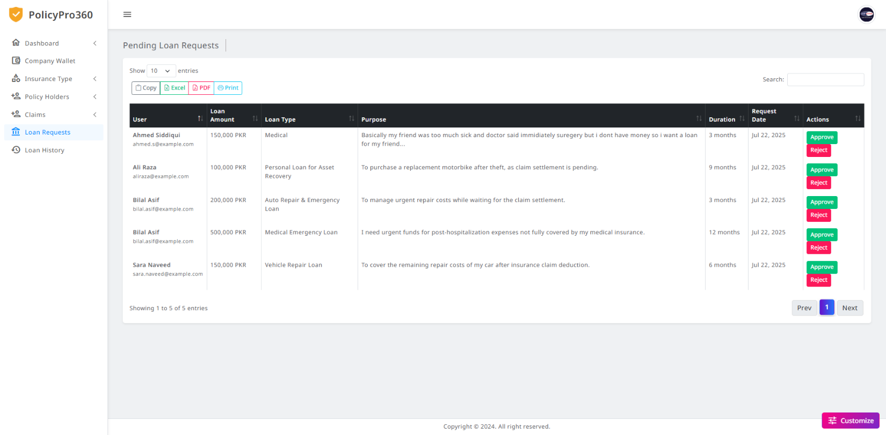

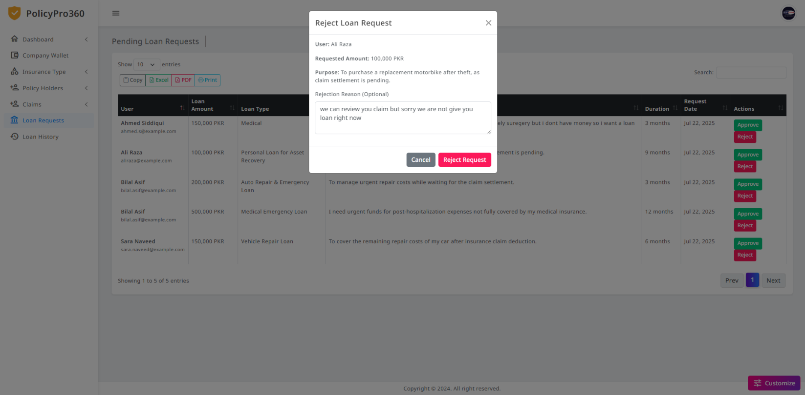

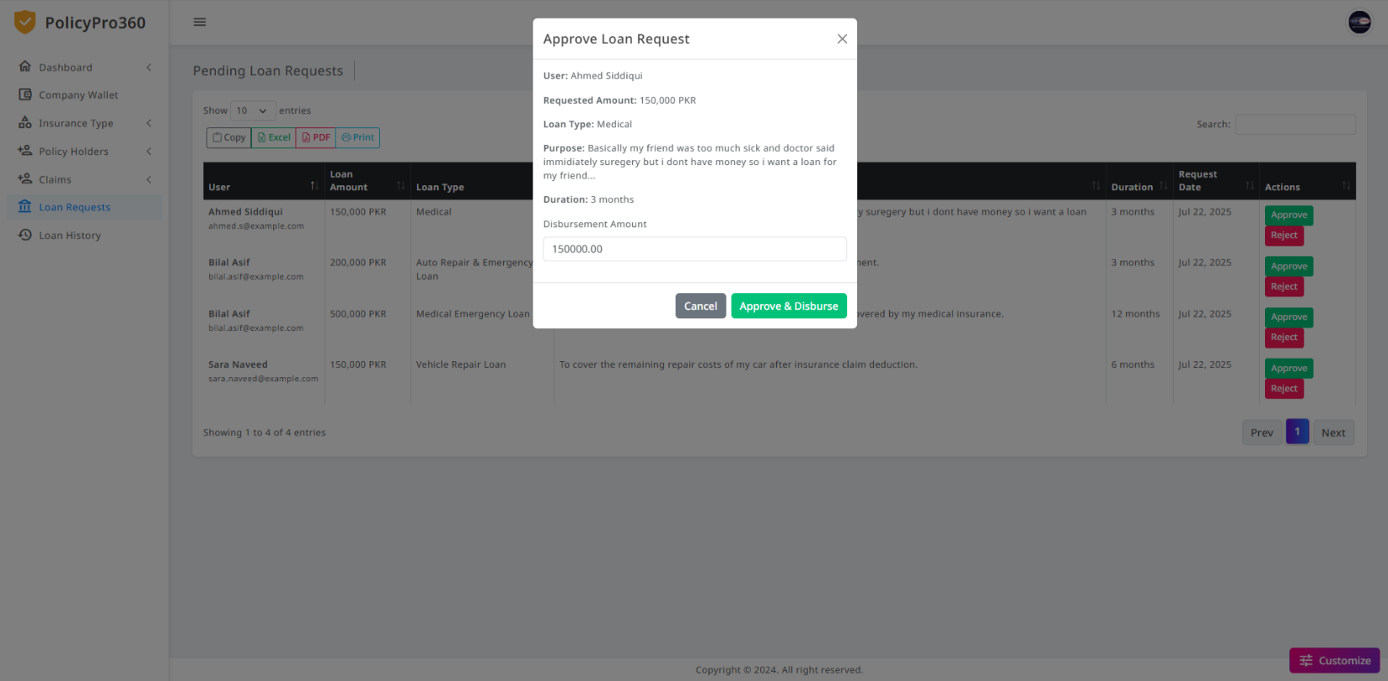

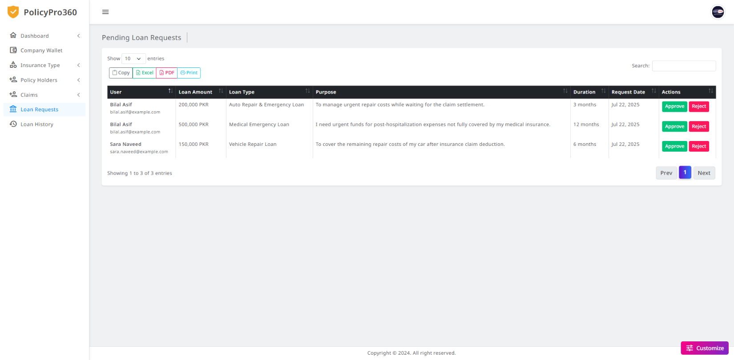

### **Company User Loan History**

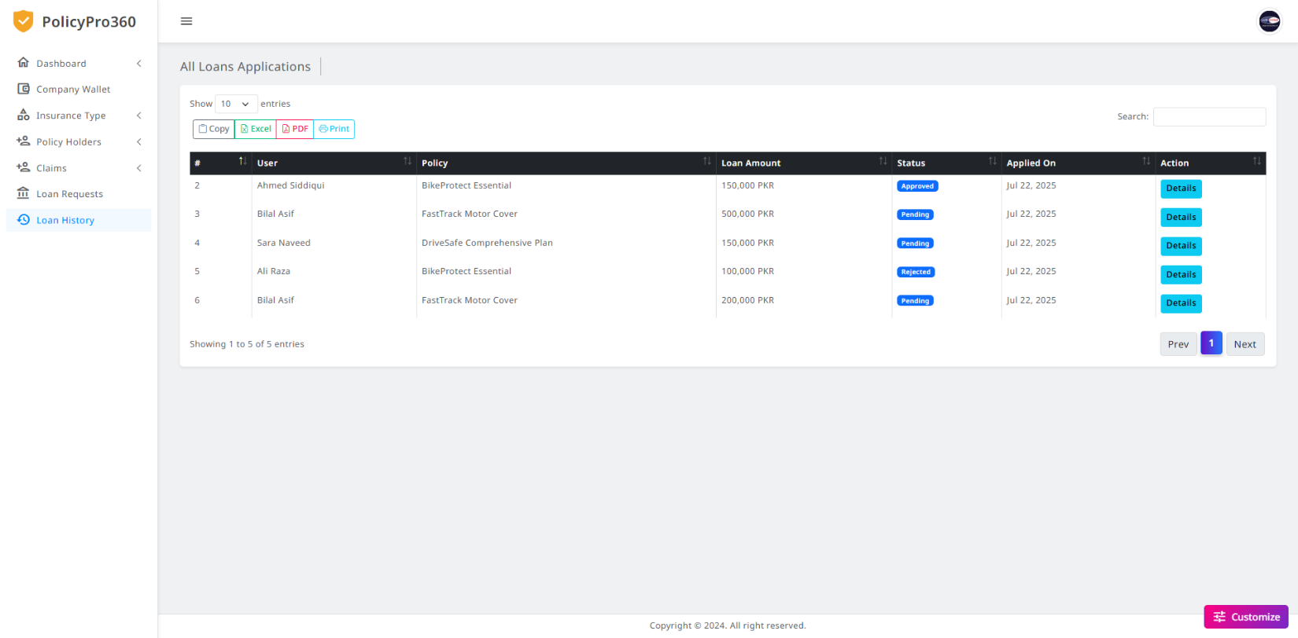

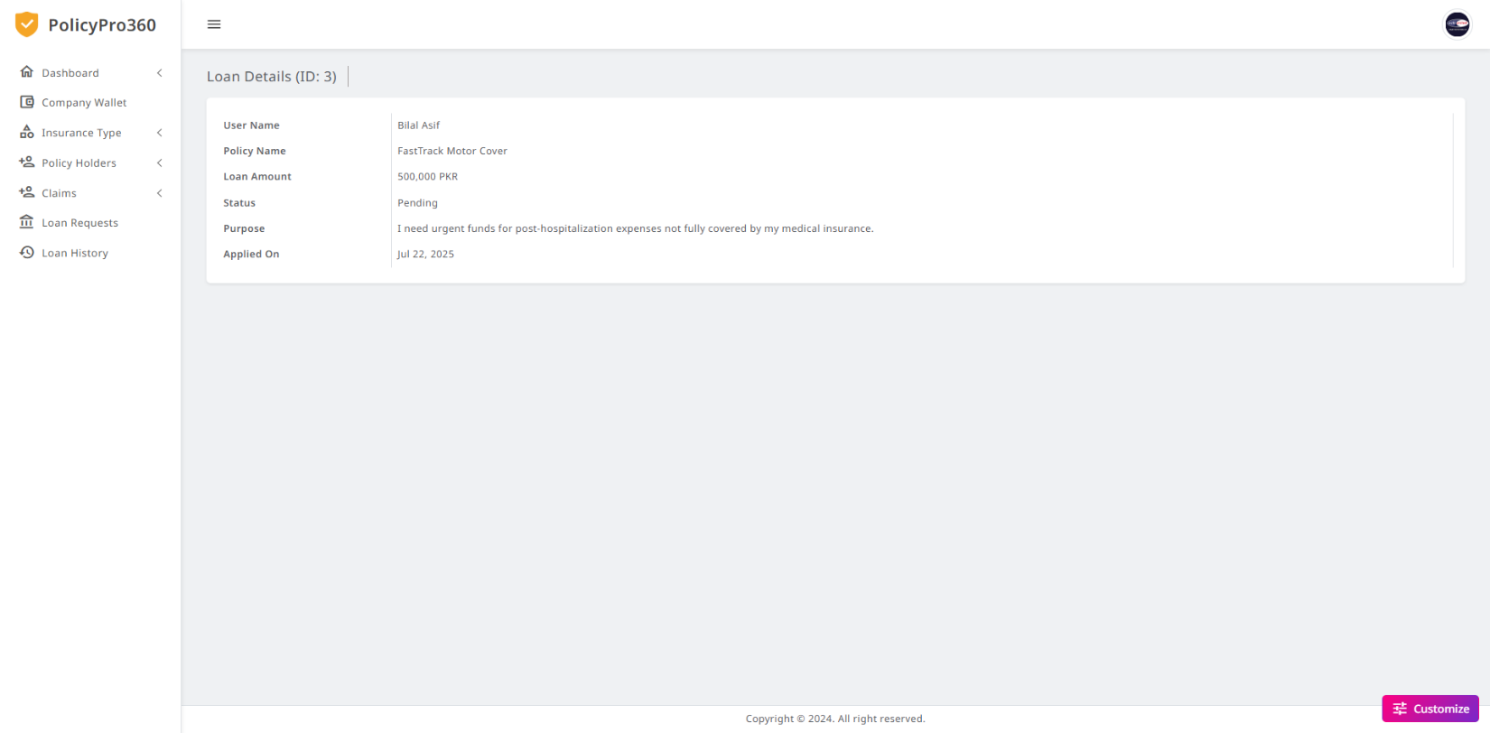

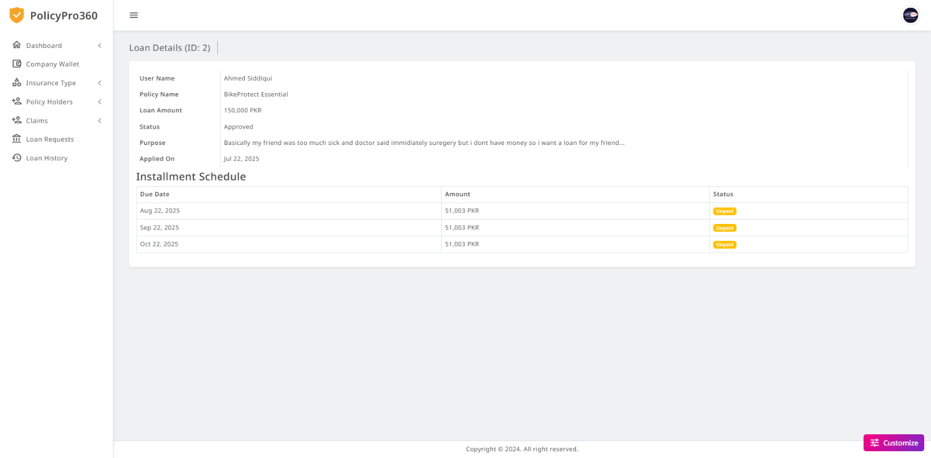

### **Company Profile**

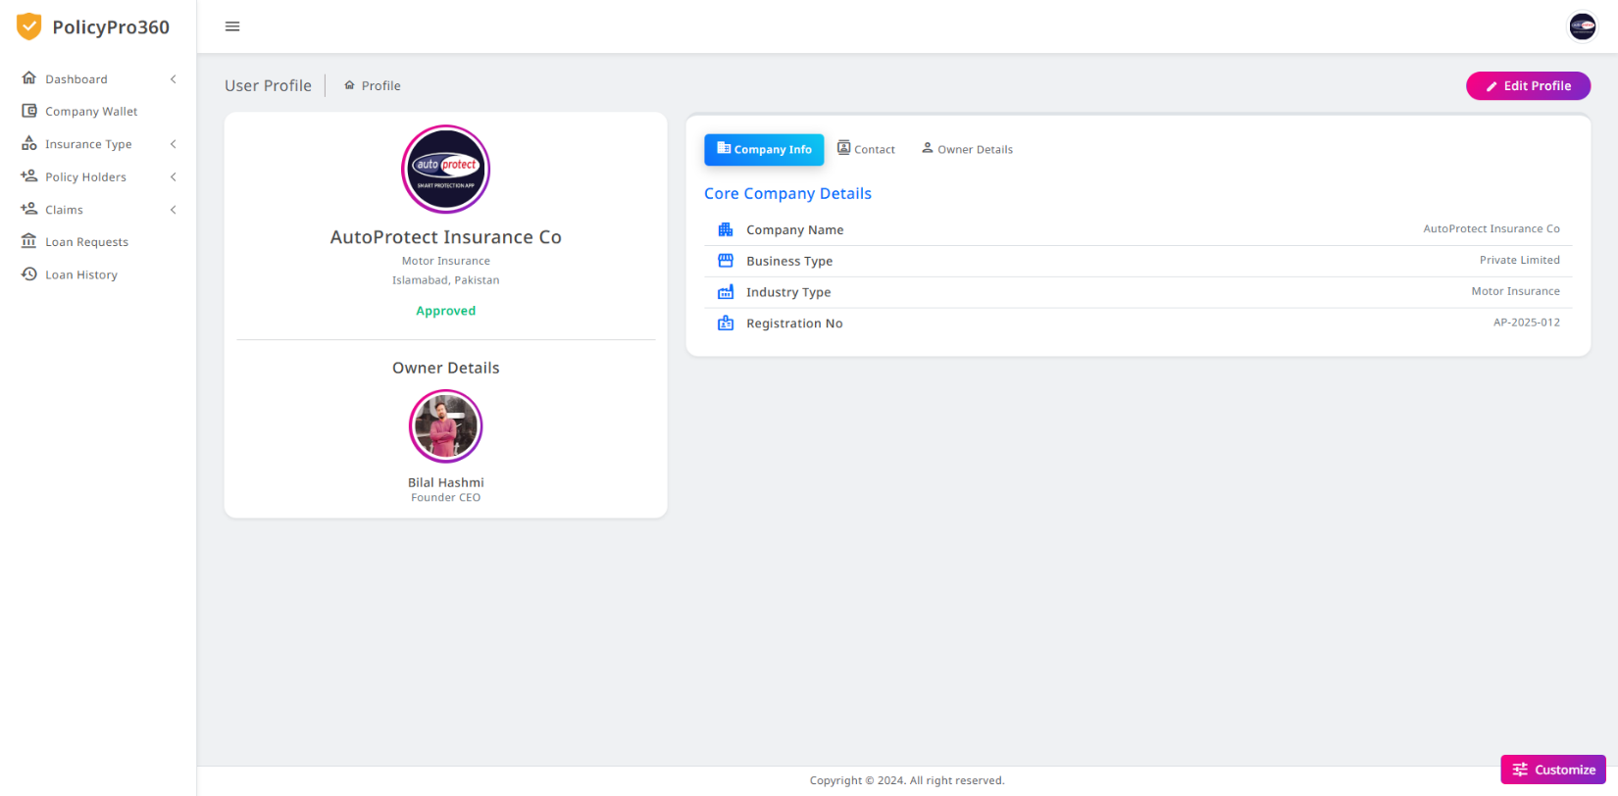

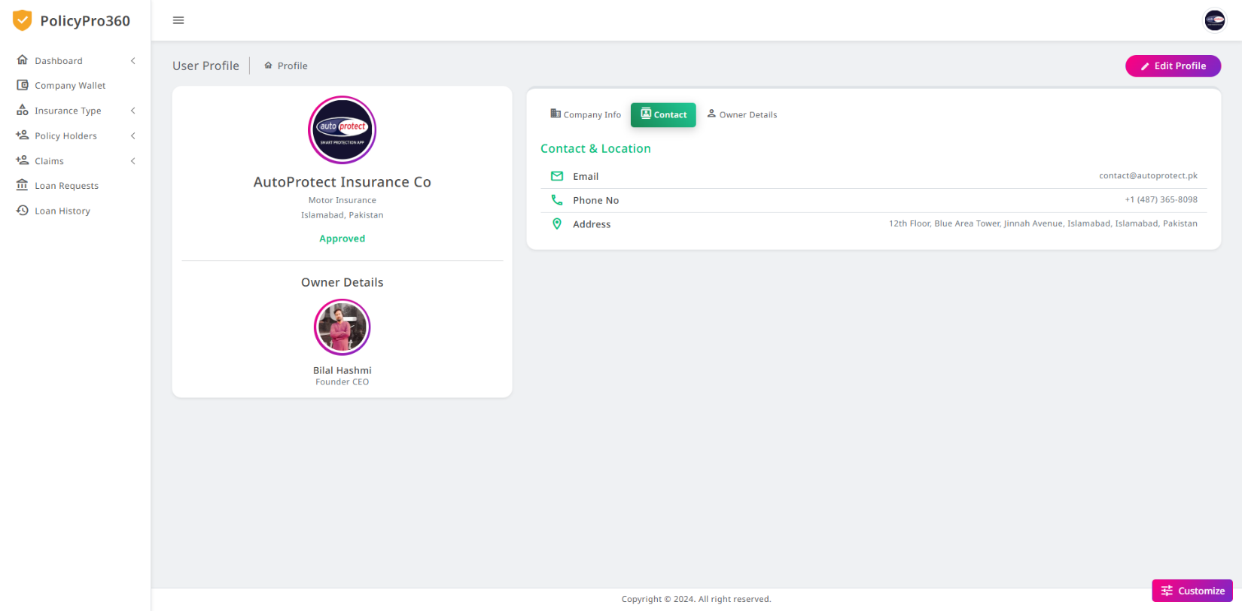

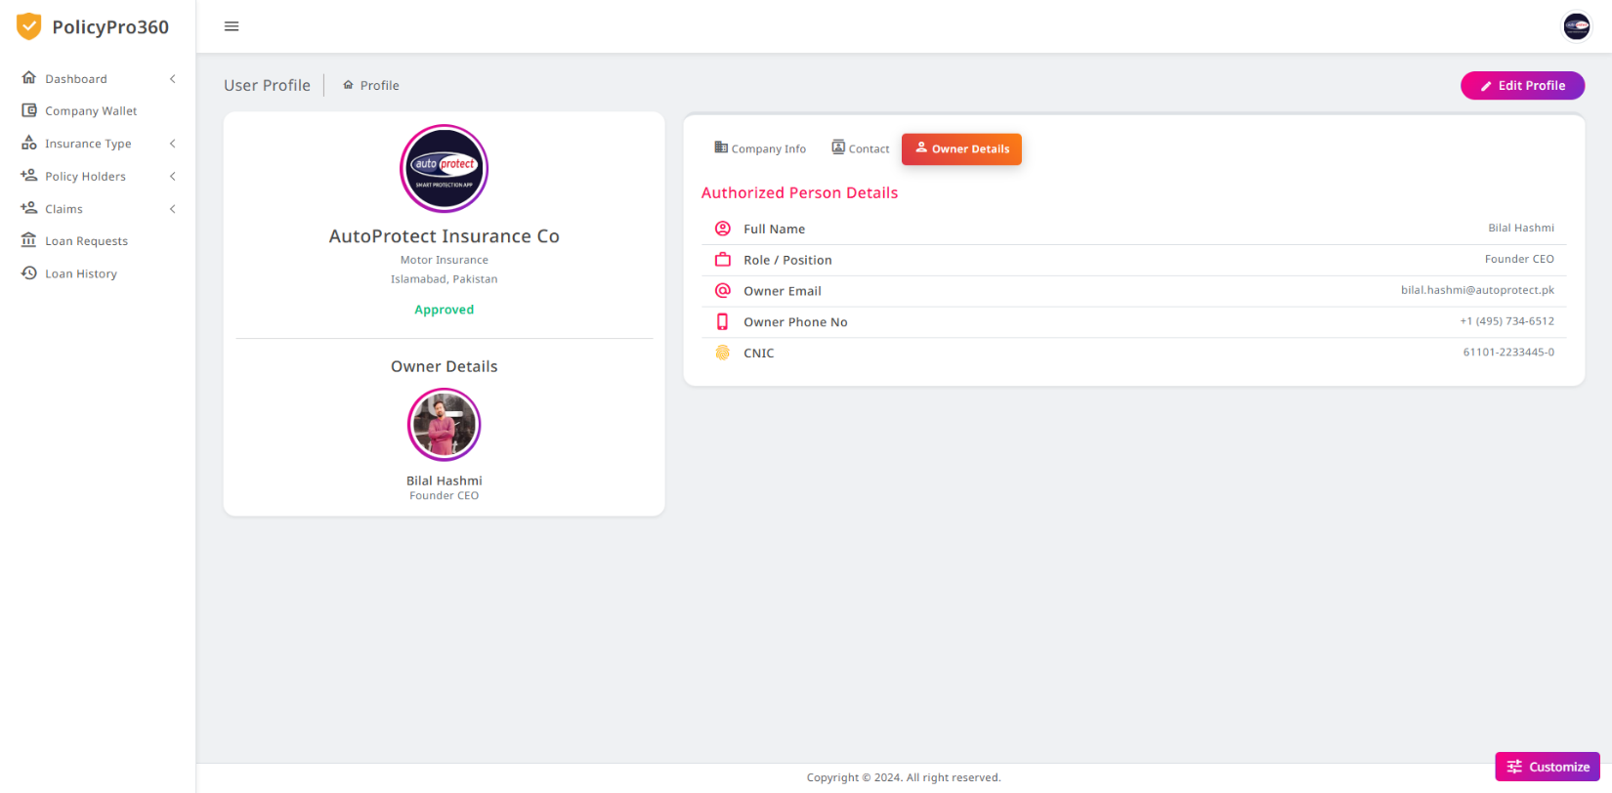

### **Company Edit Profile**

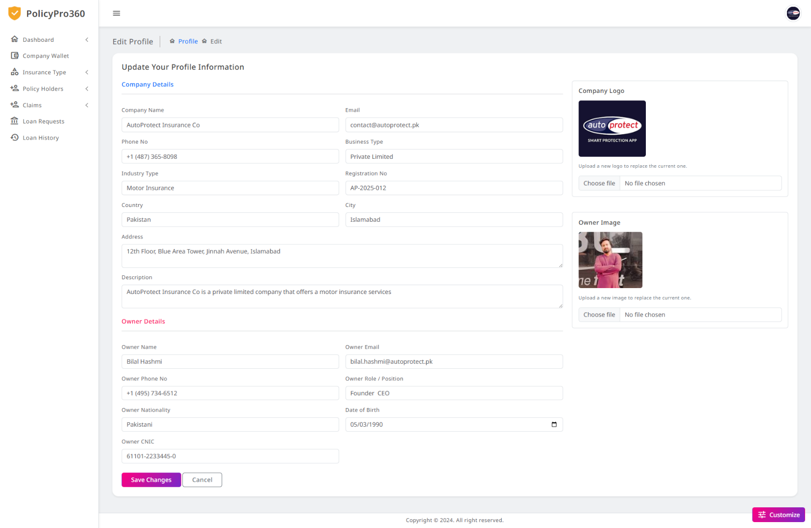

### **Company Logout**



### **Admin Login**

**Admin Dashboard**

### **Admin Register**

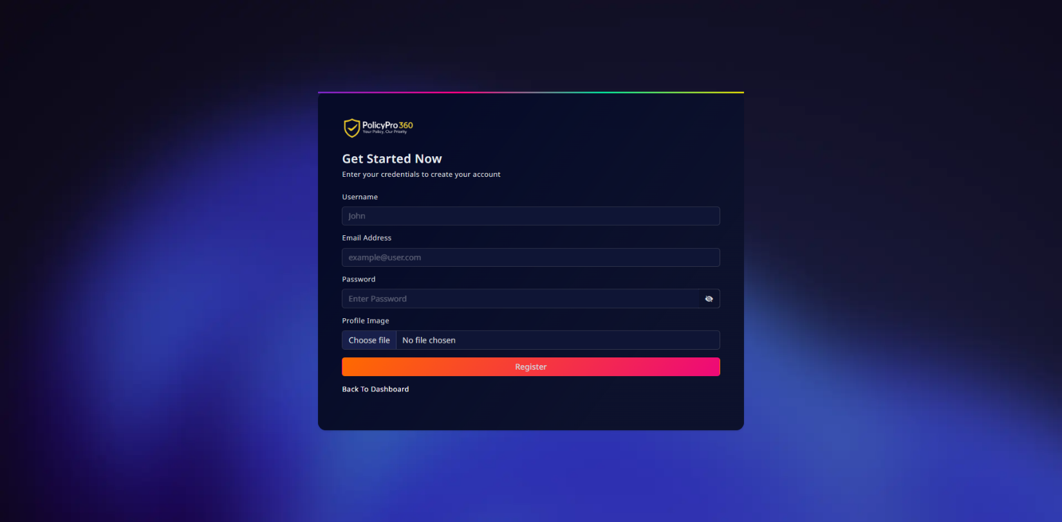

### **Admin Wallet**

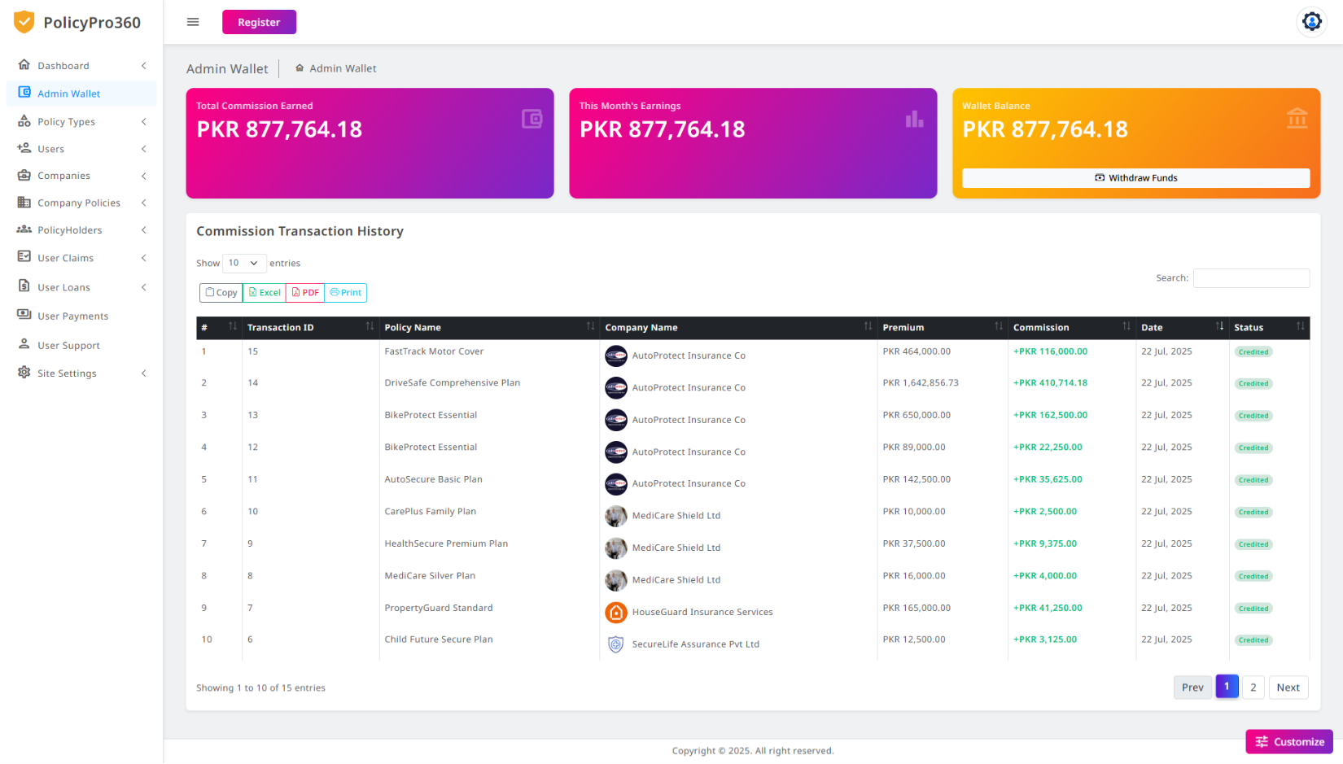

### **Admin Policy Category**

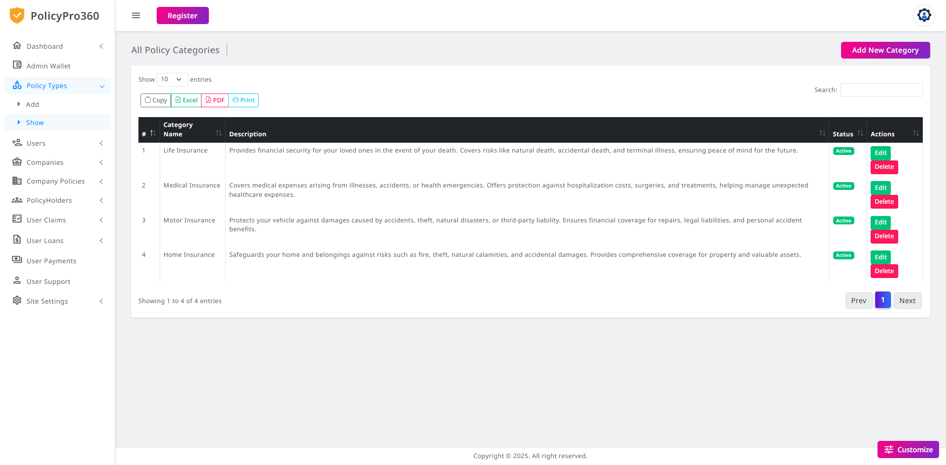

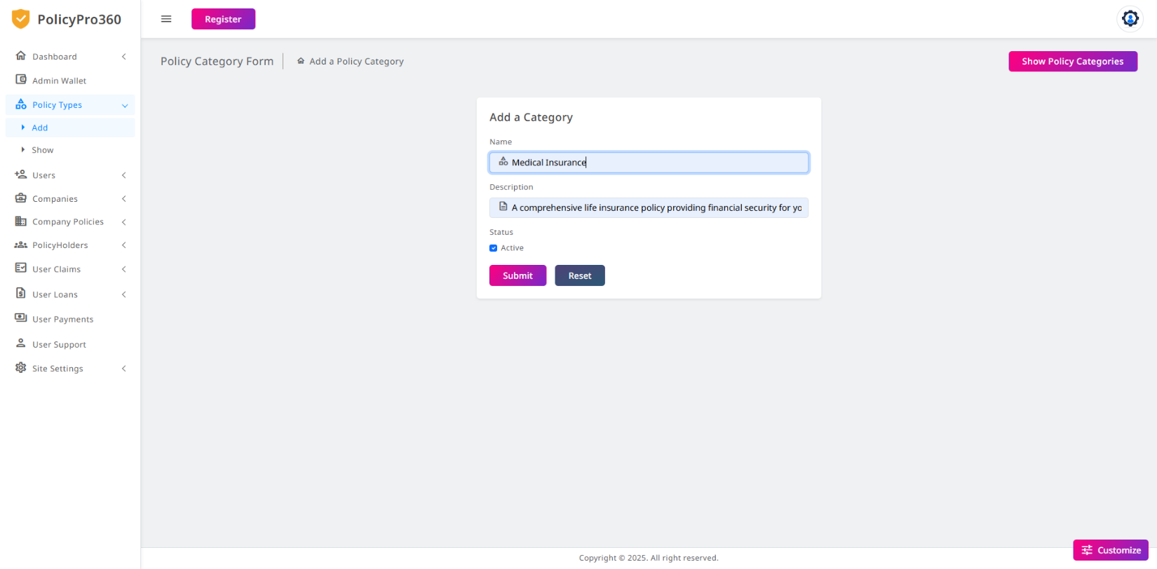

### **Admin Companies**

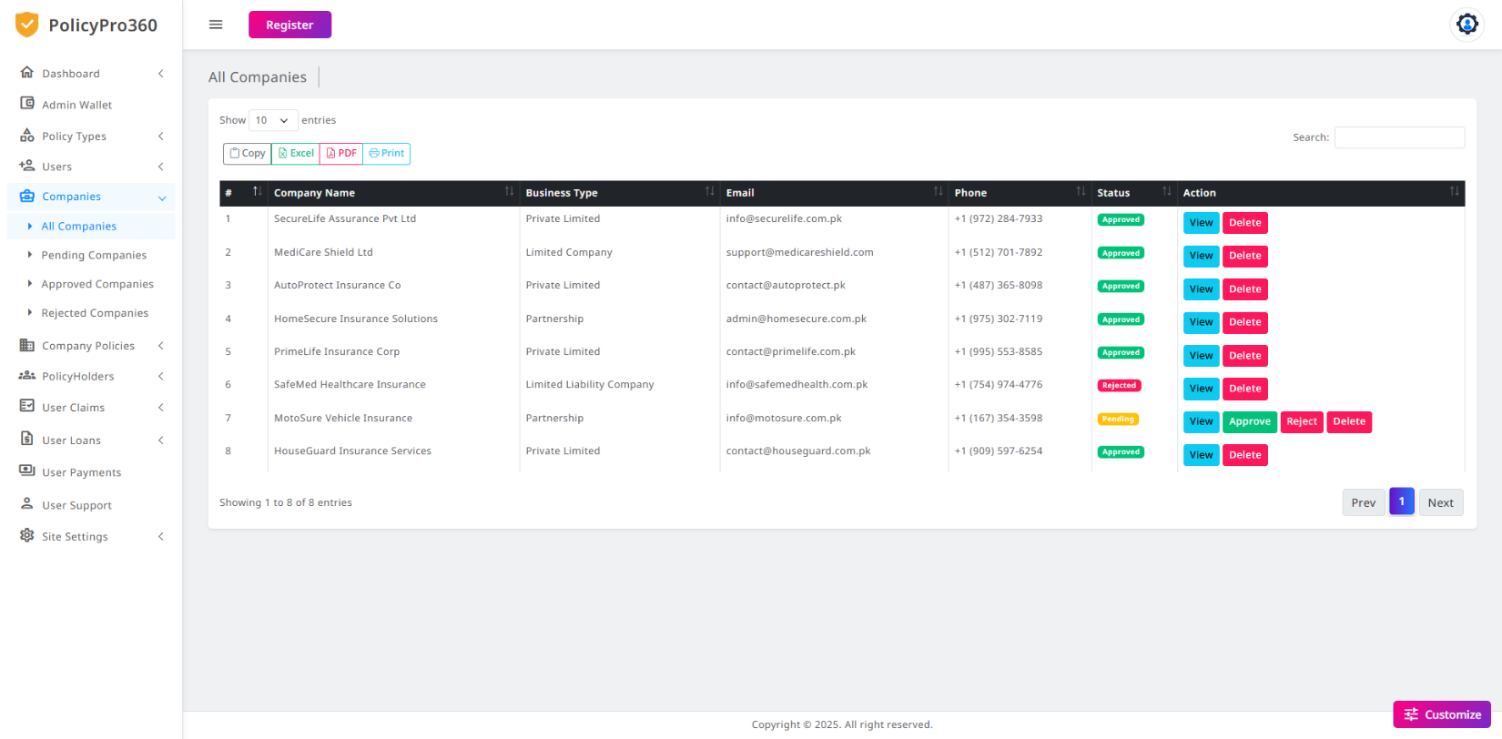

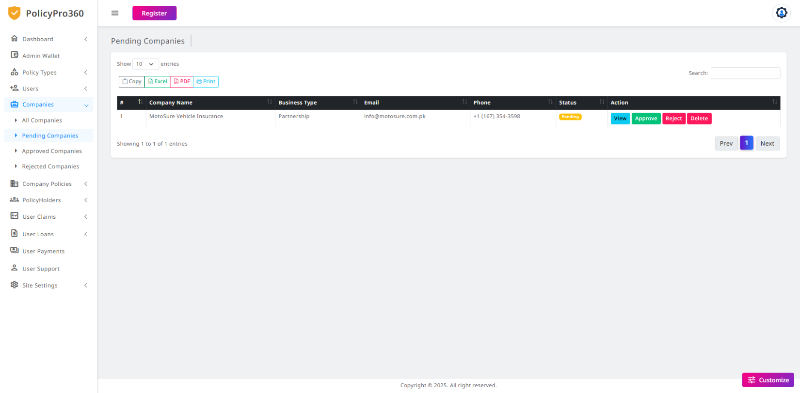

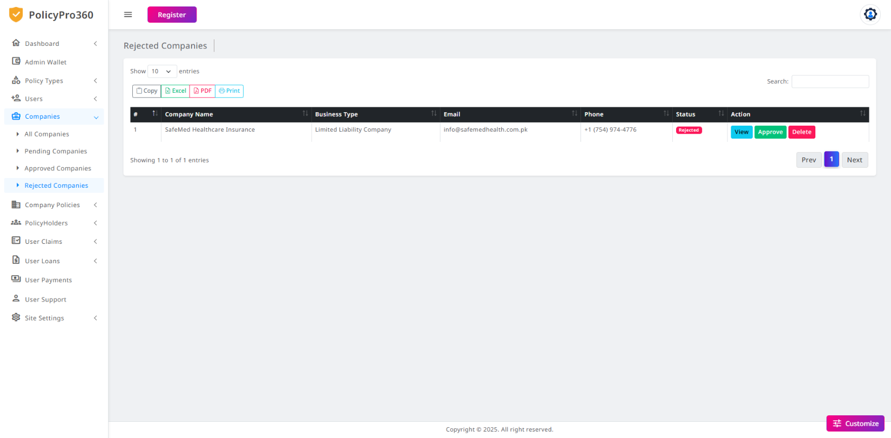

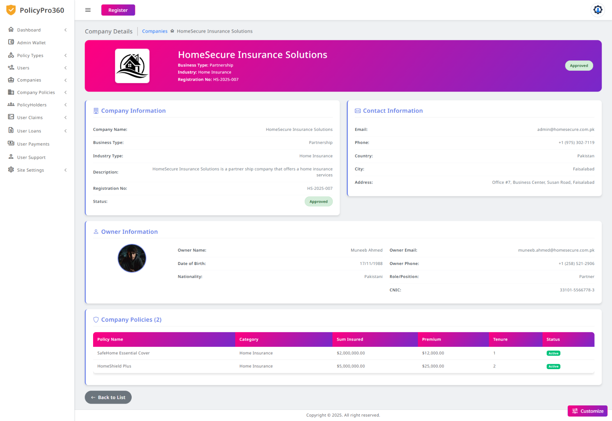

### **Admin Company Policies**

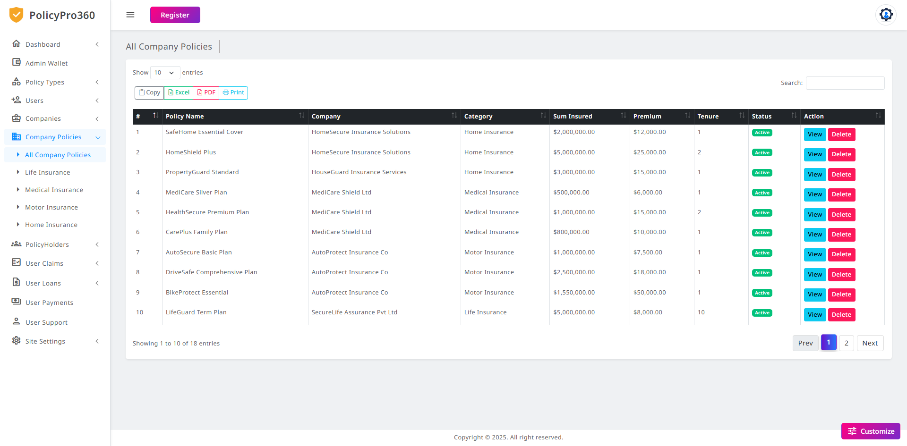

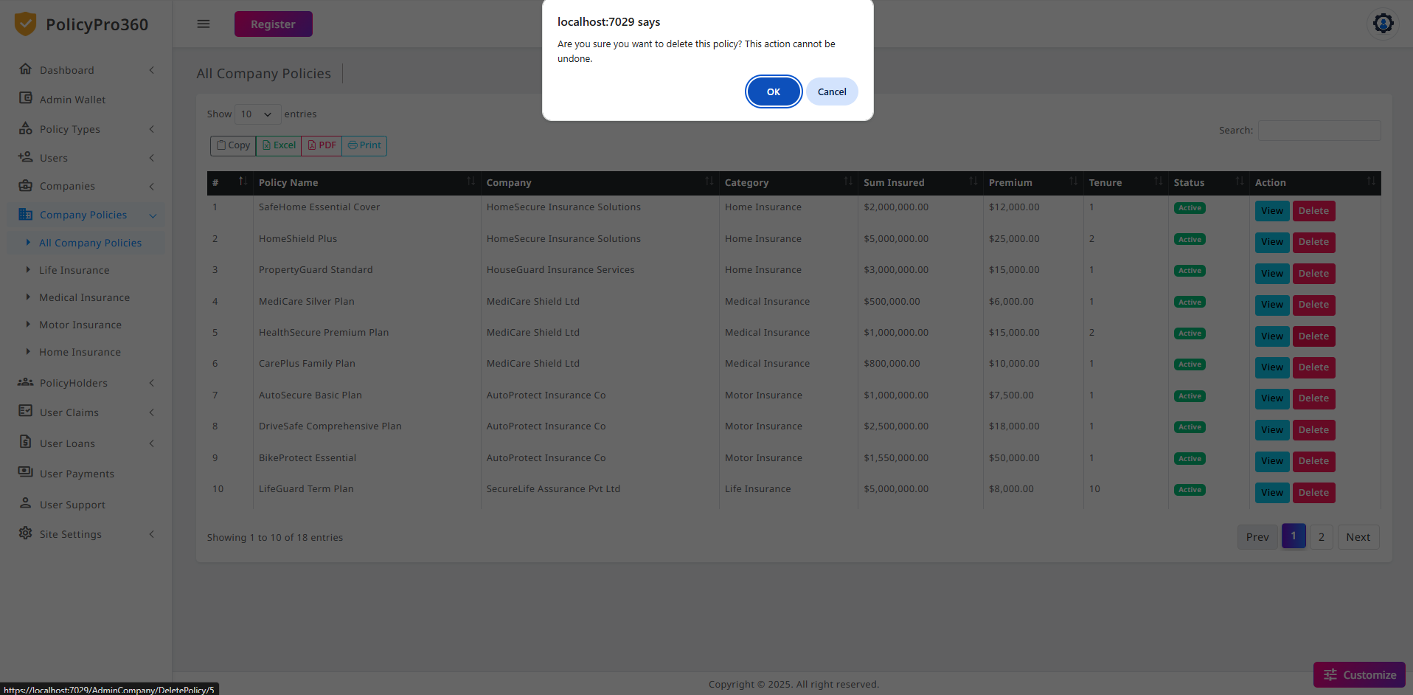

### **Admin Company Policy View**

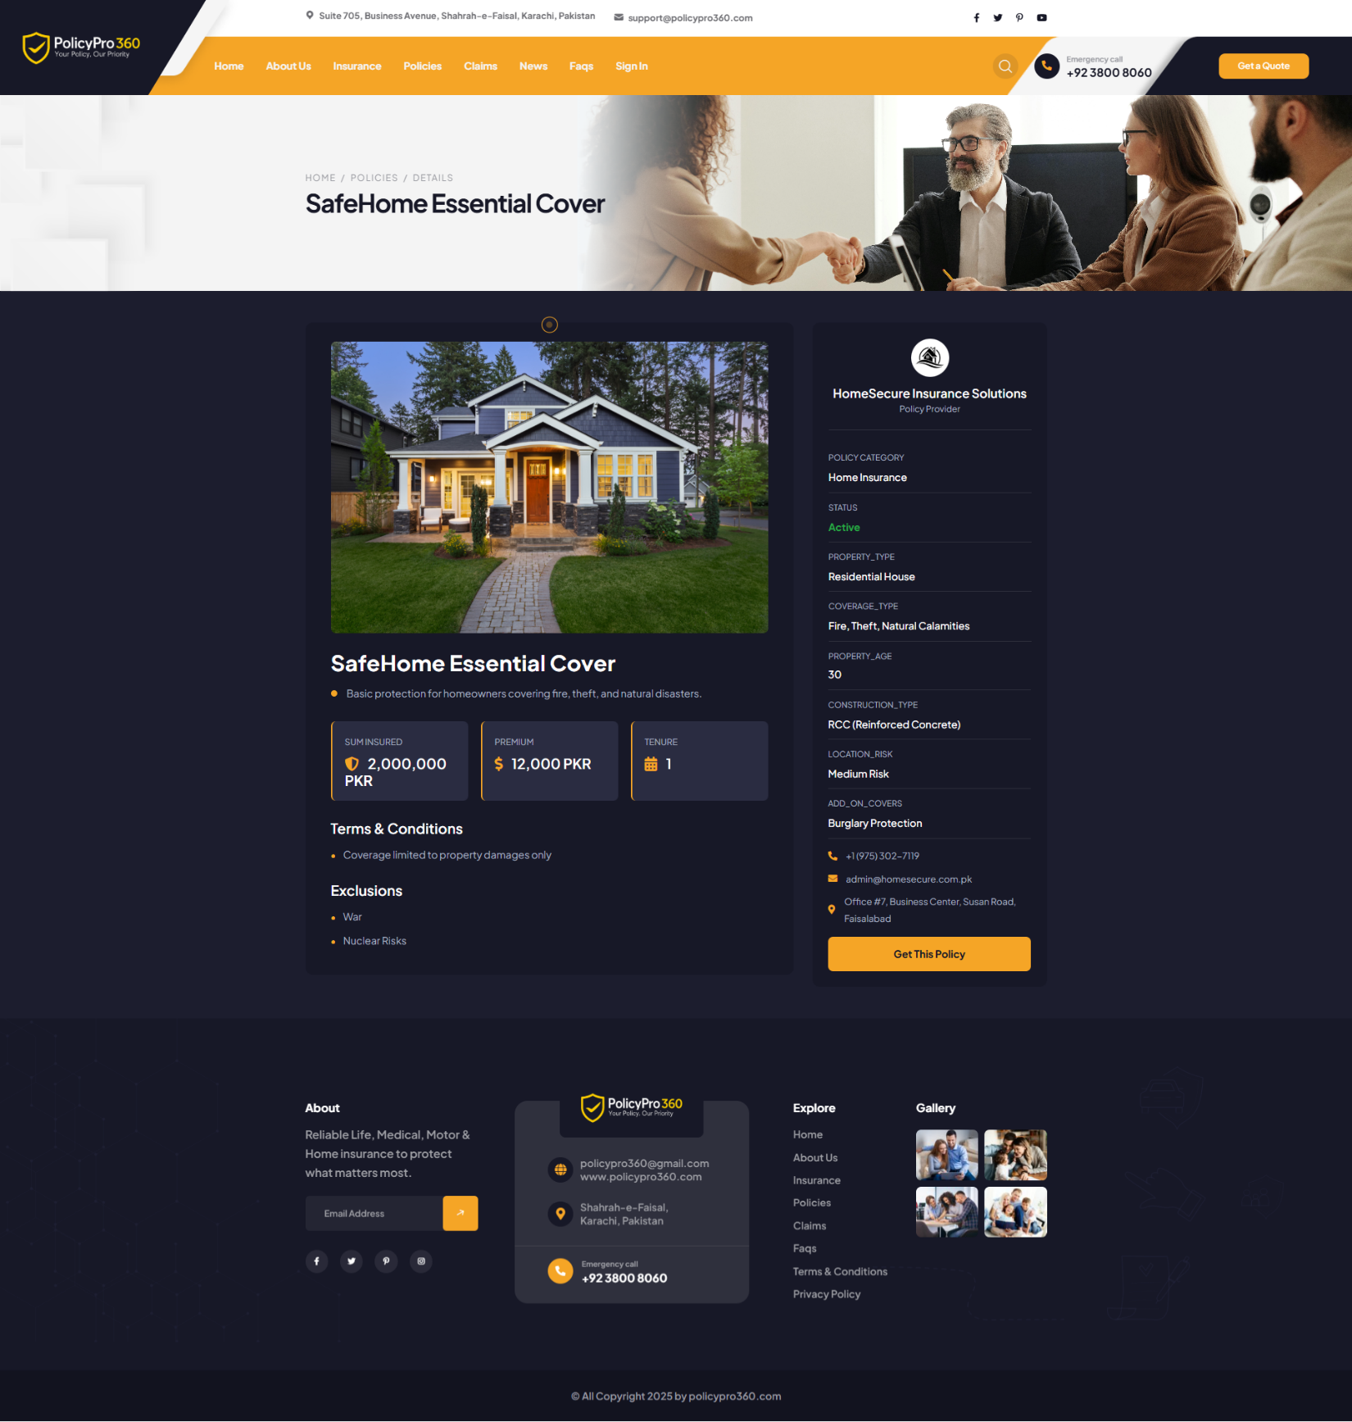

### **Admin User All Policyholders**

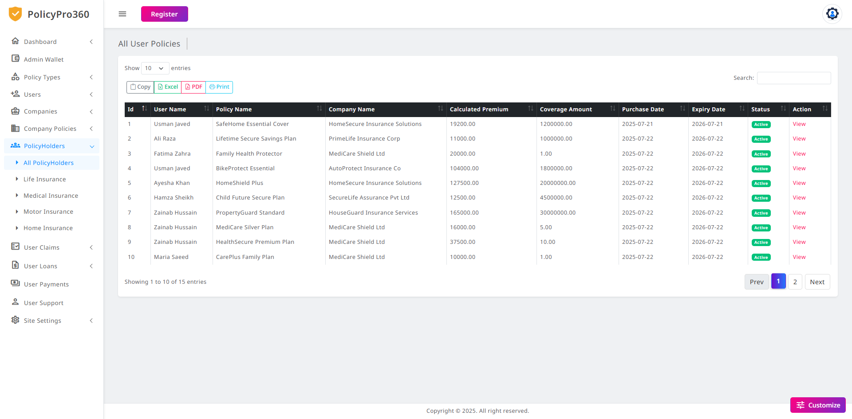

### **Admin User Claims**

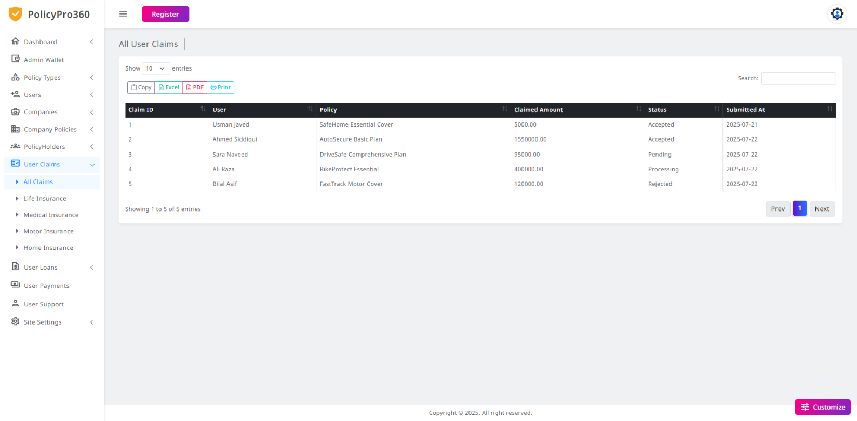

### **Admin User Loans**

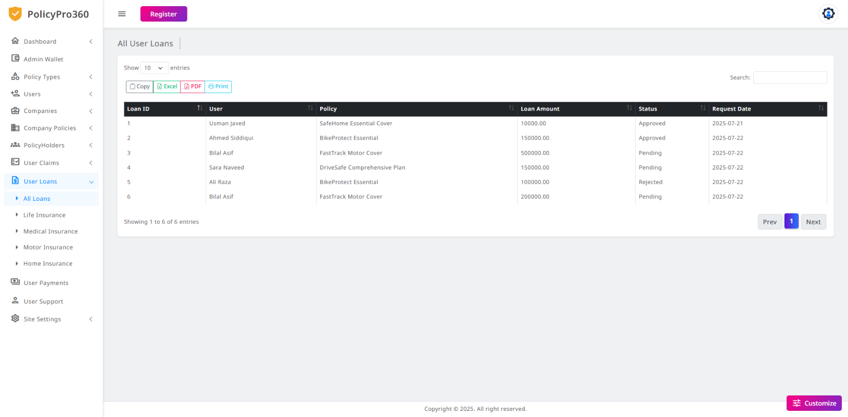

### **Admin User Payments**

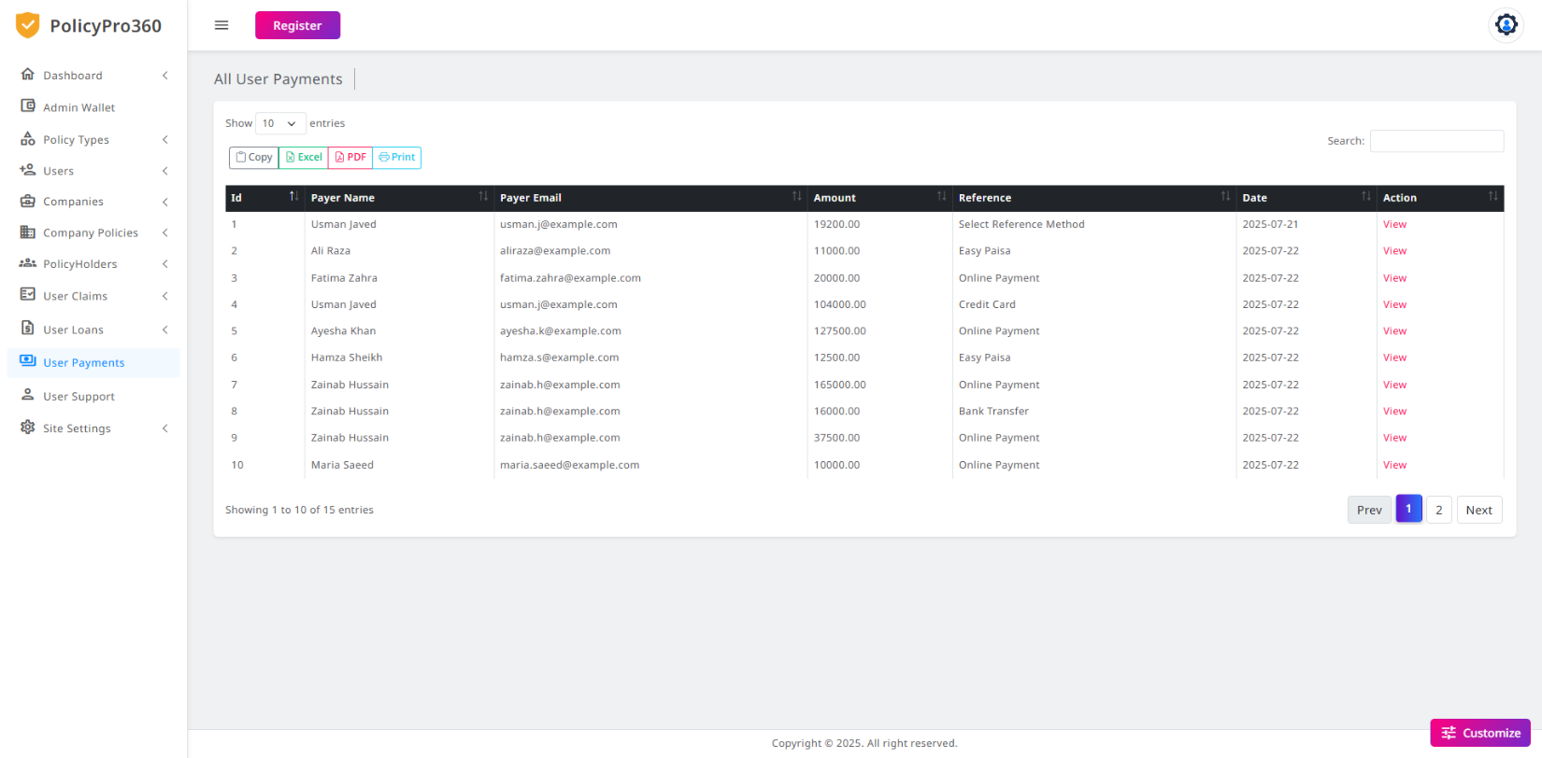

### **Admin User Supports**

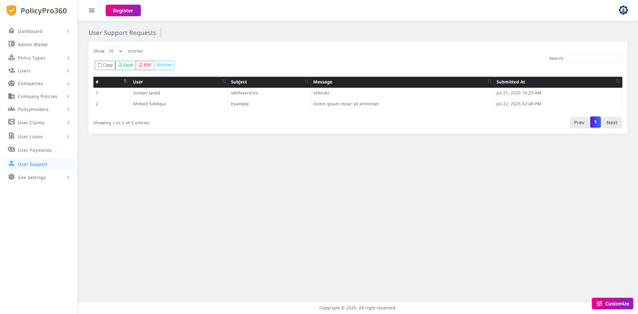

### **Admin Site Settings – FAQs**

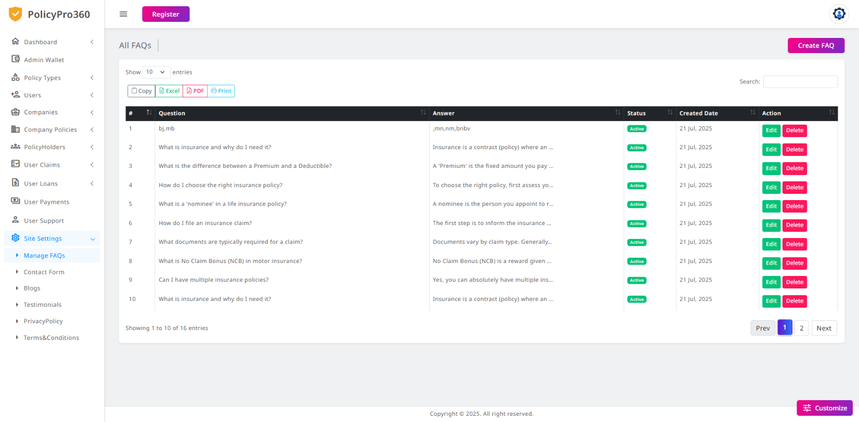

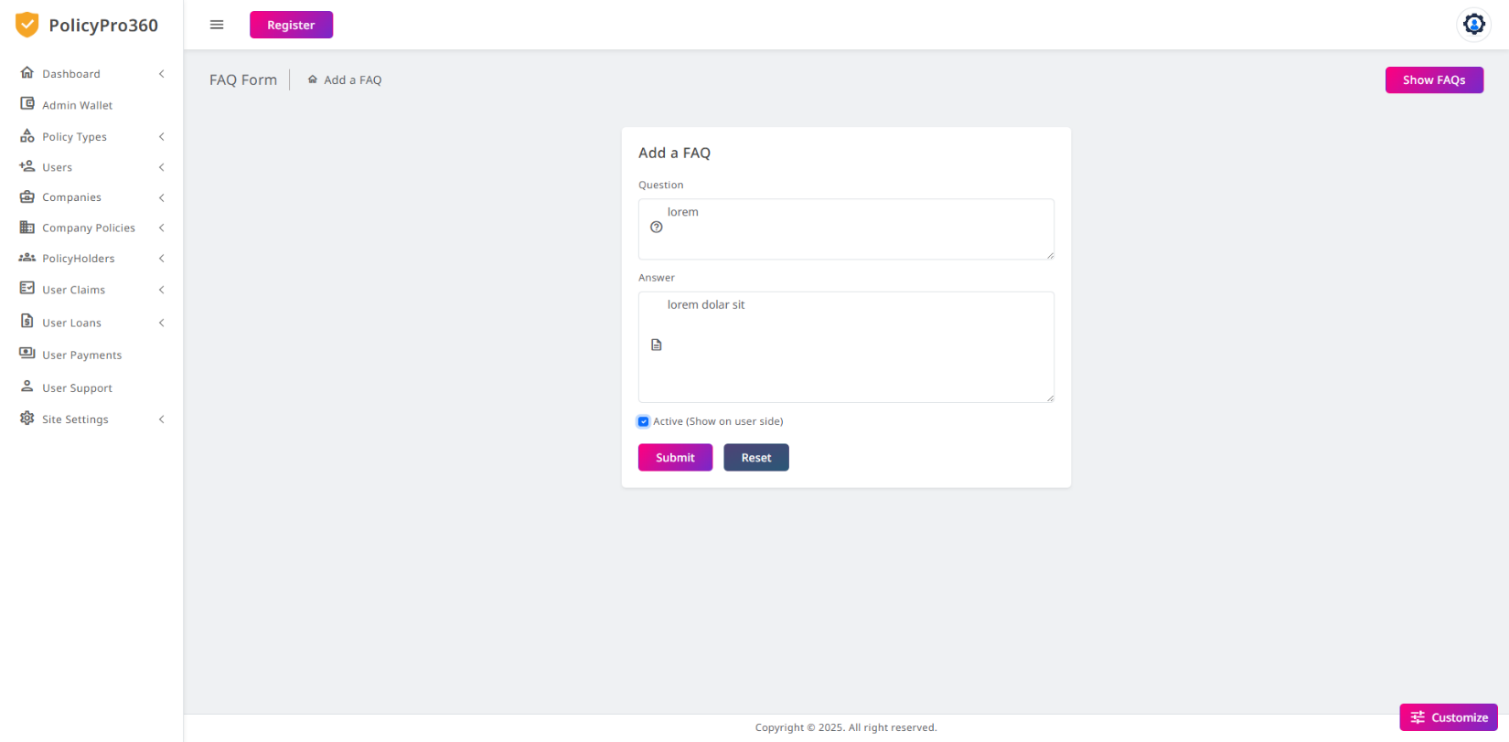

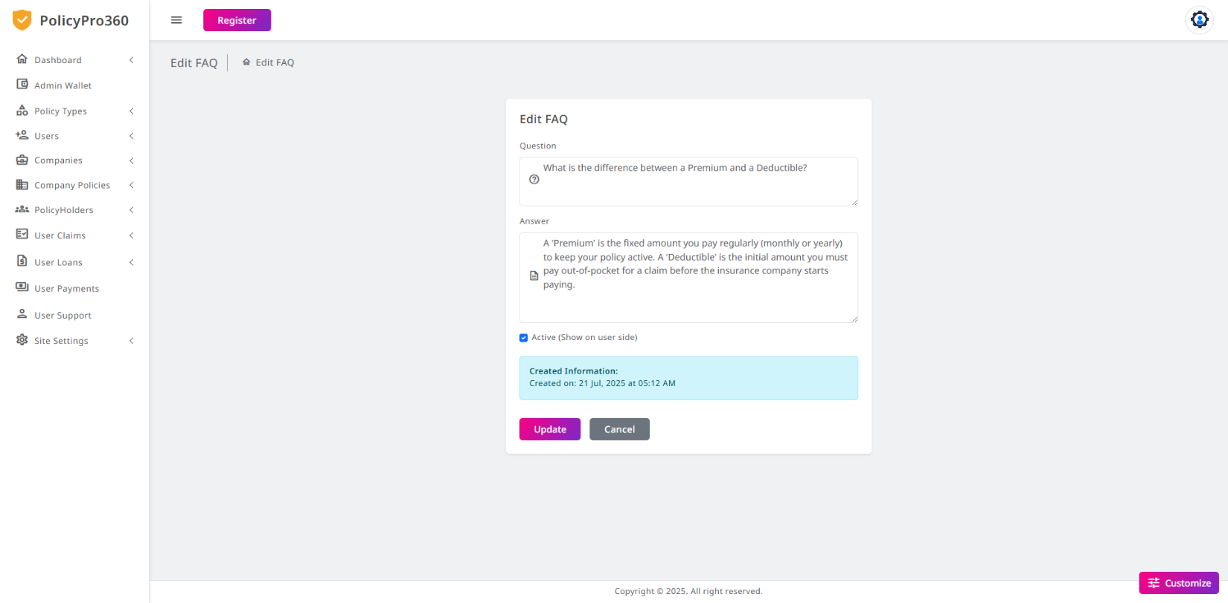

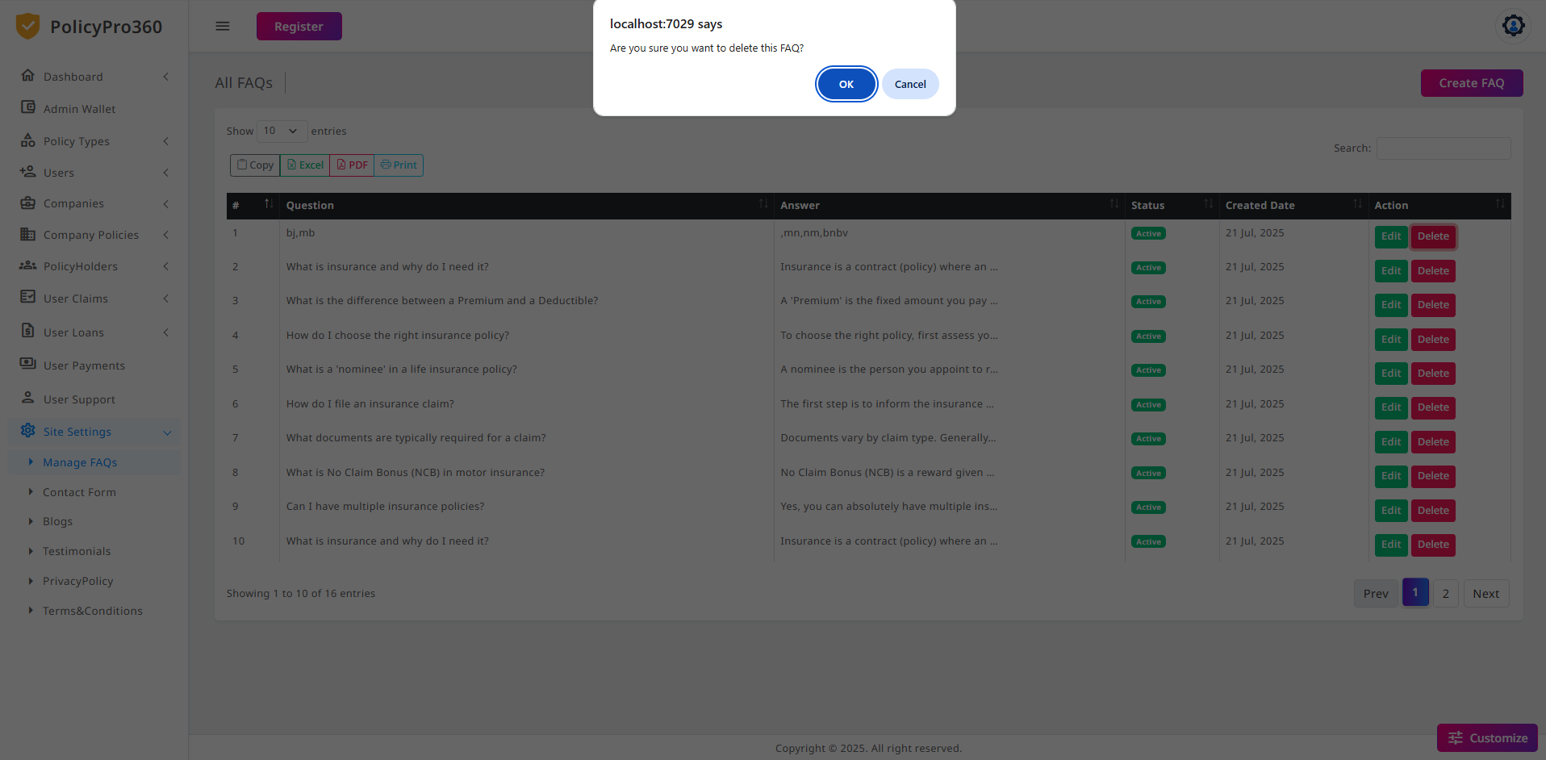

### **Admin Site Settings – Contact Form**

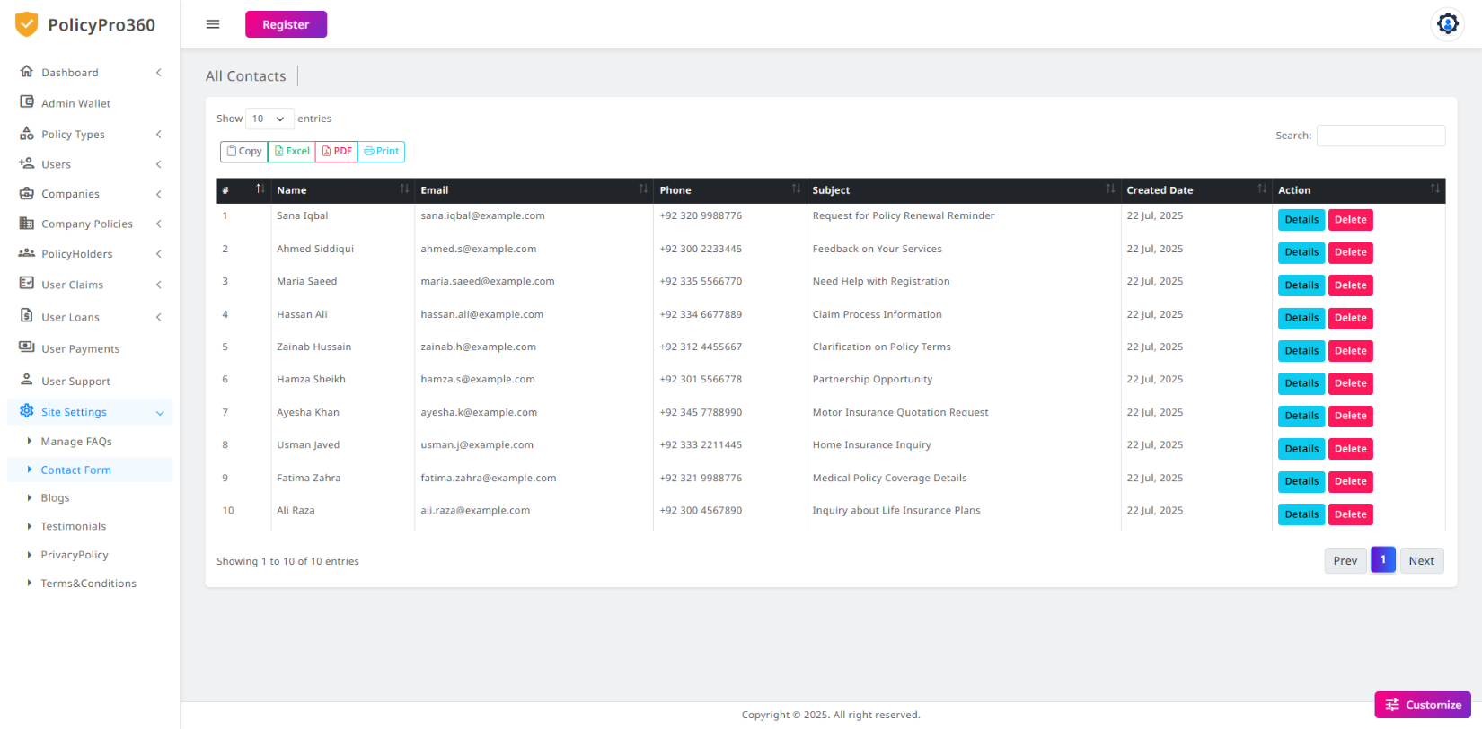

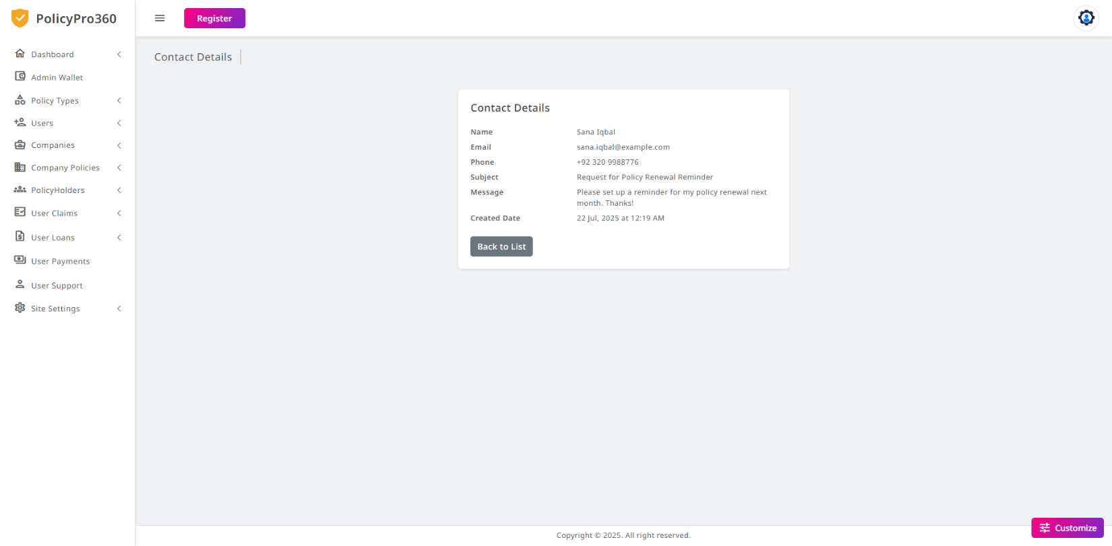

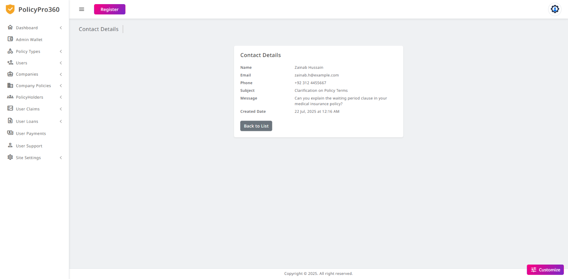

### **Admin Site Settings – Contact Form**

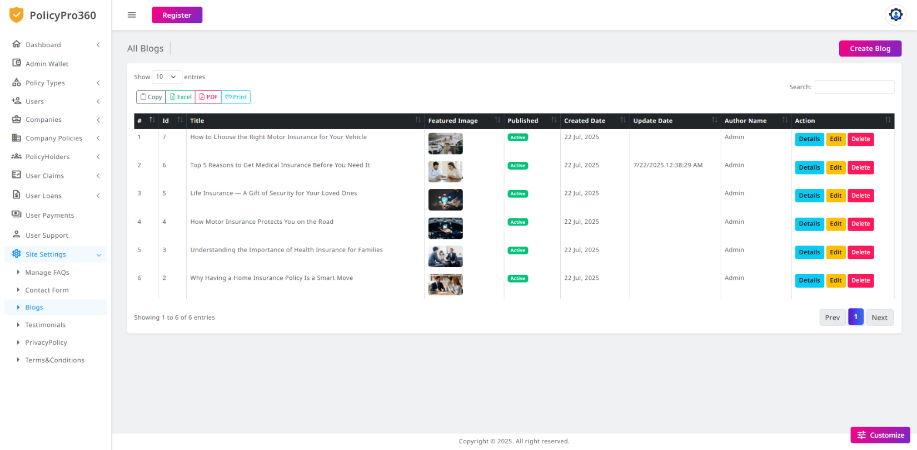

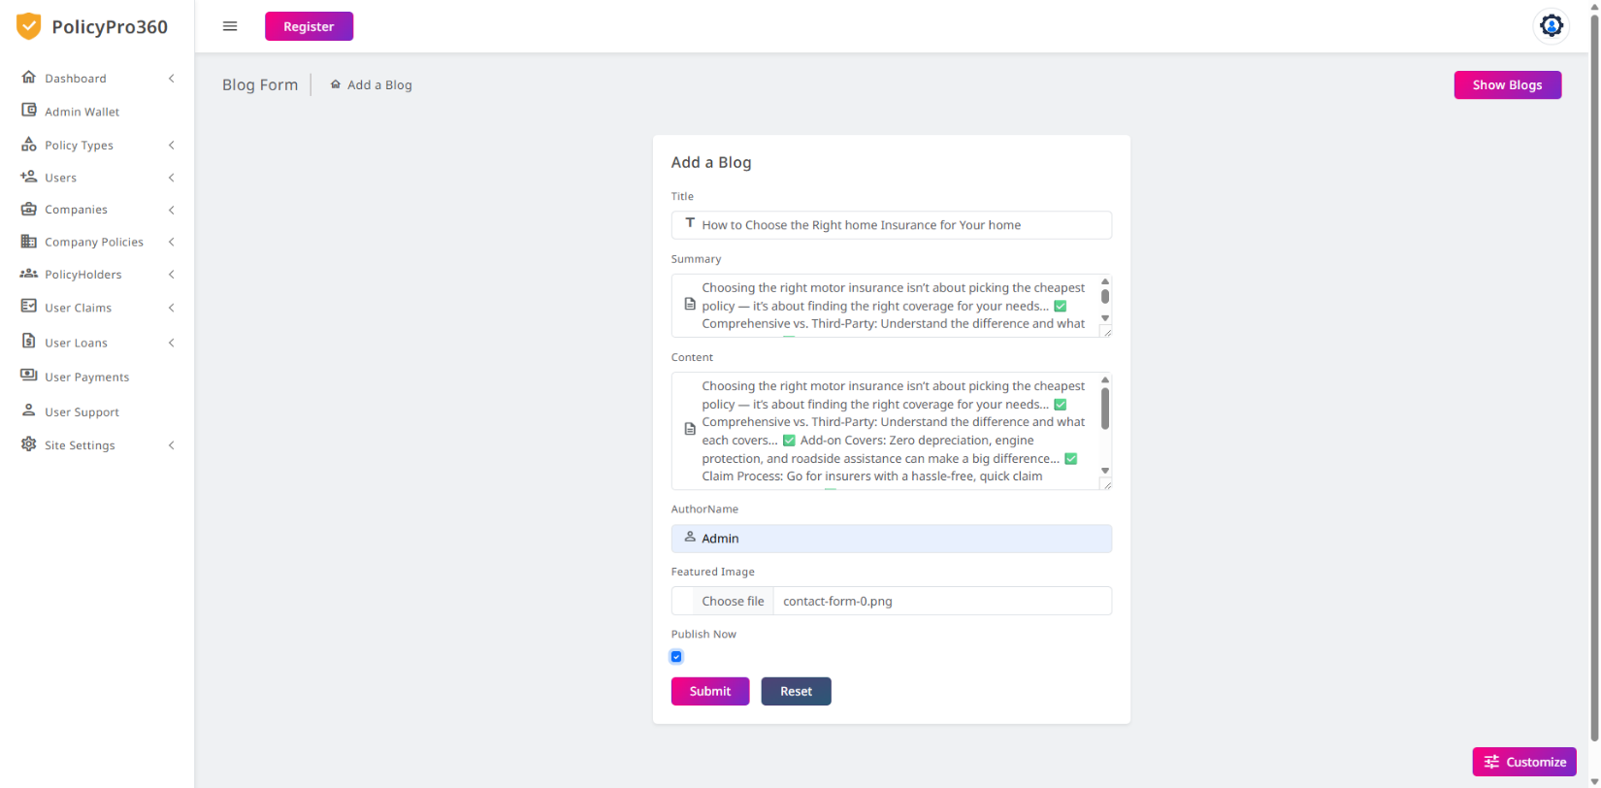

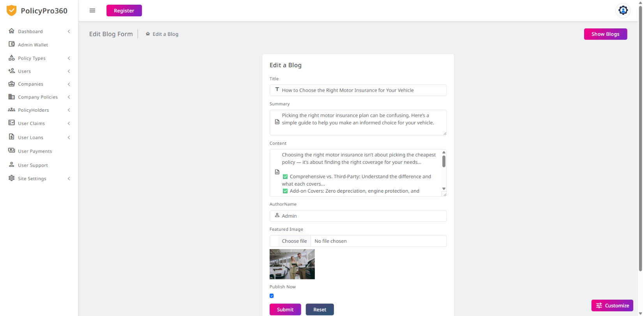

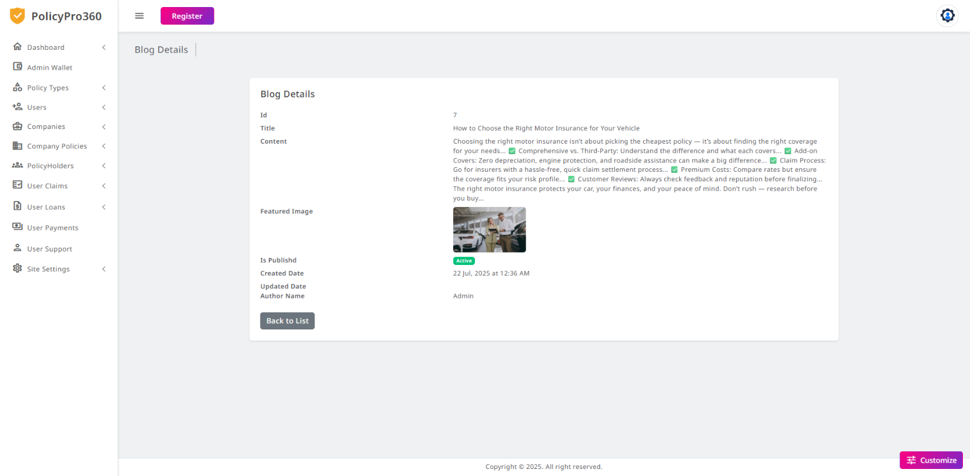

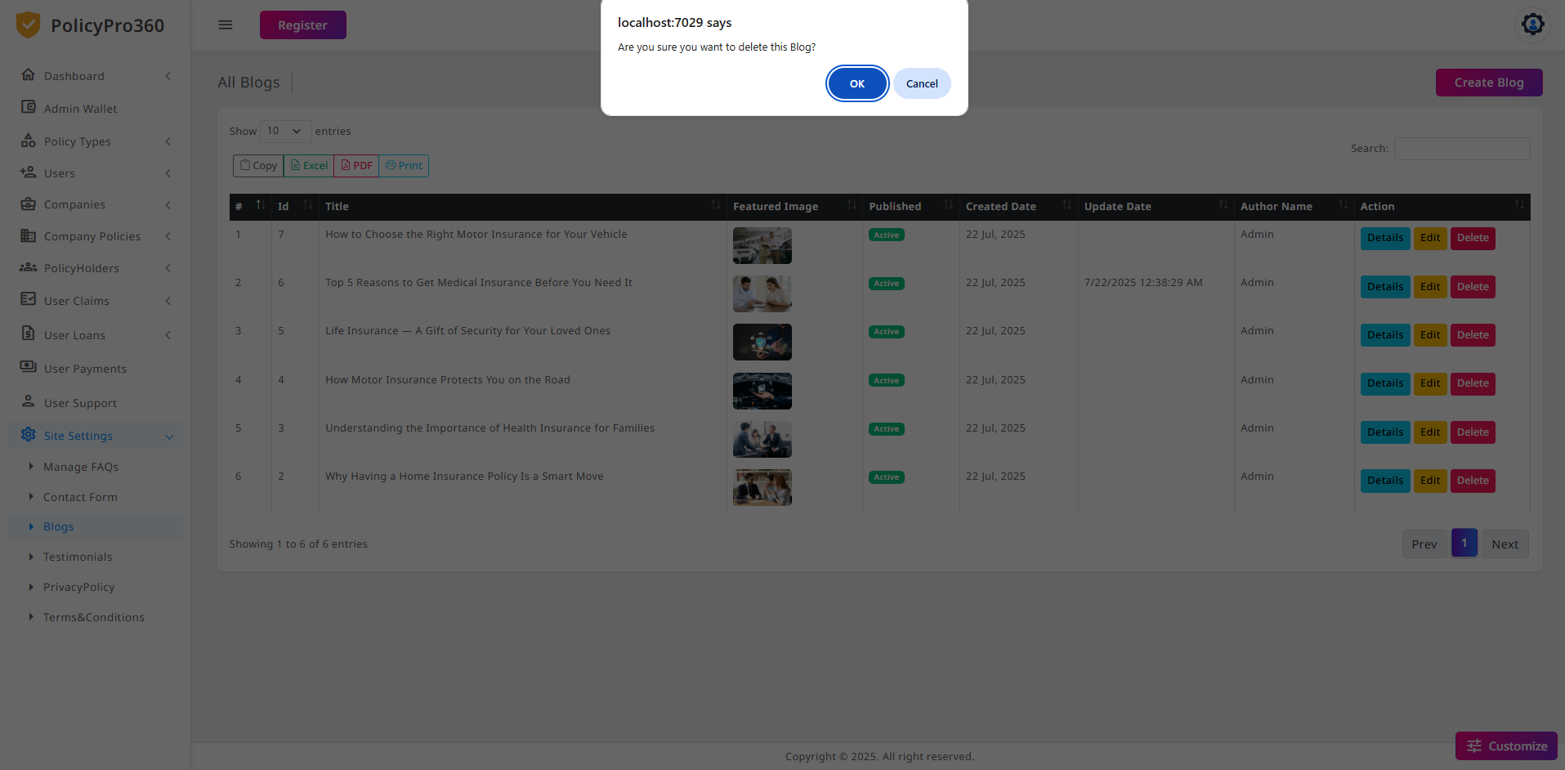

### **A screenshot of a computer AI-generated content may be incorrect.Admin Site Settings – Terms and Conditions**

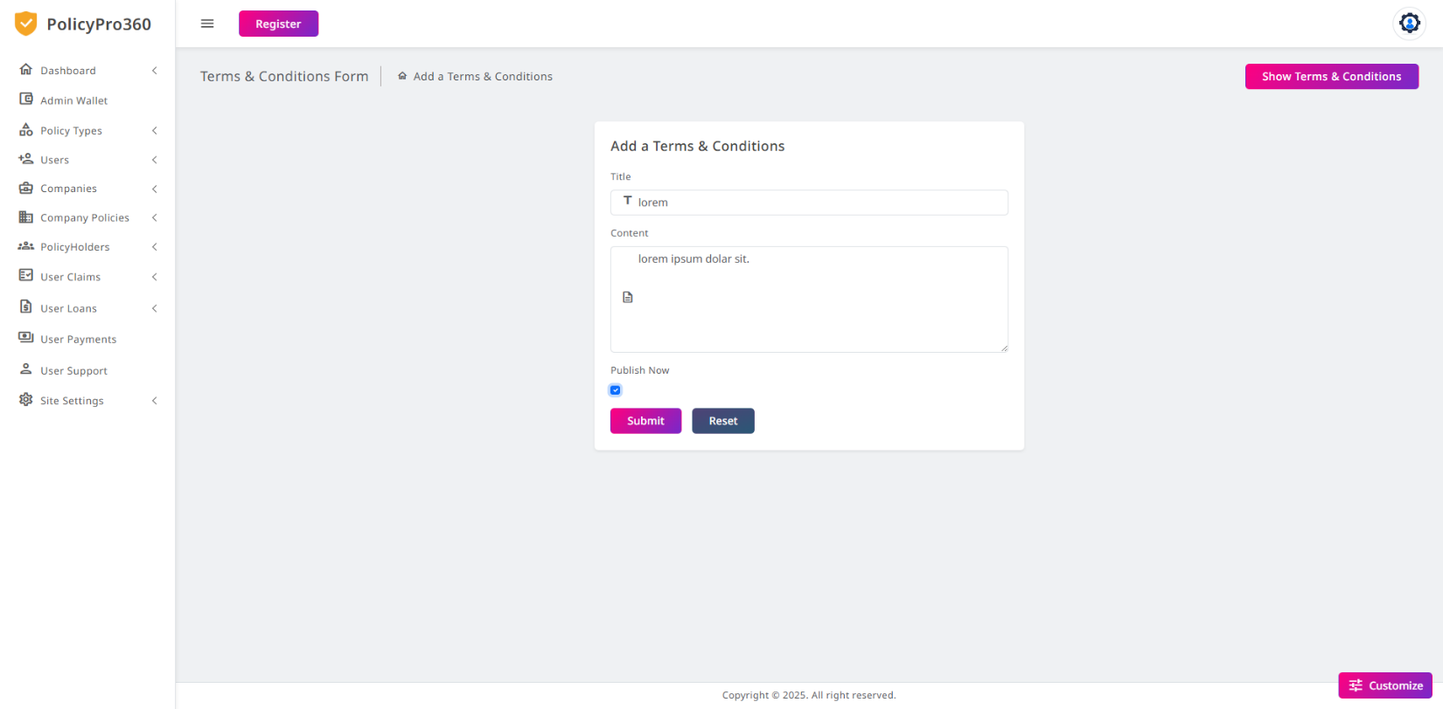

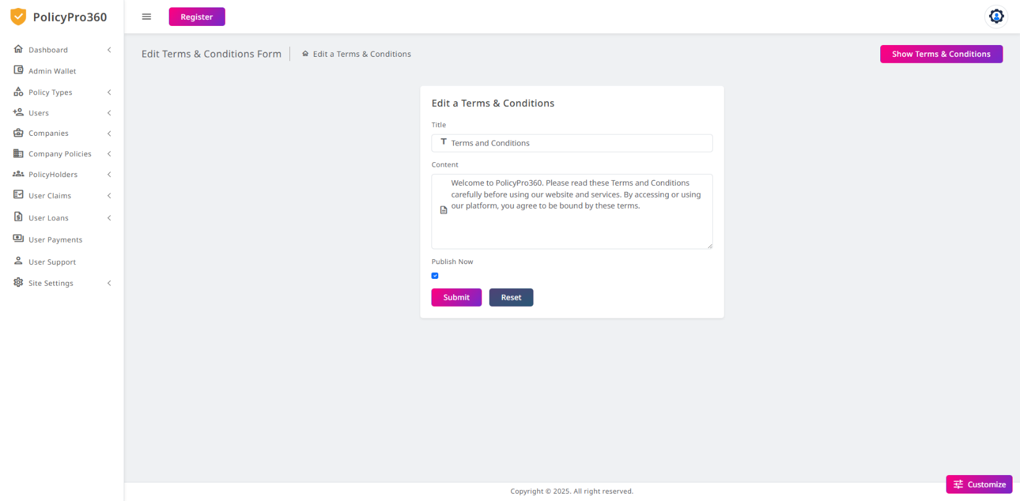

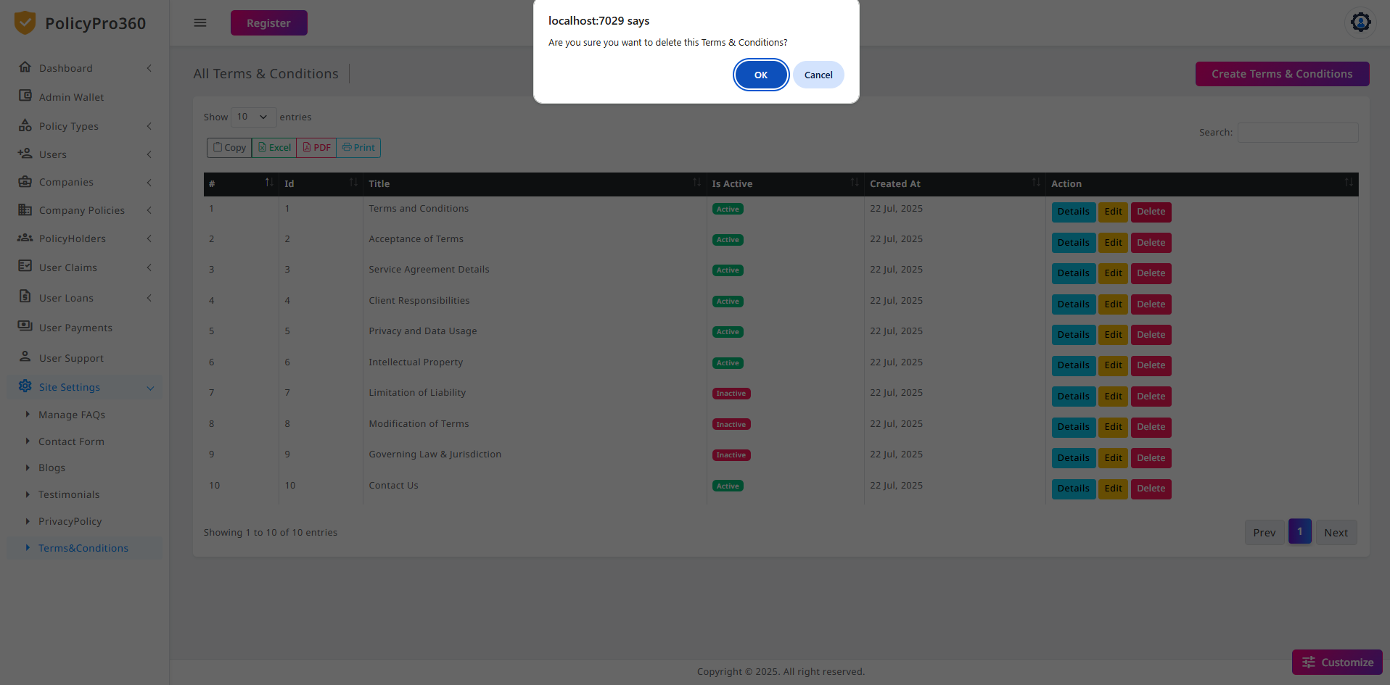

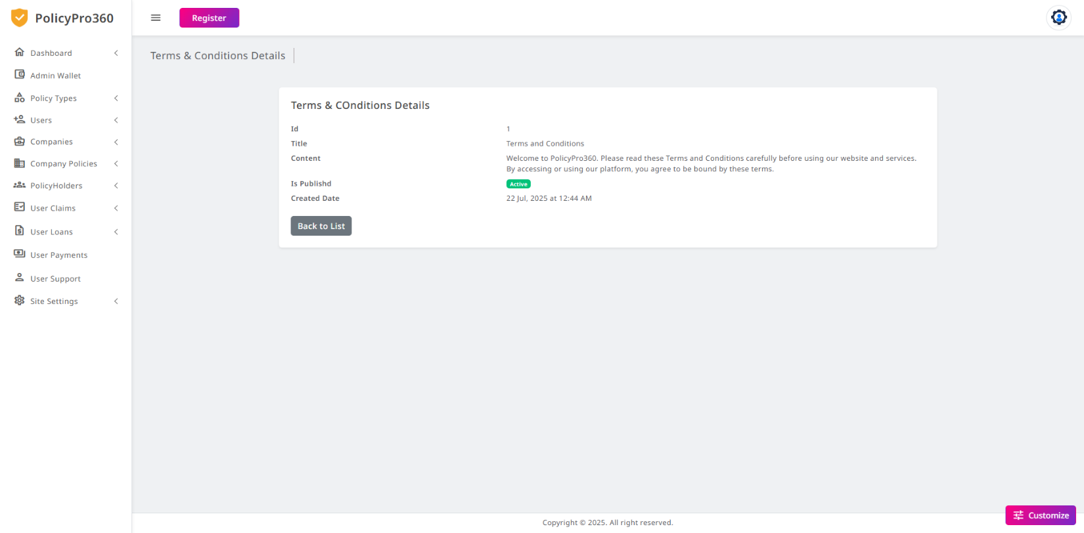

**Admin Site Settings – All Testimonials**

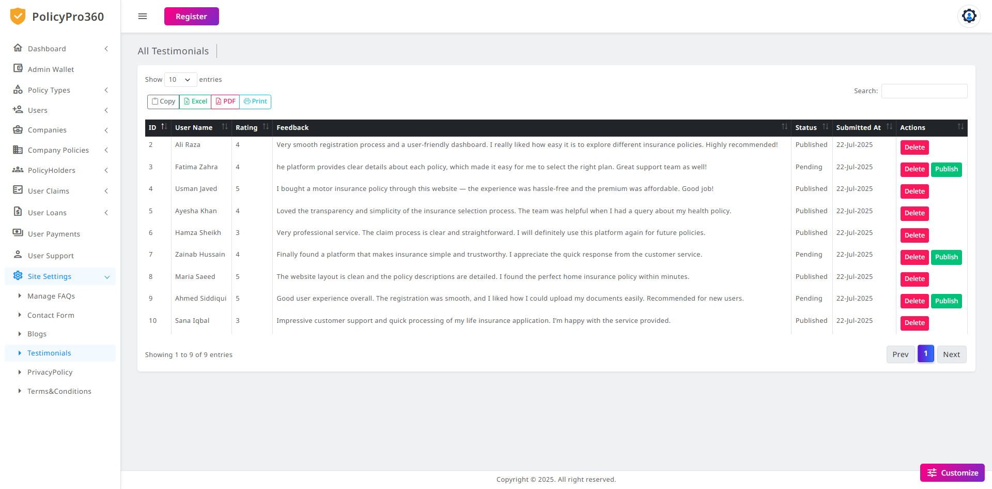

### **Admin Site Settings – Privacy Policy**

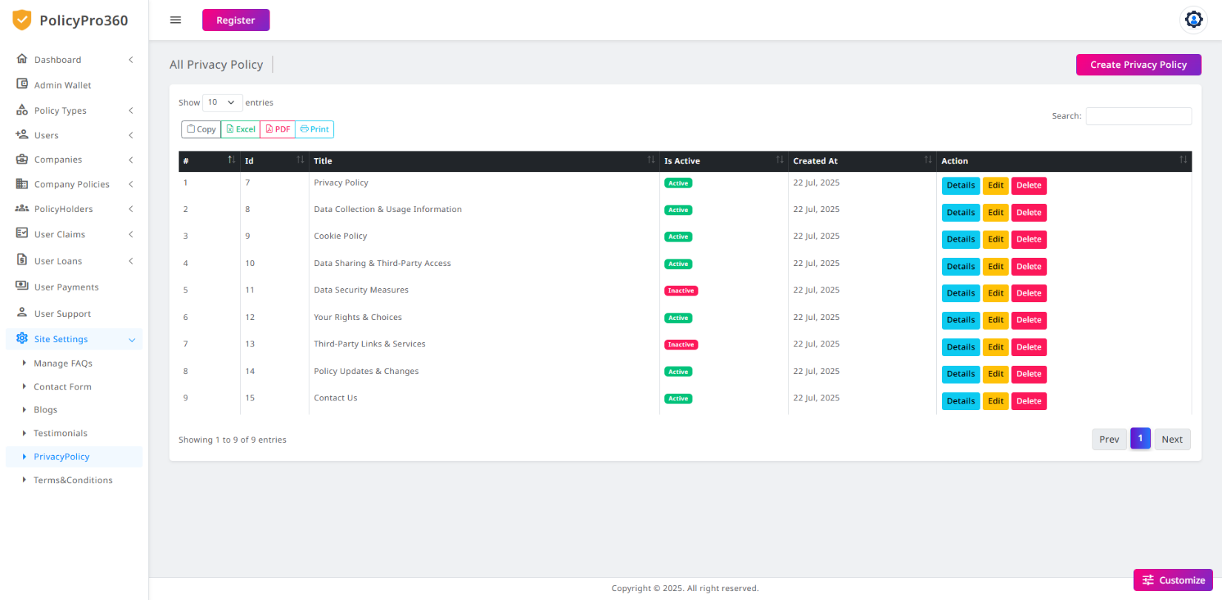

### **Admin Logout**



|  |
| --- |
| POLICYPRO360 |
| TASK SHEET |
| |  |  |  |  |  |  | | --- | --- | --- | --- | --- | --- | | S.No | Task Description | Assigned To | Start Date | End Date | Status | | 1 | Requirement Gathering | MUHAMMAD SAMI KHAN KASHAF JAMIL & MUHAMMAD HASAN | 24-June | 25-June | ✅ Completed | | 2 | Database Design | MUHAMMAD SAMI KHAN  & KASHAF JAMIL | 26-June | 27-June | ✅ Completed | | 3 | Frontend UI Design | FIZA ZULFIQAR, RABEEA QASIM  & KASHAF JAMIL | 28-June | 30-June | ✅ Completed | | 4 | User Registration  & Login Module | MUHAMMAD SAMI KHAN &  KASHAF JAMIL | 01-July | 03-July | ✅ Completed | | 5 | Company Panel –  Add/View Policies | MUHAMMAD SAMI KHAN | 04-July | 06-July | ✅ Completed | | 6 | User Policy Purchase & Premium Calculation | KASHAF JAMIL &  Muhammad Sami Khan | 07-July | 09-July | ✅ Completed | | 7 | Admin Panel | KASHAF JAMIL | 10-July | 12-July | ✅ Completed | | 8 | Payment Integration | MUHAMMAD SAMI KHAN  KASHAF JAMIL | 13-July | 15-July | ✅ Completed | | 9 | Testing & Debugging | FIZA ZULFIQAR & MUHAMMAD ARMAN | 16-July | 18-July | ✅ Completed | | 10 | Documentation Preparation | Kashaf Jamil & Sami Khan | 19-July | 21-July | ✅ Completed | | 11 | Final Report & Submission | All Team Members | 22-July | 24-July | ✅ Completed | |







|  |
| --- |
| POLICYPRO360 |
| PROJECT REVIEW AND MONITORING REPORT |
| |  |  |  |  |  | | --- | --- | --- | --- | --- | | Review Date | Phase Reviewed | Reviewed By | Remarks | Status | | 03-June | Requirement Gathering | Miss Kiran Shakeel | Requirements clearly understood. | ✅ Approved | | 10-June | Design Phase | Miss Kiran Shakeel | UI is clean and well-structured. | ✅ Approved | | 17-June | Module Development | Miss Kiran Shakeel | Good progress. Minor validation improvements needed. | ✅ Approved | | 24-June | Admin/Company Panel | Miss Kiran Shakeel | Functionality working as expected. | ✅ Approved | | 30-June | Final Testing & Completion | Miss Kiran Shakeel | Project ready for final submission. | ✅ Approved | |



|  |
| --- |
| POLICYPRO360 |
| UNIT TESTING CHECKLIST |
| |  |  |  |  |  | | --- | --- | --- | --- | --- | | ****Module**** | ****Test Case**** | ****Expected Output**** | ****Status**** | ****Module**** | | User Registration | Valid input | User registered successfully | ✅ Pass | User Registration | | Login | Wrong credentials | Show error message | ✅ Pass | Login | | Policy Listing | View all policies | Display correct data | ✅ Pass | Policy Listing | | Premium Calculation | Select term & policy | Calculate and display premium | ✅ Pass | Premium Calculation | | Company Add Policy | Add valid policy details | Save and list policy | ✅ Pass | Company Add Policy | |





|  |
| --- |
| POLICYPRO360 |
| FINAL SUBMISSION CHECKLIST |
| |  |  |  | | --- | --- | --- | | Item | Status | Remarks | | Complete Source Code | ✅ Submitted | All modules included | | Database File | ✅ Submitted | .SQL file exported | | Final Documentation | ✅ Submitted | Well formatted, approved | | Presentation Slides | ✅ Ready | Prepared and reviewed | | Unit & Integration Testing | ✅ Done | All modules tested | | Teacher Review & Approval | ✅ Approved | Miss Kiran Shakeel | | Project Uploaded (If needed) | ✅ Done | Uploaded to Google Drive | | Screenshots Attached in Report | ✅ Yes | As proof of execution | |



